Part 1 – Sequences and Scatter Plots
Open the file Arithmetic_Sequences_and_Series.tns. Move to page 1.2.  - Column A, titled n, shows a finite sequence with six terms.  - Column B, titled seq1, shows the term numbers. | 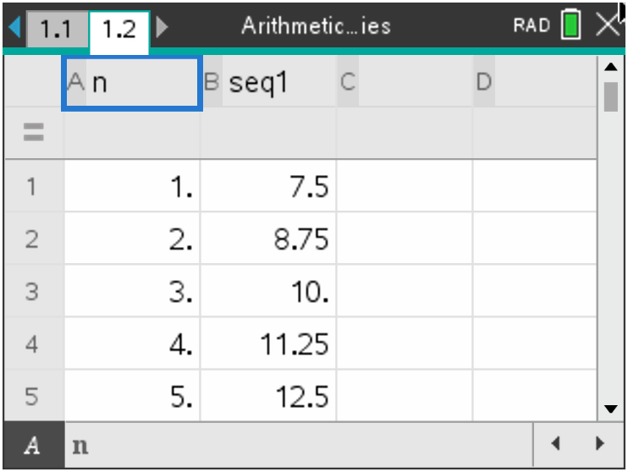
Find the differences between consecutive terms of the sequence in Column B and record them in Column C, title it diff.  - For the first difference, in the first row of Column C, subtract the second term of Column 2 from the first by typing =b2 – b1. Do this for the next four rows: =b3 – b2, b4 – b3, etc. | 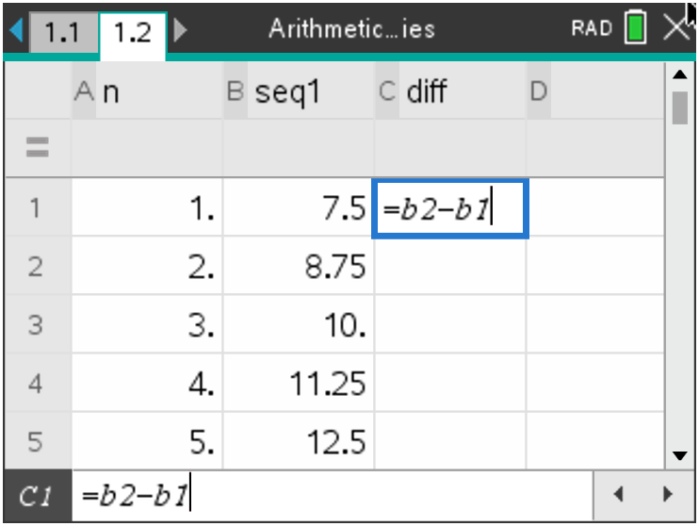
Now enter the following data into the first 6 rows of Column D: 5, 8, 13, 21, 34, 55. Title it seq2.  - Column 4 shows a finite sequence with six terms.  - L1 shows the term numbers for this sequence.  Find the consecutive differences for the Column D sequence and record them in Column E using the same method from before finding the differences in Column B. | 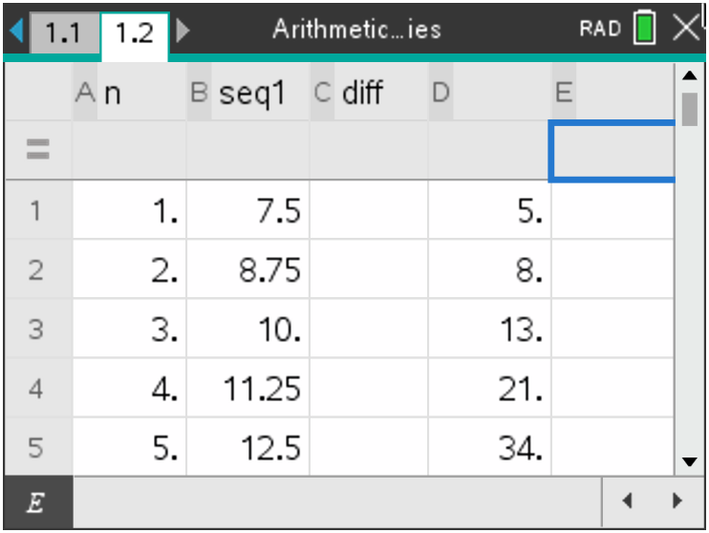
Move to page 1.3 and graph the sequences in Columns B and D.  Press the var button and select n. Move down to the y input. Press the var button a second time and select seq1, press enter. | 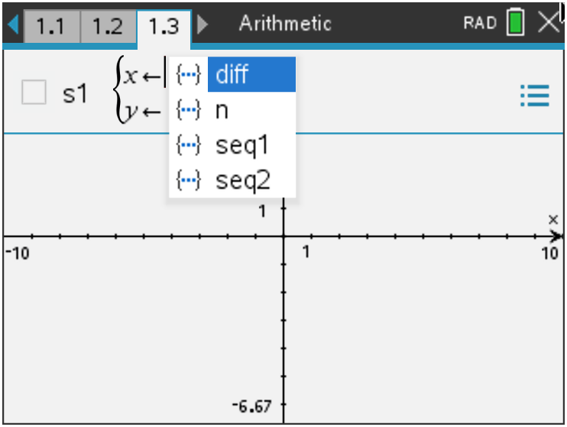
Press tab and repeat for seq2 $\left(x ←n and y ←seq2\right)$, then press enter.  Once both are graphed, press menu, 4 Window/Zoom,  9 Zoom – Data. | 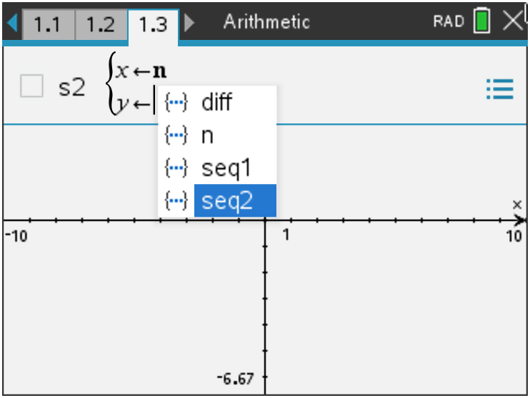
1. For each sequence, write the differences between the consecutive terms and give a description of the scatter plot.
a. Column B: seq1

b. Column D: seq2

c. Study the graphs and the differences you found in Column C and Column E. Make a conjecture.

Move back to page 1.2 and clear the data from Columns B, C, D, and E. Leave the natural numbers in Column A. To clear, select the equals box below each heading, press menu, 3 Data, 4 Clear Data.  - Enter the following sequences into Column B and Column D.  Column B: 3, -2, -7, -12, -17, -22  Column D: 1, 2, 4, 7, 11, 16  - Recalculate the differences between consecutive terms and record them in Columns C and E.  Move to page 1.3 and press menu, 4 Window/Zoom,  9 Zoom – Data. | 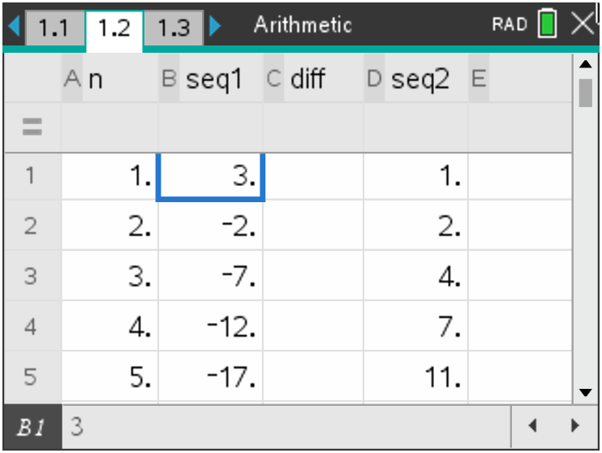
2. For each sequence, write the differences between the consecutive terms and give a description of the scatter plot.
a. New Column B Sequence

b. New Column D Sequence

c. With a classmate, discuss how your observations affect your conjecture about the scatter plot of a sequence and the differences between the consecutive terms. Share your discussion with the class.

Part 2 – Explicit Formulas and Sums
An arithmetic sequence is formed by adding a fixed number, called a common difference $(d)$, to each previous term (this number can be positive or negative).
The explicit formula for the nth term in an arithmetic sequence is
$u_{n}= u_{1}+ \left(n-1\right)∙d,$
- $u_{n}$ is any term of a sequence
- $n$ is the term number
- $u_{1}$ is the first term
- $d$ is the common difference
You can use this formula to calculate any term in an arithmetic sequence.
Move to page 2.1 and generate a sequence in Column B to display the first 30 terms of  $u_{n}=7.5+ \left(n-1\right)∙1.25$.  - Title Column B as seq3.  - Move down to the equal row below the heading seq3. Press menu, 3 Data, 1 Generate Sequence.  - Enter 7.5 + (n–1)*1.25, n0 is 1, nMax is 30, and the step is 1. Press enter or select OK.  Note: There are two rows that are optional to fill. You can enter your initial term as 7.5 or leave it blank and you do not have to enter a ceiling value since we are only looking at the first 30 terms. | 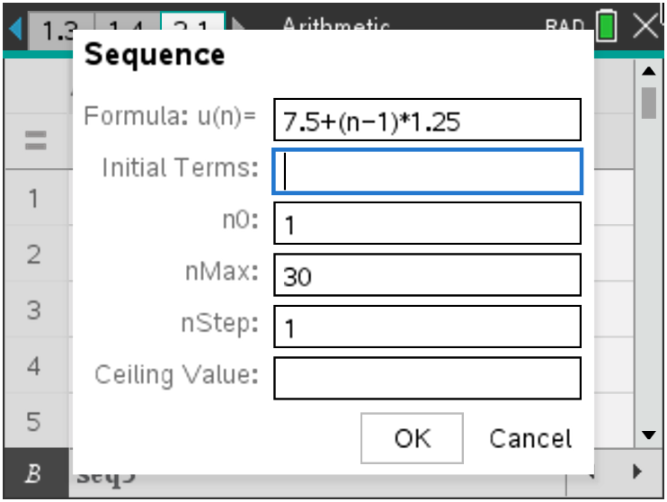
3. Simplify the formula $u_{n}=7.5+ \left(n-1\right)∙1.25$ by distributing and combining like terms. Use this formula in the sequence command (equal row below the heading Column C) to generate 30 terms of this sequence in Column C.
Note: If the handheld asks if this is a column reference or a variable reference due to a Conflict
Detected, select Variable Reference.
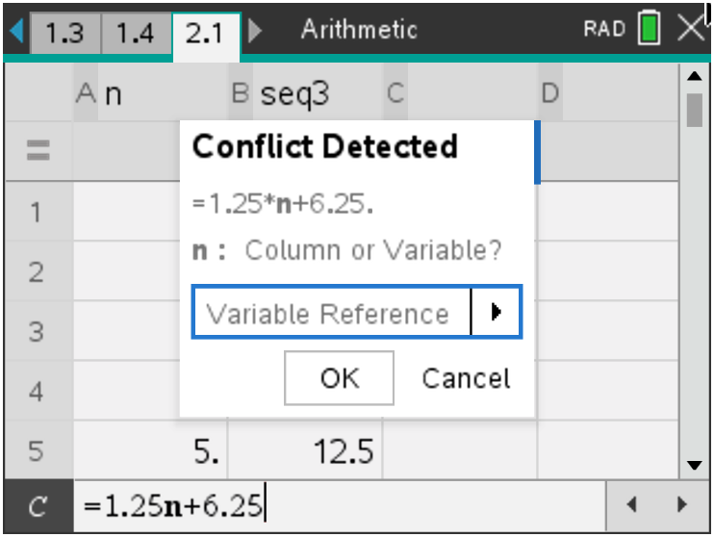
Explain what you notice about the terms in Columns B and C.

Part 3 – Practice Finding the Sum of a Series
The expression consisting of summing the terms in a sequence is called a series. To find the finite sum of the first $n$ terms of an arithmetic sequence algebraically, you will use the formula: $S_{n}= \frac{n}{2}\left(2u_{1}+ \left(n-1\right)∙d\right) or S_{n}= \frac{n}{2}\left(u_{1}+ u_{n}\right)$  Move to page 2.2. You can use the handheld to check the sum of the 30 terms by hand on the home screen enter sum(seq3).  The Sum command can be found by pressing menu,  6 Statistics, 3 List Math, 5 Sum of Elements. Seq3 can be typed in manually or found by pressing the var button. | 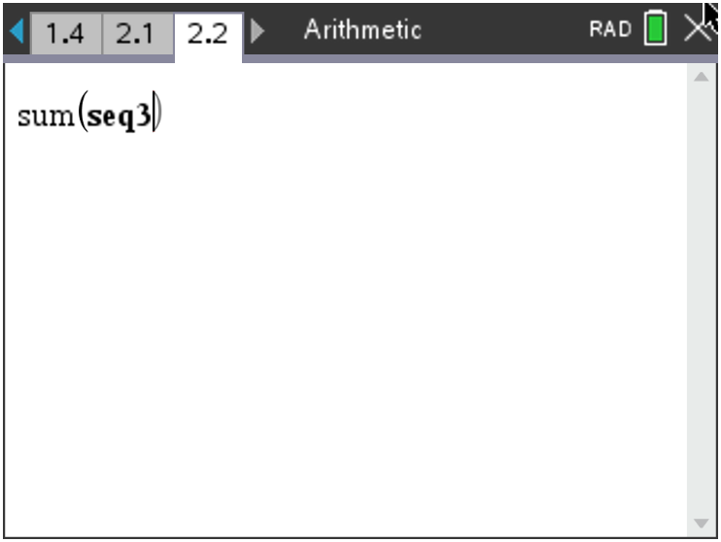
4. Find the sum of the first 30 terms of this sequence in Column B algebraically. Check your result using the sum command.

5. Now, let’s look at another sequence. Find the sum of the first 80 terms of the sequence below, using the Data and Statistics page to generate the following sequence as was done in part 2 and the sum() command on page 3.1.
62, 67, 72, 77, 82…
a. Find the explicit formula for this sequence in simplified form.

b. Find the sum of the first 80 terms.

Further IB Extension
The Clemson Tigers football team play in the multilevel Memorial stadium. The closer you are to the field, the higher the ticket prices. The ticket prices for the first 4 rows of a Tigers football game are as follows:
Row 1: $120 per ticket; Row 2: $117 per ticket; Row 3: $114 per ticket
These ticket prices continue in an arithmetic pattern.

(a) Find the common difference between each consecutive row price. [1 mark]

(b) Calculate the price of a ticket in row 20. [2 marks]

(c) Find the total cost of buying 2 tickets in each of the first 20 rows. [3 marks]

