Lesson Overview
In this TI-Nspire lesson, students will explore different methods of generating random samples from a population of interest. The lesson explores four different methods for generating a random sample: 1. drawing names from a hat; 2. numbering every element in the population of interest and generating random numbers to choose the sample; 3. using a layered sampling strategy, randomly sampling a category and then choosing a random sample within that category; and 4. randomly sampling points in a coordinate grid. |  |  | Learning Goals
- Recognize the differences between a population and a sample and between a population characteristic and a sample statistic;
- understand that a random sample is one in which every possible sample of equal size has the same chance of being selected;
- identify several strategies for selecting a random sample;
- recognize that random samples often have clusters or repeats just due to chance.
 | A random sample is a sample in which every possible subset of the population has equal chance of being selected. There are many ways to generate random samples such as: drawing names from a hat, generating random numbers, etc.
Prerequisite Knowledge |  |  | Vocabulary
Choosing Random Samples is one lesson in a series of lessons that investigates the statistical process. In this lesson, students explore different methods of generating random samples. This lesson builds on the concepts of the previous lessons. Prior to working on this lesson students should have completed Why Random Sampling? Students should understand:  - the concept of random sampling;  - how to answer simple, statistical questions;  - how to find and interpret measures of central tendency. |  |  | - sample a set of data collected from a population  - random sample: set of data in which every possible subset of the population has equal chance of being selected  - population: the entire set of elements in the group of interest (people, animals, shapes, words) from which data might be collected  - characteristic: a summary value for a population  - statistic: a number describing some aspect of a sample
Lesson Pacing
This lesson should take 50–90 minutes to complete with students, though you may choose to extend, as needed.

Lesson Materials
- Compatible TI Technologies:
TI-Nspire CX Handhelds, TI-Nspire Apps for iPad®, TI-Nspire Software
- Choosing Random Samples_Student.pdf
- Choosing Random Samples_Student.doc
- Choosing Random Samples.tns
- Choosing Random Samples_Teacher Notes
- To download the TI-Nspire activity (TNS file) and Student Activity sheet, go to http://education.ti.com/go/buildingconcepts.
Class Instruction Key
The following question types are included throughout the lesson to assist you in guiding students in their exploration of the concept:
Class Discussion: Use these questions to help students communicate their understanding of the lesson. Encourage students to refer to the TNS activity as they explain their reasoning. Have students listen to your instructions. Look for student answers to reflect an understanding of the concept. Listen for opportunities to address understanding or misconceptions in student answers.
Student Activity: Have students break into small groups and work together to find answers to the student activity questions. Observe students as they work and guide them in addressing the learning goals of each lesson. Have students record their answers on their student activity sheet. Once students have finished, have groups discuss and/or present their findings. The student activity sheet can also be completed as a larger group activity, depending on the technology available in the classroom.
Deeper Dive: These questions are provided for additional student practice and to facilitate a deeper understanding and exploration of the content. Encourage students to explain what they are doing and to share their reasoning.

Mathematical Background
Students typically begin using data, both categorical and measurement, to answer simple statistical questions with little attention paid to how the data were selected. A next step is to focus on methods for collecting data about a particular population, in particular the process of selecting a random sample, and the value of doing so. Students are familiar with selecting four students from class to be on a committee, and, to be fair, everyone’s name is put into a box, mixed up and someone draws four names “at random”. Students realize that they may not get selected but understand that it is fair because every student has the same chance of being selected. In other words, random sampling is a fair way to select a subset (a sample) of the set of interest (the population).
To understand how a sampling process works, students need to understand the difference between a population (the large set of interest) and a sample (a subset of that population). Numbers used in describing a characteristic of the population (typically measures of center, spread, maximum and minimum) can be estimated by calculating the corresponding statistic using the data in the sample.

Part 1, Page 1.3
Focus: A population is the entire set of elements in a group of interest, and a sample is a set of data collected from that population. A random sample is a sample where every possible sample of the same size has an equal chance of being selected. A characteristic of the population such as maximum value is called a statistic for a sample from that population.  On page 1.3, students can select the bag, drawing students’ names from the class list at random, without replacement.  Draw selects a student from the available class list. | 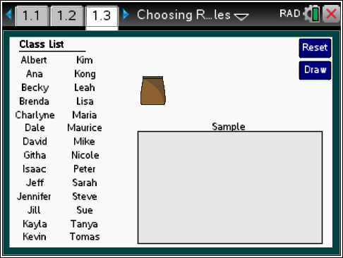
 |  |  |  | TI-Nspire Technology Tips
b narrows selection to boys or girls or both.
e cycles through the sampled names.
Arrow keys move selected name.
/. resets the page.
After a name is drawn from the bag it can be dragged into the box or moved using tab and the down arrow key on a keyboard. The name is automatically moved once another name is drawn from the bag.
Reset returns to the original screen.
Class Discussion
Suppose a teacher wanted four students to represent the class at a school-wide meeting, puts the names into a bag, shakes the bag, and then draws four names. The class has 16 girls and 12 boys. Answer each of the questions and explain your answer in each case.
- What is the population in this situation? |  | Answer: The class is the population.
- Do you think all four of those selected will be boys? |  | Answer: It is possible but not likely as there are more girls than boys.
- Which do you think is the most likely to occur? Two boys, two girls; all girls or all boys? |  | Answers will vary. Some may choose two boys and two girls, but others might think it would be all girls because there are more girls in the class.
- Does this way of selecting the students seem fair? |  | Answers will vary. Students should begin to articulate that everyone has an equal chance of being selected, which seems fair.

Class Discussion (continued)
Have students… | Look for/Listen for…
Go to page 1.3.
- Select Draw. Move the name into the Sample box. Draw three more times. Which students did you select for the committee? | Answers will vary. One sample consisted of Tanya, Jennifer, Maurice and Brenda.
- Compare your sample of students to the students chosen by others. Did anyone get all girls in their sample? | Answers will vary. This could happen.
- Is there anyway to be sure that someone’s name is chosen? Explain your reasoning. | Answer: Without taking that name out of the bag to start, there is no way to be sure someone’s name will be chosen.
A random sample is a sample where every possible sample of the same size has an equal chance of being selected. Look at the names on page 1.3. Decide whether the following would be a random sample and if not, explain why.
- Put the names with three letters in a hat and draw one, then the names with four letters into the hat and draw one, and then the name with more than four letters and draw one. | Answer: Not a random sample because Ana, Kim and Sue would have a chance of being chosen, but Mike, Kong, Dale, Jeff, Jill, Lisa would have a chance of being chosen. To be a random sample every sample of the same size must have the same chance of being chosen and that isn’t true in this example.
- The teacher chose every eighth person in the list: Githa, Kong and Sarah. | Answer: Not a random sample because none of the other students would have a chance of being chosen.
- Choose the students with the three or more vowels in their name. | Answer: Not a random sample because those with one or two vowels would not have a chance to be chosen.
- Put the names on a spinner divided into equal sections for each student. Spin the spinner and choose the person whose name was on the section the spinner landed on. Do this three times to get three people. | Answer: This would be a random sample because every possible sample of size three would have a chance of being chosen.

Class Discussion (continued)
Have students… | Look for/Listen for…
Consider the number of letters in the first names of the class.
- What is the maximum number of letters in the first names of the class? | Answer: 8 letters
- The answer to the question above could be called a characteristic of the population of the students in the class since it is a summary value for the population of the class. The corresponding value for a sample is called a statistic. Draw a sample of five students from the class. What is the value of the statistic from your sample that corresponds to the answer to the characteristic from the question above? | Answers will vary. In one sample the maximum number of letters was five
- Number of girls in the sample could be another statistic. What is the number of girls in the sample you drew? | Answers will vary. One random sample of five students had three girls.
Which of the following are true? Explain your reasoning.
- The mean number of letters in first names in the entire class will be the same as the statistic, mean number of letters in the first names in a sample. | Answer: False. Samples will be close but not exactly the same as the population being sampled.
- The value of a statistic will usually vary from sample to sample. | Answer: True because each sample could involve a slightly different subset of the population.

Part 2, Page 1.5
Focus: Random samples have unexpected streaks or repetitions.  On page 1.5, students can take samples of varying sizes from the class list.  Draw selects n random numbers from 1 to 28 in the box.  List highlights the students’ names corresponding to the random numbers drawn.  Reset returns the page to the original screen. | 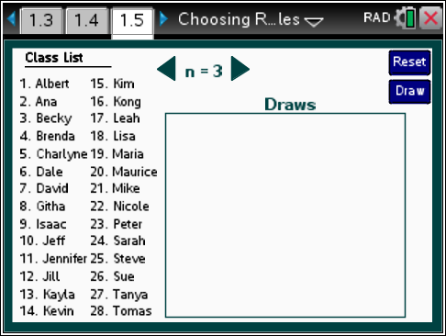
 |  |  |  | TI-Nspire Technology Tips
b accesses page options.
Up/Down arrows cycle through the samples.
· draws a new sample and sends to the list.
/. resets the page.
Class Discussion
Suppose you wanted to be sure you had two boys and two girls in a sample of four students drawn from page 1.5.
- How could you make sure your random sample had the same number of boys as girls? |  | Answers may vary. One strategy might be to draw four names; if the sample doesn’t have two boys and two girls, draw again and repeat until you get a sample that does. Another might be to draw one at a time until you get two girls and two boys, ignoring the extras. Some students may suggest going back to page 1.3.
- On page 1.3, describe how you would use the menu to select a random sample of two boys and two girls. |  | Answer: Use menu> Boys and Draw twice; then menu> Girls and Draw twice.
Student Activity Questions—Activity 1
1. A teacher decided to collect the homework from a random sample of four students each day rather than grading everyone’s homework every day. On page 1.5, set n = 4.
a. Select Draw to see who will have to turn in their homework on Monday. Identify the students you think will be in the sample. Select List to check your thinking.
Answer: The students whose numbers correspond to the randomly generated set of numbers will be chosen.

Student Activity Questions—Activity 1 (continued)
b. If a student is selected at the beginning of the week to turn in their homework, do you think they are “safe” for the rest of the week? Use the TNS activity to support your answer.
Answers will vary. Students should note that having a student selected at least twice in 5 days is fairly common: For example, the tables show the number of the students selected for each day of the school week over a three week period.
Week 1 |  |  |  |  |  | Week 2 |  |  |  |  | Week 3
Mon. | 6 | 4 | 15 | 10 |  | 22 | 3 | 7 | 2 |  | 5 | 28 | 2 | 22
Tues. | 1 | 11 | 4 | 20 |  | 2 | 7 | 23 | 9 |  | 8 | 26 | 13 | 7
Wed. | 8 | 25 | 17 | 13 |  | 27 | 14 | 2 | 18 |  | 20 | 1 | 2 | 24
Thur. | 16 | 2 | 11 | 1 |  | 24 | 21 | 28 | 7 |  | 23 | 20 | 3 | 7
Fri. | 17 | 27 | 7 | 20 |  | 14 | 17 | 19 | 11 |  | 17 | 21 | 15 | 28

Part 3, Pages 2.2 and 2.3
Focus: Random sampling can be used to select a group and then again to select objects within the groups.  On page 2.2, blocks are chosen at random, and then a number of cells within the blocks are chosen at random.  Blocks chooses the number of blocks. | 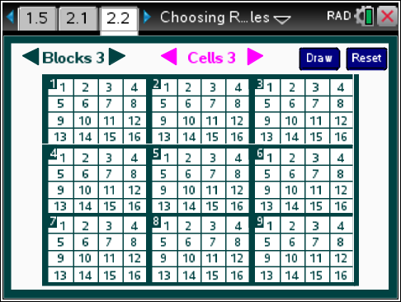
 |  |  | TI-Nspire Technology Tips
b accesses page options.
e moves between blocks and cells.
· selects blocks and cells.
/. resets the page.
Cells chooses the number of cells within each block.
Draw highlights random cells in the randomly chosen blocks.
Reset returns to the original screen
On page 2.3, students select the same set of random cells in each of the chosen blocks.

Student Activity Questions—Activity 2
1. Sampling can be used to analyze the way people write, for example, how many words they use in their sentences, or how big those words are. Lewis Carroll, the author of Alice in Wonderland, also wrote the poem Jabberwocky. All of the verses in the poem except the last verse (which repeats the first part) are below.
\1\Jabberwocky
’Twas brillig, and the slithy toves
Did gyre and gimble in the wabe:
All mimsy \2\were the borogoves,
And the mome raths outgrabe.
“Beware the Jabberwock, my son!
The jaws that \3\bite, the claws that catch!
Beware the Jubjub bird, and shun
The frumious Bandersnatch!”
He took \4\his vorpal sword in hand;
Long time the manxome foe he sought—
So rested he by \5\the Tumtum tree
And stood awhile in thought.
And, as in uffish thought he stood,
The \6\Jabberwock, with eyes of flame,
Came whiffling through the tulgey wood,
And burbled as it came!
\7\One, two! One, two! And through and through
The vorpal blade went snicker-snack!
He left it \8\dead, and with its head
He went galumphing back.
“And hast thou slain the Jabberwock?
Come \9\to my arms, my beamish boy!
O frabjous day! Callooh! Callay!”
He chortled in his joy.

Student Activity Questions—Activity 2 (continued)
a. Suppose you are interested in the number of letters in the words from the poem above. What is the population?
Answer: all the words in the poem.
b. Rather than counting all of the letters in each word, you can take a sample and use the sample to estimate the number of letters per word. The poem has been divided into 9 lines that correspond to the 9 blocks. Work with a partner. Go to page 2.2, and set Block 9 and Cell 1. Select Draw. List the numbers displayed.
Answers will vary. One example: 1-8; 2-2; 3-11; 4-13; 5-2; 6-10; 7-11; 8-11; 9-9.
c. Using the randomly generated numbers, find the word in Block 1 and Cell 8. Begin with the title of the poem and count a hyphenated word as one word.
Answers will vary. In the example above, the word would be did (remembering to count the word Jabberwocky).
d. Find the other randomly selected words. Use your sample to estimate the mean number of letters per word in Jabberwocky.
Answers will vary. Using the example above: line 1-word 8; line 2-word 2; line 3-word 11; line 4-word13; line 5- word 2; line 6- word 10; line 7-word 11; line 8-word 11; line 9-word 9. These random numbers produced the sample: did, the, shun, he, Tumtum, tulgey, blade, hast, day. The mean number of letters in the sample of words is
2. Remember that a number describing some aspect of a sample (e.g. maximum, mean, IQR) is called a statistic.
a. What sample statistic did you find in the previous question?
Answer: the mean number of letters per word.
b. If you repeated the process of generating random numbers and using them to choose letters from each block as you did in the previous problem. Do you think you would get the same mean number of letters you did in part d above? Why or why not?
Answers may vary. Students should recognize that the same statistic will vary from sample to sample.
c. Repeat the sampling process and verify your conjecture.
Answers will vary. One sample: line 1-word 3; line 2-word 12; line 3-word 6; line 4-word 13; line 5-word 6; line 6-word 8; line 7-word 12; line 8-word 13; line 9-word 16 produces brillig, my, beware, so, awhile, through, went, slain, joy. An estimate for the mean number of letters is 4.67 letters.

Student Activity Questions—Activity 2 (continued)
Teacher Tip: Collect responses from the class in a dot plot or a frequency tally to see the distribution of the mean word lengths from the classes samples. Remind students of how the distribution of sample mean segment lengths in Lesson 17, Why Random Sampling clustered around the actual mean length of all the segments.
Note here that the actual mean number of letters in the words in Jabberwocky is 4.41 ().
3. A city was considering whether to have people in a nine-block residential area switch from their own wells to city water. They wanted to randomly sample the homes, all single family, so they could get information from about 40 homes all together to help them make the decision. Use page 2.3 and describe how they might choose their sample.
Answers will vary. One plan might be to choose 8 blocks and 5 cells in each block. Another might be to choose 5 blocks and 8 cells in each block.
Part 3, Page 2.5
Focus: Random samples have clusters and gaps.  Page 2.5 displays a random sample of n points on a grid in the first quadrant.  Random Sample displays random points on the grid.  Selecting a point displays the coordinates and selecting the point again hides them. | 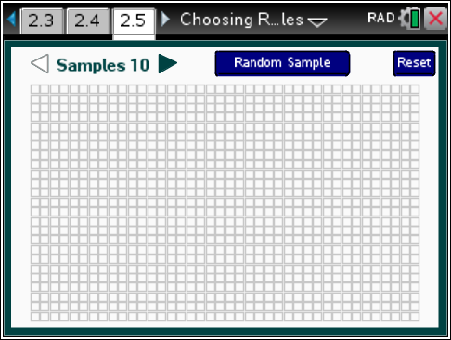
 |  |  | TI-Nspire Technology Tips
b accesses page options.
e moves among points and sample size, random sample and reset.
· generates a new random sample or highlights a point to display coordinates of a selected point.
d deselects highlighted points.
/. resets the page.

Class Discussion
Samples can also be drawn from different locations by using a coordinate grid, generating random numbers for each coordinate and using the points to create a scatter plot. Go to page 2.5.
- Select Random Sample. Identify some randomly selected points that have the same x-coordinates; the same y-coordinates. |  | Answers will vary. One sample contained (10, 13) and (16, 13) and (33, 23) and (38, 23). There were no points with the same y-coordinates.
 | - Set sample size to 50. Describe the distribution of the randomly generated points, noting any clusters or gaps. | Answers will vary. In one sample there were no points in a region in the lower left part of the graph, from about to .
 | - Generate samples on page 2.5 and use them to determine whether the following statements are true.  a. If the set of points in a sample is truly random, there will be no clusters or gaps.  b. As the number of points in a random sample increases, there will be fewer or no clusters or gaps among the points.  c. There will be some regularity in the display of points if the points were chosen randomly. | Answer: All of the statements are false as students can observe from repeatedly generating random samples of points.
 | Streaks and clusters often occur in random samples. How many streaks of 4 or more heads occur just randomly when you toss a coin? Revisit Lesson 15, Probability and Simulation. On page 1.3, toss the coin 30 times, then scroll through the outcomes of each toss in the table. Compare your results to others in your class. | Answers will vary. In one set of 30 tosses, two streaks of four heads and one of five heads occurred.
 | Deeper Dive — page 2.2
 | Another way to find the mean length of the words in Jabberwocky is to randomly sample five of the nine lines and then randomly choose two words from each of those lines.
 | - Does this seem like a “fair” way to get a sample of words? Explain why or why not. | Answers will vary. Students should see that this method does give every line a chance of being chosen and every word in a line.

Deeper Dive — page 2.2 (continued)

- Use this method and compare your results to your answers from the questions in Student Activity 2. | Answers will vary. One sample gave Block 1: Cells 11, 14; Block 2: Cells 5, 15; Block 3: Cells 4, 14; Block 7: Cells 4, 12; and Block 9: Cells 9, 10. This produces the set of words: gimble, wabe, the, jaws, that, Bandersnatch, two, went, day, callooh. The mean number of letters per word in this sample is 5.
- Jabberwocky actually repeats the first four lines at the end of the poem. How do you think including these lines in your population will change the results you found in the questions in Student Activity 2 or from your answer to the question above? Check your thinking by selecting a random sample of the entire poem and finding the mean number of letters per word. | Answers will vary. In one sample, the mean number of letters per word for the entire poem was 4.46.
How long is the average word used in the Abraham Lincoln’s Gettysburg Address? The text is below.
- Figure out a way to generate random numbers to select a sample of 20 or fewer words from the text to estimate the mean number of letters in the words in the Gettysburg Address.
Four score and seven years ago our fathers brought forth on this continent, a new nation, conceived in Liberty, and dedicated to the proposition that all men are created equal.
Now we are engaged in a great civil war, testing whether that nation, or any nation so conceived and so dedicated, can long endure. We are met on a great battle-field of that war. We have come to dedicate a portion of that field, as a final resting place for those who here gave their lives that that nation might live. It is altogether fitting and proper that we should do this.
But, in a larger sense, we cannot dedicate—we cannot consecrate—we cannot hallow—this ground. The brave men, living and dead, who struggled here, have consecrated it, far above our poor power to add or detract. The world will little note, nor long remember what we say here, but it can never forget what they did here. It is for us the living, rather, to be dedicated here to the unfinished work, which they who fought here have thus far so nobly advanced. It is rather for us to be here dedicated to the great task remaining before us—that from these honored dead we take increased devotion to that cause for which they gave the last full measure of devotion—that we here highly resolve that these dead shall not have died in vain, that this nation, under God, shall have a new birth of freedom, and that government of the people, by the people, for the people, shall not perish from the earth.
--Abraham Lincoln November 19, 1863
Deeper Dive — page 2.2 (continued)

Possible answer: Breaking the words into lines of 16 words and then selecting random numbers for one word in each sentence. You may have to generate several different random numbers for the last line as there are not 16 words in that line.
  - Four score and seven years ago our fathers brought forth on this continent, a new nation,
  - conceived in Liberty, and dedicated to the proposition that all men are created equal. Now we
  - are engaged in a great civil war, testing whether that nation, or any nation so conceived
  - and so dedicated, can long endure. We are met on a great battlefield of that war.
  - We have come to dedicate a portion of that field, as a final resting place for
  - those who here gave their lives that that nation might live. It is altogether fitting and
  - proper that we should do this. But, in a larger sense, we cannot dedicate—we can
  - not consecrate—we cannot hallow—this ground. The brave men, living and dead, who struggled
  - here, have consecrated it, far above our poor power to add or detract. The world will
- little note, nor long remember what we say here, but it can never forget what they
- did here. It is for us the living, rather, to be dedicated here to the unfinished
- work, which they who fought here have thus far so nobly advanced. It is rather for
- us to be here dedicated to the great task remaining before us—that from these honored
- dead we take increased devotion to that cause for which they gave the last full measure of
- devotion—that we here highly resolve that these dead shall not have died in vain, that
- this nation, under God, shall have a new birth of freedom—and that government of the
- people, by the people, for the people, shall not perish from the earth.
Random Sample:
line 1 – word 16; line 2 – word 15; line 3 – word 3; line 4 – word 9; line 5 – word 7; line 6 – word 12; line 7- word 1; line 8 – word 6; line 9 – word 16; line 10 – word 4; line 11 – word 13; line 12 – word 16; line 13 – word 4; line 14 – word 6; line 15 – word 1; line 16 – word 15; line 17 – word 2
Selected words: nation, Now, in, met, portion, It, proper, this, will, long, here, for, here, to, devotion, of, by
Average word length in the sample: 3.882 letters

Deeper Dive — page 2.2 (continued)

- Identify the population, the population characteristic, and the sample statistic in the question above. | Answer: The population is all of the words in the Gettysburg Address, the population characteristic is the mean number of letters in the words, and the sample statistic is what we found as an answer in the question above, for example, 4.42 letters.  Note that the actual mean length of the words is
Deeper Dive

Sometimes clusters are random, and sometimes they indicate some other factor is in play. Look at the map below of London in 1854. The wells are marked with a large dot and a name.
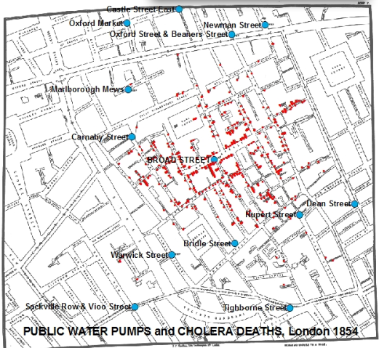
www.udel.edu/johnmack/frec682/cholera/cholera2.html

Deeper Dive (continued)

- Describe any clusters of deaths. Identify any possible connections you think might exist among the pumps and the deaths.
Answers may vary. The deaths seem to cluster around the Broad Street well.
- Go to www.udel.edu/johnmack/frec682/cholera/ and describe how the cause of the cholera epidemic was identified.
Answer: A doctor (John Snow) thought that the cholera was spread through bad water. He mapped the deaths and the wells and thought that the bad well might be the Broad Street well because so many people in that area died. When they capped the well, the deaths stopped.
Go to page 2.3. Here the randomly chosen cells are the same in each block. Identify a situation where this would be a good way to choose a random sample.
Answers will vary. Any situation where you want to vary the block or group but keep the something within the group constant such as random rooms for treatments but the same spot within each room.

Sample Assessment Items
After completing the lesson, students should be able to answer the following types of questions. If students understand the concepts involved in the lesson, they should be able to answer the following questions without using the TNS activity.
1. Paul and Ritae decide to conduct a survey to see whether students are in favor of a new start time for school. Paul stood at the school entrance and asked the first 100 students who come to school on Monday. Ritae got a list of all students at the school and randomly selected 50 to survey. Paul found 40% of his sample in favor of the new dress code policy; Ritae found only 18%. Which do you believe is more likely to be representative of the school population? Explain your choice.
Adapted from New York Engage Module 5 grade 7
Answer: Paul is not taking a random sample, so his results are not likely to be representative of the whole group.
2. Which of the following would give you a random sample?
a. put the 20 problems for an assignment in a hat and draw a sample of 5
Answer: Would be random because every problem has an equal chance to be selected
b. Choose the pages in the phone book that are multiples of ten and randomly select numbers on those pages to call to find out who they will vote for in a coming election
Answer: This would not be random because not all the possible voters would have a chance to be selected; only those on that pages 10, 20, and so on.
3. Identify the population for each sample:
a. A poll of 30 seventh grade students selected from all the seventh grade students wanted to change the dress code for the middle school.
Answer: all seventh grade students
b. A survey given to some of the people at the mall on Friday night indicated that shopping hours at the mall should be extended.
Answer: People who were shopping at the mall on that Friday night.
4. Are the following a sample statistic or a population characteristic?
a. The number of students absent from class during the month of January.
Answer: population characteristic
b. The typical number of home runs hit in a particular season for major league baseball players?
Answer: sample statistic
5. Which of the following data collection methods do you think would produce a sample representative of the population?
a. Population: potential voters: Generate a random sample of telephone numbers and call the numbers asking the people who respond how they intend to vote.
b. Population: All students in school; sample includes every tenth student in the hall outside of class.
c. Population: Students in your class; sample consists of students that have the letter “r” in their last name.
d. Population: Students in your class; sample selected by putting their names in a bag and drawing the sample from the hat.
e. Population: Everyone in a room; sample selected by having everyone toss a coin, and those that result in heads are the sample.
Answer: d. Population: Students in your class; sample selected by putting their names in a bag and drawing the sample from the hat. and e. Population: Everyone in a room; sample selected by having everyone toss a coin, and those that result in heads are the sample.

Student Activity Solutions
In these activities you will generate random samples from a population and generate statistics based on populations. After completing the activities, discuss and/or present your findings to the rest of the class.
Activity 1 [Page 1.5]
1. A teacher decided to collect the homework from a random sample of four students each day rather than grading everyone’s homework every day. On page 1.5, set .
a. Select Draw to see who will have to turn in their homework on Monday. Identify the students you think will be in the sample. Select List to check your thinking.
Answer: The students whose numbers correspond to the randomly generated set of numbers will be chosen.
b. If a student is selected at the beginning of the week to turn in their homework, do you think they are “safe” for the rest of the week? Use the TNS activity to support your answer.
Answers will vary. Students should note that having a student selected at least twice in 5 days is fairly common: For example, the tables show the number of the students selected for each day of the school week over a three week period.
Week 1 |  |  |  |  |  | Week 2 |  |  |  |  | Week 3
Mon. | 6 | 4 | 15 | 10 |  | 22 | 3 | 7 | 2 |  | 5 | 28 | 2 | 22
Tues. | 1 | 11 | 4 | 20 |  | 2 | 7 | 23 | 9 |  | 8 | 26 | 13 | 7
Wed. | 8 | 25 | 17 | 13 |  | 27 | 14 | 2 | 18 |  | 20 | 1 | 2 | 24
Thur. | 16 | 2 | 11 | 1 |  | 24 | 21 | 28 | 7 |  | 23 | 20 | 3 | 7
Fri. | 17 | 27 | 7 | 20 |  | 14 | 17 | 19 | 11 |  | 17 | 21 | 15 | 28

Activity 2 [Page 2.2]
1. Sampling can be used to analyze the way people write, for example, how many words they use in their sentences, or how big those words are. Lewis Carroll, the author of Alice in Wonderland, also wrote the poem Jabberwocky. All of the verses in the poem except the last verse (which repeats the first part) are below.
\1\Jabberwocky
’Twas brillig, and the slithy toves
Did gyre and gimble in the wabe:
All mimsy \2\were the borogoves,
And the mome raths outgrabe.
“Beware the Jabberwock, my son!
The jaws that \3\bite, the claws that catch!
Beware the Jubjub bird, and shun
The frumious Bandersnatch!”
He took \4\his vorpal sword in hand;
Long time the manxome foe he sought—
So rested he by \5\the Tumtum tree
And stood awhile in thought.
And, as in uffish thought he stood,
The \6\Jabberwock, with eyes of flame,
Came whiffling through the tulgey wood,
And burbled as it came!
\7\One, two! One, two! And through and through
The vorpal blade went snicker-snack!
He left it \8\dead, and with its head
He went galumphing back.
“And hast thou slain the Jabberwock?
Come \9\to my arms, my beamish boy!
O frabjous day! Callooh! Callay!”
He chortled in his joy.
- Suppose you are interested in the number of letters in the words from the poem above. What is the population?
Answer: all the words in the poem.
- Rather than counting all of the letters in each word, you can take a sample and use the sample to estimate the number of letters per word. The poem has been divided into 9 lines that correspond to the 9 blocks. Work with a partner. Go to page 2.2, and set Block 9 and Cell 1. Select Draw. List the numbers displayed.
Answers will vary. One example: 1-8; 2-2; 3-11; 4-13; 5-2; 6-10; 7-11; 8-11; 9-9.
- Using the randomly generated numbers, find the word in Block 1 and Cell 8. Begin with the title of the poem and count a hyphenated word as one word.
Answers will vary. In the example above, the word would be did (remembering to count the word Jabberwocky).
- Find the other randomly selected words. Use your sample to estimate the mean number of letters per word in Jabberwocky.
Answers will vary. Using the example above: line 1-word 8; line 2-word 2; line 3-word 11; line 4-word13; line 5- word 2; line 6- word 10; line 7-word 11; line 8-word 11; line 9-word 9. These random numbers produced the sample: did, the, shun, he, Tumtum, tulgey, blade, hast, day. The mean number of letters in the sample of words is
- Remember that a number describing some aspect of a sample (e.g. maximum, mean, IQR) is called a statistic.
- What sample statistic did you find in the previous question?
Answer: the mean number of letters per word.
- If you repeated the process of generating random numbers and using them to choose letters from each block as you did in the previous problem. Do you think you would get the same mean number of letters you did in part d above? Why or why not?
Answers may vary. Students should recognize that the same statistic will vary from sample to sample.
- Repeat the sampling process and verify your conjecture.
Answers will vary. One sample: line 1-word 3; line 2-word 12; line 3-word 6; line 4-word 13; line 5-word 6; line 6-word 8; line 7-word 12; line 8-word 13; line 9-word 16 produces brillig, my, beware, so, awhile, through, went, slain, joy. An estimate for the mean number of letters is 4.67 letters.
- A city was considering whether to have people in a nine-block residential area switch from their own wells to city water. They wanted to randomly sample the homes, all single family, so they could get information from about 40 homes all together to help them make the decision. Use page 2.3 and describe how they might choose their sample.
Answers will vary. One plan might be to choose 8 blocks and 5 cells in each block. Another might be to choose 5 blocks and 8 cells in each block.

