Student Worksheet for Secant Tangent Exploration, Part 1:
Experimental biologists often want to know the rates at which populations grow under controlled laboratory conditions. The figure below shows how the number of fruit flies grew in a controlled 50-day experiment. The graph was made by counting flies at regular intervals, plotting a point for each count, and drawing a smooth curve through the plotted points. The researchers want to know the population change on day 23, can you help them?
Day | Flies
10 | 17
20 | 104
23 | 150
30 | 265
35 | 310
40 | 330
45 | 340

Page | Question/Task | Answer
1.2 | Enter the data from the table above into the spreadsheet. | N/A
1.3 | Study the curve, select Menu, 4: Statistics, 1: Stat Calculations, and select the best regression model for the data. | N/A
1.4 | Select your answer, write it in the space on the right.
1.6 | *You will use this page to investigate and answer questions related to page 1.7*  a) What kind of line is passing through the two points?  b) What is the slope of this line?  (Remember, the slope of this type of line is the average rate of change!)  c) What does it mean in the context of the problem? | a) b)  c)
1.7 | Hover over 45 in the ordered pair, click it twice, and change it to 40.  What is the slope of the line when x = 40?  What does this represent in the context of the problem?  (A template is provided at right for assistance).  Proceed in this manner for the rest of these questions.  What is the slope of the line when x = 30?  What does this represent in the context of the problem?  What is the slope of the line when x = 25?  What does this represent in the context of the problem?  What is the slope of the line when x = 20?  What does this represent in the context of the problem?  ESTIMATE what the slope of secant line PQ would be if the distance between P and Q is really close to zero.  Finally, ESTIMATE the slope of the tangent line on day 23. What does this represent in the context of the problem? | The amount of ______ has (increased/decreased) an average of ________ flies per ______ between day 23 and day _____.
1.9 | Part 2:  Let’s look at the average and instantaneous rates of change algebraically. Remember, we are interested in finding the rate of change of the flies on day 23.  Both average rate of change methods yielded the same result; the first one is the way we used from the graph on the last page. What does the ‘22’ from the screenshot at left represent?  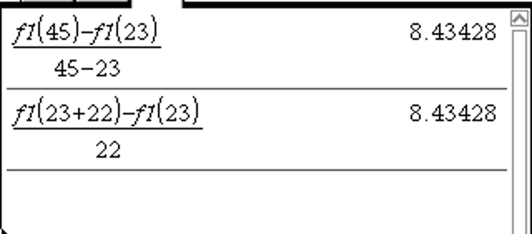  If you wanted to find the average rate of change on day 40, what would the ‘22’ change to? ____  Do this on the Nspire using the second method. Write down your answer.  Use the second method shown in the screenshot and find the average rates of change on day 30, day 25, and day 20, and record the results below? Do they match those we found in the graph?  If we want to find the average rate of change from day 23 to day 24, what does the ‘22’ become? ____  Do this on your Nspire. Can we get closer, say from day 23 to day 23.5? Day 23.1? Try it and record what you get.  If we want to find the rate of change on day 23 using the second method, what would the ‘22’ become? ____  Try this on your Nspire. What is the result? Why?
1.10 | This is getting closer and closer to the actual (instantaneous) rate of change on Day 23. You are letting the denominator approach zero, but not quite get there because you can’t divide by zero.  If you let the original ‘22’ from the screenshot be represented by the variable h, and you let h approach zero, write a formula generalizing the calculations you made using the second method.
Problem 2  (2.2, 2.3, 2.4) | Extension: Take the collection of all the slopes of tangent lines along the function and graph those on a scatter-plot.  Discussion questions:  Knowing that each point on the scatter-plot on page 2.4 is a tangent slope, does the shape or behavior of the graph seem to make sense as based on the original? Explain why.  The graph on p. 2.4 is never negative, why?  The graph on p. 2.4 has an absolute maximum, why?

