Frisbee Golf Equations
In this project, you will create a frisbee golf game. The drawing and animation code have already been written for you in the “Frisbee Golf Template.tns” file. You will write the code to generate various forms of equations. You will also write the code to display the equation and calculate the answer. When playing the game, each equation solved correctly will earn you a new frisbee. How skilled are you at Frisbee Golf? | Objectives:
Programming Objectives:
- Use variables to store values
- Use the randint() function to generate random numbers.
- Use the print() function to display
- Use a while loop to repeat code.
Math Objectives:
- Solve one step equations with rational solutions. (May adjust for integers or positive numbers only. See teacher note on step 6)
- Solve multi-step equations with rational solutions.
(May skip. See teacher note on step 20.)
- Use substitution to verify a value is a solution to an equation.
Math Course Connections: Middle School Mathematics
In this project, you will create a frisbee golf game. The drawing and animation code have already been written for you in the “Frisbee Golf Template.tns” file. You will write the code to generate various forms of equations. You will also write the code to display the equation and calculate the answer. When playing the game, each equation solved correctly will earn you a new frisbee. How skilled are you at Frisbee Golf?
.
Sample Game:
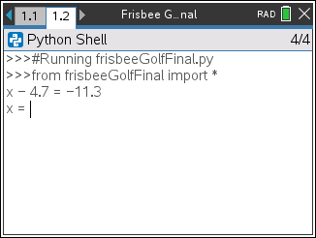…….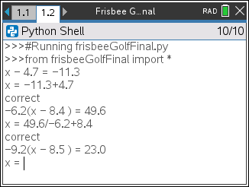…….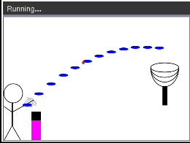
The game asks for the For each question answered Press the “t” key to aim and
value of x correctly, earn a frisbee. Throw the frisbee.
- Obtain the “Frisbee Golf Template.tns” from your teacher. A large portion of the code has been prepared for you ahead of time.
- Let’s examine the code.  Generate two random integers, store in x and n  Libraries needed for the project  *You will write lines of code to generate random equations and their answers.  Format the number display to ensure place value  Get user answer. Check to see if it is correct.  Draw the hoop |  | 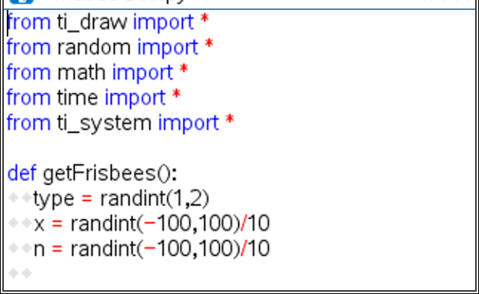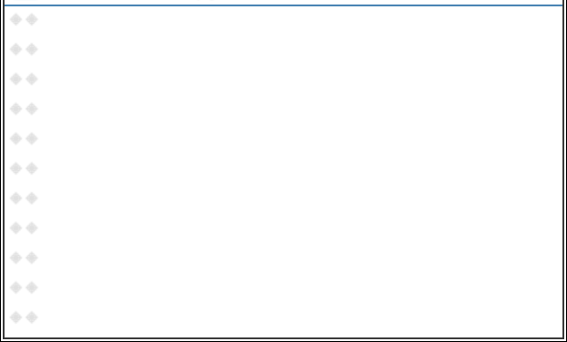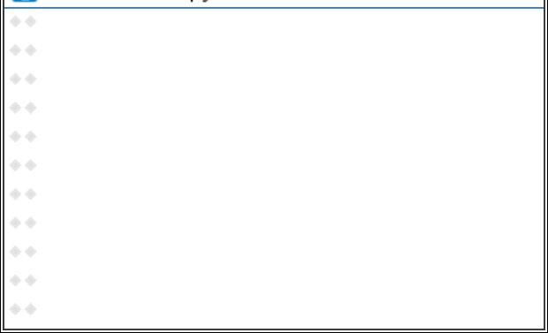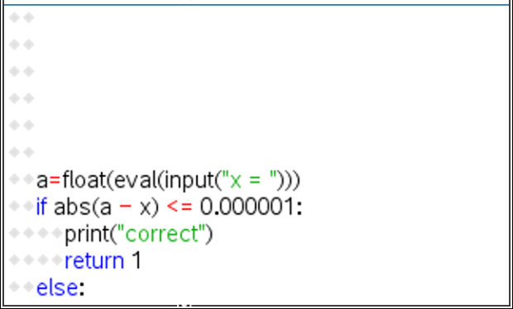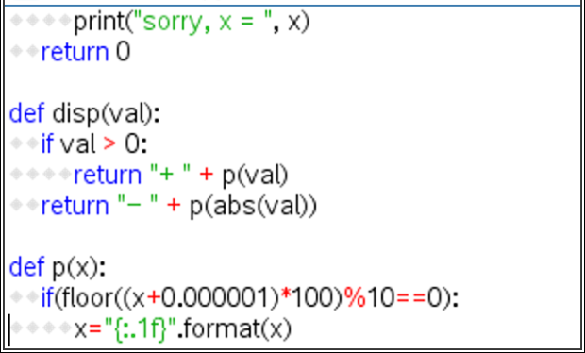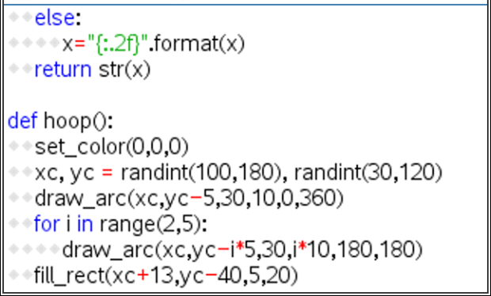  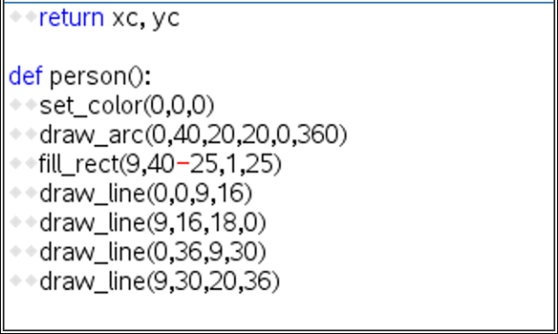  Animate the frisbee  Draw the frisbee  Draw the person  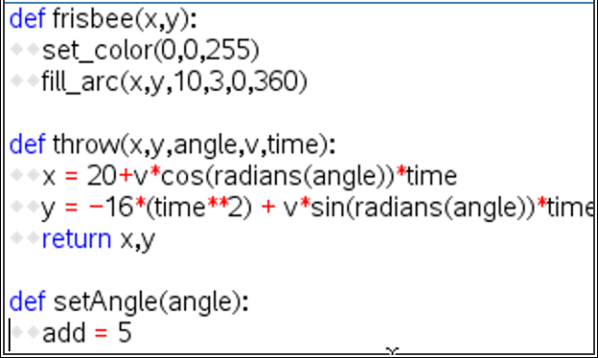  Animate toss angle until the user presses “t”  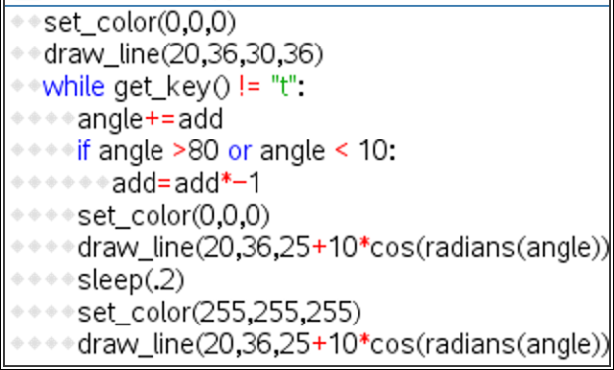  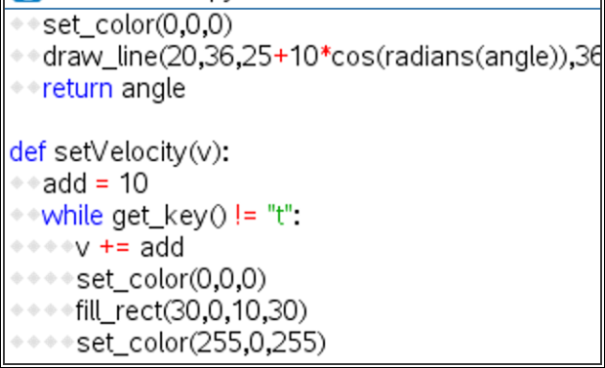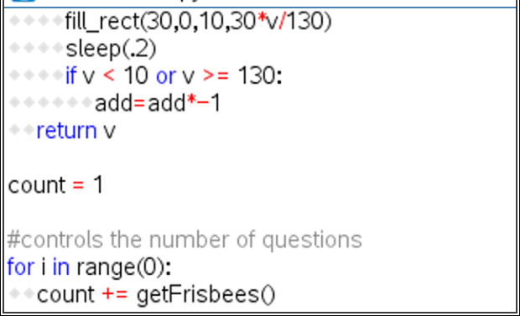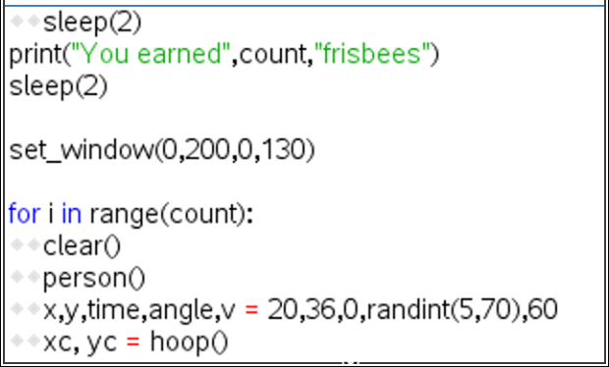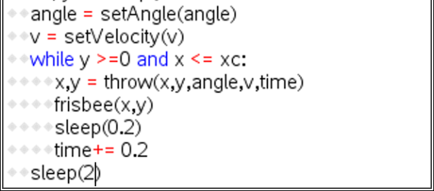  Change and toss velocity until the user presses “t”  *Repeatedly ask the equation questions. Add earned frisbees. You will eventually change range(0) to range(4).  Draw the objects, aim and power the frisbee, toss the frisbee, repeat for each frisbee earned
- Obtain the file “Frisbee Golf Template.tns” if you don’t already have it.  Execute the code (ctrl r)  The “aim” angle will automatically increase and  decrease. Press “t” when the desired angle is  achieved.  Now, determine how hard to throw the frisbee.  When ready, press “t”.  The frisbee will fly along the given path.  In this case, the goal was missed.  If you had earned more frisbees, you would  have more shots at the goal.  . |  | 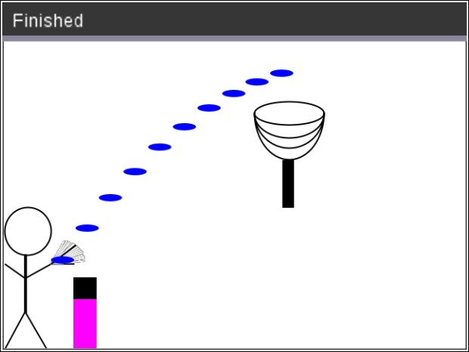
- Now to earn more frisbees! To earn frisbees, the user must solve equations correctly.
The first type of equations will look like: x + number = result or number + x = result
Solve the following equations for x.
a.) x + 8 = 13 b.) x + 1.8 = 5.3 c.) 8.3 + x = 17.5 d.) 2.5 + x = 6.8 e.) x – 5.3 = 7.8

- A.) Check your answers from step 4. Did you know you can use the scratchpad and the such that key, |, to check your work. To get to the such that key, press [ctrl] [=].  x + 8 = 13 | x = 7 is false because 7 + 8 = 15 not 13.  x + 8 = 13 | x = 5 is true because 7 + 5 = 13  B.) Look back over your work in step 4. What patterns do you notice? | 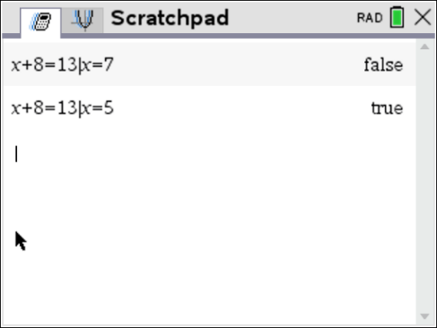
- This first section of code will generate equations similar to the ones in step #4.  type = randint(1,2) will help determine if x comes first or second.  x = randint(-100,100)/100 randomly creates a rational value for x  x could be a positive or negative  n = randint(-100,100)/100 randomly create a rational value to add to x.  n could be positive or negative | 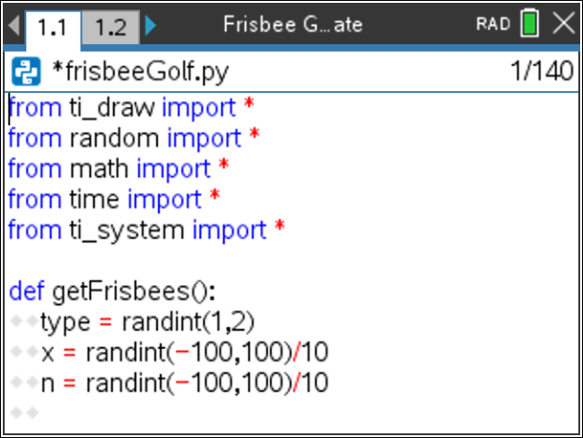
- To create an equation such as “x + 3.5 = 9.2”, add the following three lines of code.  if type == 1:  r = x + n  print(“x”,disp(n),”=”,p(r))  **if menu built-ins control - if  **print menu built-ins  Make sure the two lines below the if are indented two spaces (diamonds). | 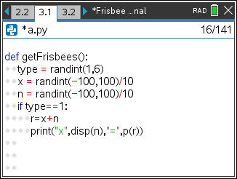
- To create an equation such as “7.2 + x = 9.1”, add the lines:  elif type == 2:  r = x + n  print(p(n),“+ x =”,p(r))  **elif menu built-ins control - elif  The line print(p(n), “+ x=”, p(r)) could be written without the function p(). It would look like print(n,“+ x = “,r). However, sometimes, python stores and prints rational numbers such as 8.2 as 8.19999999999. The function p() ensures this doesn’t happen when printed. | 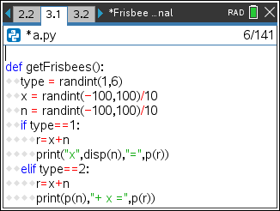
- The code has already been written to check your answer.  If you scroll down to about line 40, you’ll see this code.  The line a=float(eval(input(“x = “))) asks the user enter the answer.  The eval() around the input lets the user enter a number such as 3.5 or an expressions such as 7.2+5.1.  The if(abs(a-x) <= 0.000001): then checks to see if it correct. | 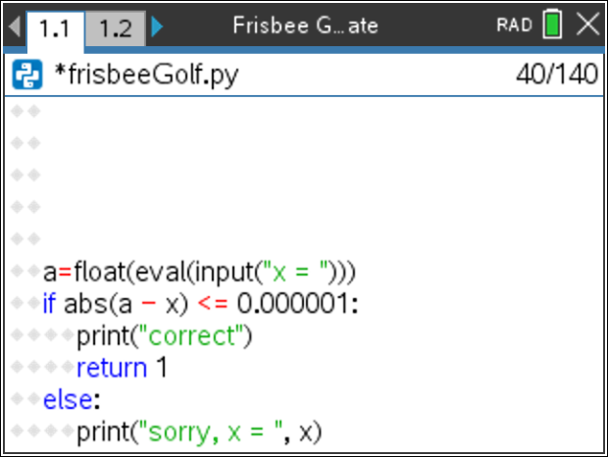
- Currently, the program is set to ask 0 questions.
If you run the code now, it should behave the same way it did in step 1.
To ensure you haven’t made an error, run the code. [ctrl] [r]
It shouldn’t ask questions yet, but it also shouldn’t have any errors.
If there are errors, check your code with the code in steps 7-8.

- Now to change the number of questions from 0 to 5.  Scroll down to the section labeled “controls the number of questions”  Change the line  for i in range(0): to for i in range(5): | 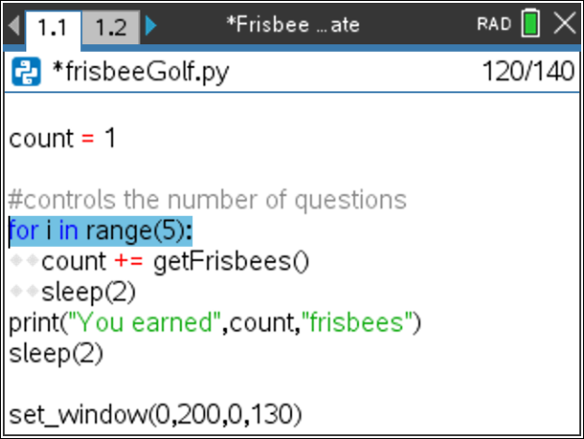
- Execute the code [ctrl] [r].  The program should ask 5 questions.  The sample question on the right is “x + 10 = 1”  The user may either enter -9 or 1 – 10.  The program will count either answer correct.  Play the game a few times.  If you answer 3 out of 5 questions correctly, you should get 4 frisbees.  If you answer 5 out of 5 questions correctly, you should get 6 frisbees. | 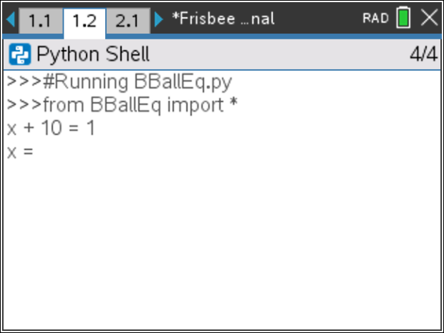
- Now to program the third type of equation for the game. Solve the following equations:
a.) 1.2x = -4.2 b.) -5.6x = 20.72 c.) 7.8x = 0 d.) 9.1x = 11.83 e.) -5.4x = 24.3
- A.) Check your answers using the scratchpad and the such that key.  To get to the such that key, press [ctrl] [=].  1.2*x = -4.2 | x = 3.5 is false because 1.2*3.5 is 4.2 not -4.2.  1.2*x = -4.2 | x = -3.5 is true because 1.2*-3.5 is -4.2.  B.) Look back over your work in step 12. What patterns do you notice? | 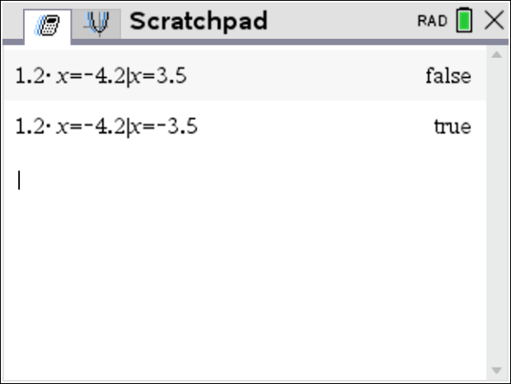
- Change the line that generates the type variable to randint(1,3).  type = randint(1,3) | 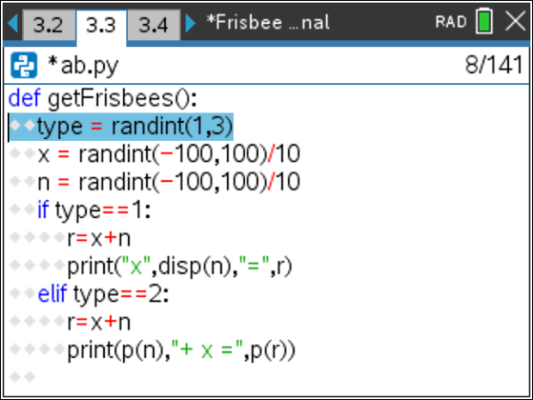
- Add the following lines to create and display the third type of equation.  elif type == 3:  r=x*n  print(p(n)+“x”,”=”,p(r)) | 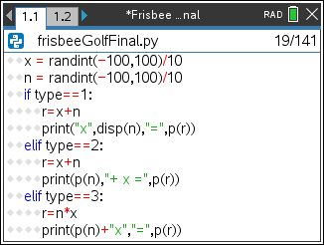
- Execute your code. [ctrl] [r]  Play your game a few times. Ensure it displays all types of equations before continuing the code.  Remember: you can don’t have to do the math in your head. The example on the right shows the user entered “-13.7 + 8.3” for the answer.  You should have:  addition problems where x comes first such as x + 7.9 = 3.1  addition problems where x come second such as 4.5 + x = 9.4  multiplication problems such as 8.1x = 9.2 | Example:
- Now to program the fourth type of equation. Solve the following equations:
a.) x/1.3 = 12.5 b.) x/3.8 = -28.1 c.) x/-2.4 = 17.2 d.) x/-9.7 = -90.1
f.) Use the scratchpad and the such that key to check your work.
g.) Look back over your work in step a. What patterns do you notice?

- Change the line that generates the type variable to randint(1,4).  type = randint(1,4) | 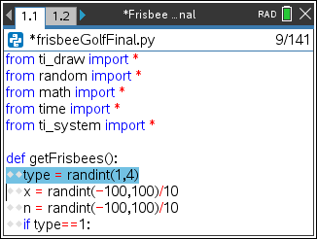
- Add the following lines to create and display the fourth type of equation.  To keep the values “nicer”, you’ll generate r, then find x.  You can’t divide by 0. To avoid this possibility, you’ll add a while loop that will regenerate n while it equals 0.  elif type == 4:  r = randint(-100,100)/10  while n == 0:  n=randint(-100,100)/10  x=n*r  print("x/"+p(n),"=",p(r))  **randint menu random randint | 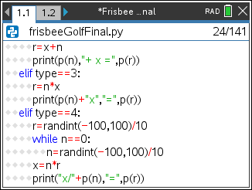
Execute your code. [ctrl] [r]
Play your game a few times.
Ensure it displays all 4 types of equations: x + n = r n + x = r n*x = r x/n = r
- Now to program the fifth type. Solve the following equations:
a.) 5.3x + 6.1 = 12.46 b.) -3.1x + 9.3 = 36.27 c.) 1.9x – 3.1 =4.69 d.) -9.2x – 3.1 = -70.26
f.) Use the scratchpad and the such that key to check your work.
g.) Look back over your work in step a. What patterns do you notice?

- Change the line that generates the type variable to randint(1,5).  type = randint(1,5) | 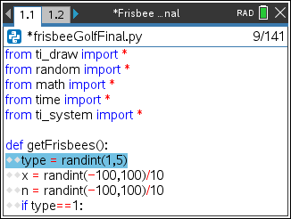
- Add the following lines to create and display the fifth type of equation.  elif type == 5:  a = randint(-100,100)/10  while a==0:  a = randint(-100,100)/10  r=a*x+n  print(p(a)+"x",disp(n),"=",p(r)) | 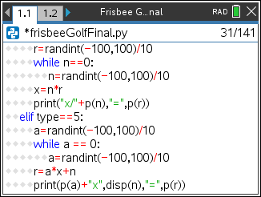
- Execute your code. [ctrl] [r]
Play your game a few times.
Ensure it displays all 5 types of equations: x + n = r nx = r ax + n = r
n + x = r x/n = r

- Now to program the sixth type. Solve the following equations:
a.) 5.3(x + 6.1) = 12.72 b.) −2.6(x + 4.3) = 7.28 c.) 9.4x - 3.2 = -13.16 d.) −3.2(x - 1.4) = 20.16
f.) Use the scratchpad and the such that key to check your work.
g.) Look back over your work in step a. What patterns do you notice?

- Change the line that generates the type variable to randint(1,6).  type = randint(1,6) | 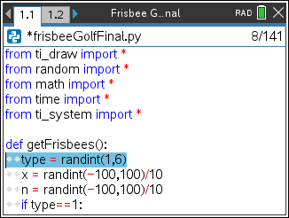
- Add the following lines to create and display the sixth type of equation.  elif type == 6:  a = randint(-100,100)/10  while a==0:  a = randint(-100,100)/10  r=r*(x+n)  print(p(a)+"(x",disp(n),") =",p(r)) | 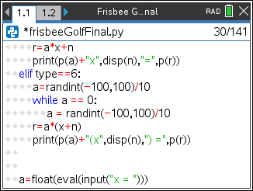
- Execute your code. [ctrl] [r]
Play your game a few times.
Ensure it displays all 6 types of equations: x + n = r nx = r ax + n = r
n + x = r x/n = r a*(x + n) = r
- Congratulations! Your Frisbee Golf game is complete. The only thing left to do is practice!
- Optional Challenges:
*Can you generate equations in the form (x + n)/a =r. For example, (x + 2.8)/7.1 = 3.4 or (x – 1.9)/2.5 = -3.1
*Hint: a should not be 0. Therefore, use code similar to step 27 to generate a.
r = (x + n)/a
To print, write print(“(x”, disp(n), “)/”, p(a), “=”, p(r) )
*What about an equation with four variables such as a*(x + n) + b = r? An example would be 3.1(x + 2.2) – 8.1 = 1.3.
*Hint: generate a value for b
r = a*(x + n) + b
To print, write print(p(a) + “(x”, disp(n), “)”, disp(b), “=”, p(r))

