In this activity, students use limit notation and intercepts to describe rational functions given in analytic form for a partner to sketch a graph. | 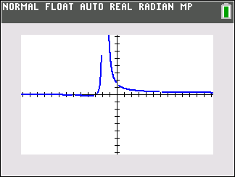
About the Lesson  - This activity involves exploring features of the graphs of rational functions and their characteristics, such as:  - End behavior asymptotes  - Behavior near vertical asymptotes  - Students should be able to use the TI-84 to verify these features of a rational function.  AP Precalculus Learning Objectives  - 1.7.A: Describe end behaviors of rational functions  - 1.11.A: Rewrite polynomial and rational expressions in equivalent forms.  - 1.11.B: Determine the quotient of two polynomial functions using long division.  Source: AP Precalculus Course and Exam Description, The College Board  Activity Instructions*  Students pair up with a set of cards with the analytical form of the function on one side and the limits and intercepts templates on the other side. Using the side with templates, one student fills out the details about the function, and the other student sketches the function’s behavior at the vertical asymptotes and the end behavior based on the information given. Both students then verify the sketch using the TI-84 Plus CE graphing calculator. Students alternate roles.  *Activity inspired by the AP Precalculus Course and Exam Description sample instructional activities | 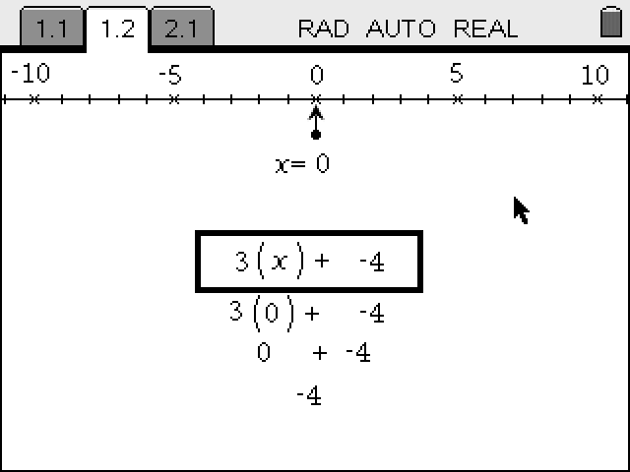  Materials:  Student document  - Limits Cards

Cards
x-int:_________

y-int:_________
x-int:_________

y-int:_________
x-int:_________

y-int:_________
x-int:_________

y-int:_________

x-int:__________

y-int:__________
x-int:__________

y-int:__________
x-int:__________

y-int:__________
x-int:__________

y-int:__________

Solutions

Wrap Up
Upon completion of the discussion, the teacher should ensure that students understand:
- The graphing application can be used to explore rational functions.
- The graphing application can be used to explore the end behavior of a rational function.

**Note: This activity has been developed independently by Texas Instruments. AP is a registered trademark of the College Board, which was not involved in the production of, and does not endorse, this product. Policies subject to change. Visit www.collegeboard.org.

