Trigonometric Ratios Name _______________________________

Right-triangle trigonometry builds on similar-triangle concepts to give you more ways to find unknown measures in triangles. In this activity, you’ll learn about trigonometric ratios and how you can use then.

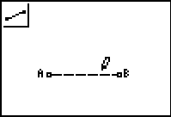
Construction
Figure 1
In steps 1-3 you will construct and label a right triangle ABC.

- Draw and label a segment labeled AB. (figure 1)
- Construct a line through point B perpendicular to AB using the perpendicular tool on the F3 menu. (figure 2) .
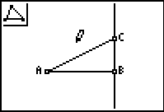
- Use the triangle construction tool on the F2 menu to construct ΔABC. Anchor and label C above B and on the perpendicular line. (figure 3).
Figure 2
Figure 3
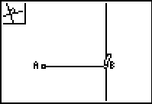
- Hide the line.
- Measure the sides of the triangle
- Measure ∠A
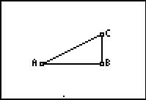
- Calculate the ratios opposite/hypotenuse, adjacent/hypotenuse, and opposite/adjacent. Move the answers to the bottom of the screen.
hypotenuse
opposite

Exploration
adjacent

- Drag point C to change the angles. When the angles change, do the ratios also change?

- Drag point A or B to scale (change the size) of the triangle. What do you notice when the angles don’t change? Explain why you think this happens.

- Complete the ratios for cosine and tangent below:

Length of leg opposite ∠A

Sine ∠A = Cosine ∠A
Length of hypotenuse

Tangent ∠A

Use these definitions to label the ratio calculations from question 7 above, as sin, cos and tan.

- Drag point C do that ∠A measures as close to 30° as you can get it. Write approximate values for the sine, cosine and tangent of 30° below.

Sin 30° = _____________ Cos 30° ______________ Tan 30°

- Without measuring, figure out the measure of ∠C and write down the number. Exit Cabri Jr for a moment and use the calculator to find the sine of that angle measure and write that down. Start Cabri Jr again. The sine of ∠C should be close to the one of the trigonometric ratios for ∠A. Which one? Explain why this is so.

- Drag point C and answer the following questions.
  - What’s the smallest possible value of the sine of an angle in a right triangle? What angle has this value? _____________________
  - What’s the greatest possible value for the sine of an angle in a right triangle? What angle has this value? _____________________
  - Why can’t you make ∠CAB exactly equal to 90°?

  - Even though you can’t make ∠CAB exactly equal to 90°, what do you think is the value of tan 90°? Explain

  - For what angle is the tangent equal to 1? Why?

  - For what angle are the sine and cosine equal? Why?

  - Suppose an angle has measure x. Complete this equation:
Sin x = cos ____________

- Complete the following table values. Compare the values Cabri Jr. calculated to the ones the calculator did using the sin, cos and tan buttons. Write the values to 2 decimal places for Cabri Jr. and 3 places for the calculator buttons. (Be sure your calculator is set to Degree mode)

Angle (A) | CJ sin(A) | CJ cos(A) | CJ tan(A) | sin(A) | cos(A) | tan(A)
0°
30°
45°
60°
90°

