Part 1 – Explore Area Accumulation
In this activity, you will explore the integral numerically and graphically using area accumulation.
Let 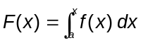 and let f(x) = sin(x).  Press  . Select F1:Tools > 8:Clear Functions. In y1, type the expression sin(x). Press   and change the window settings to match those on the right. Note that the window limits for x are 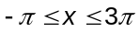 and xscl is 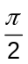. Then, press   to display the sine function. | 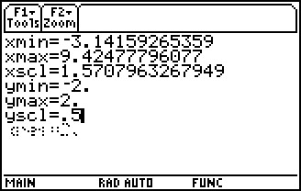
Select F5:Math > 7: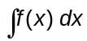 and enter 0 for the lower limit and π for the upper limit to find F(π) for a = 0. Then select F4:Regraph to clear the previous integral. Repeat the procedure to find each of the following integrals.
1. What is 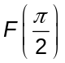 for a = 0? 2. What is 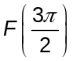 for a = ?

3. What is F(2π) for a = π? 4. What is for a = 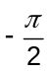?

Press . To find F(2π) for a = , enter ∫(sin(x),x,π/2,2π) and press . Let f(x) = sin(x) and a = , and complete the following table.
x | –π |  | 0 |  | π | 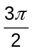 | 2π
F(x)
Use your observations to answer each question.
5. What function fits the values in the table?

6. For a fixed value of a, when is F(x) increasing? When is F(x) decreasing? Explain.

7. For 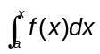, is the integral always, sometimes, or never negative when x < a? Explain.
8. Describe two different sets of circumstances that would result in a negative integral: one set when a < x and one set when x < a.

9. Describe two different sets of circumstances that would result in a positive integral: one set when a < x and one set when x < a.

10. 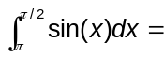 ____________

Part 2 – Curve Sketching and Kinematic Calculus
In this section, you will explore the kinematic relationship between an acceleration graph and its corresponding velocity graph.
The graph at the right shows the acceleration of an object in m/s².  1. What is the definite integral of acceleration with respect to time?  2. What is the definite integral of velocity with respect to time?  3. Sketch the corresponding kinematic velocity graph (in m/s) at the right.  4. Use your velocity graph to describe what is occurring physically to the object. | 

