EOC-What Comes Out?

What happens when you put numbers into a pattern or equation? If you put different numbers in, what happens to the numbers that come out?

Look at the question given below. The equation gives you the cost of tickets on a bus.

How many tickets are you to buy to find the correct table of values?

How can you use a graphing calculator to find the answer to the question?

**1** The equation *c*  0.75*t* represents *c*, the total cost of *t* tickets on a bus. Which table contains values that fit this equation?

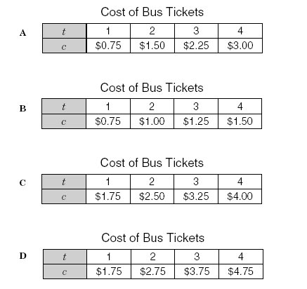

##### A student can enter the equation y=0.75x in the equation editor and, using the table, find the correct values of c.

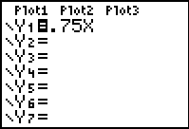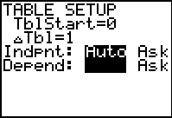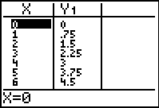

A student can also use the table in “ASK” setting and see just the input and output values that are used in this problem.



This shows that the correct table of values is answer choice A.

**47** The graph of the line *y*  2*x* + 3 is drawn on the coordinate grid below.

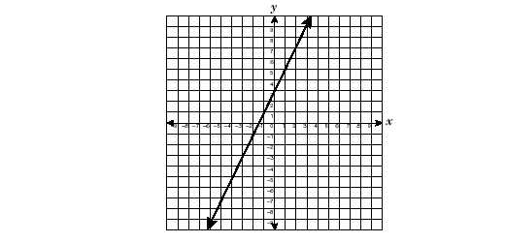

Which table of ordered pairs contains only points on this line?

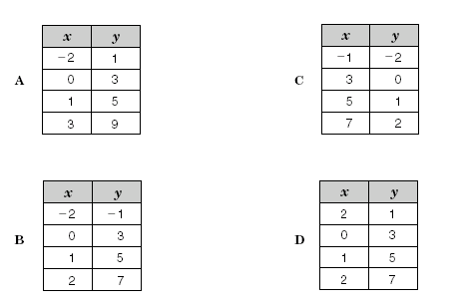

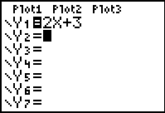 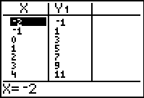

Using the equation editor and the table of values, a student can see that B is the correct answer.

Can you use the same strategy to solve the problem below.

**24** Which equation could be used to generate this table of values?

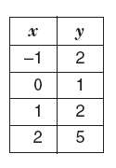

**A** *y*  2*x*

**B** *y*  2*x* + 1

**C** *y*  *x* + 1

**D** *y*  *x* 2 + 1