Function or Relation?  TI-Nspire™ CX Family | Time Required  20 minutes

Activity Overview
In this activity, students will use graphs and spreadsheets to determine if sets of data represent functions or relations.

Topic: Functions & Their Representations
- Functions vs. relations
- Graphing data using scatter plots
- Vertical line test
- Sorting spreadsheet data

Teacher Preparation and Notes
- Press / + G to hide the entry line at the bottom of the scatter plot.
- Problem 1 may be done in class, and Problems 2 and 3 could either be done in class or assigned as homework. Questions may be answered on the handheld or associated worksheet.
- To download the student and solution TI-Nspire documents (.tns files) and student worksheet, go to education.ti.com/exchange and enter “11361” in the keyword search box.

Associated Materials
- FunctionorRelation_Student.doc
- FunctionorRelation.tns
- FunctionorRelation_Soln.tns

Problem 1 – Voter Data
The data set for Problem 1 involves the percent of the popular vote by state that was won by Democratic presidential candidates in 1980 and 1984 in races against the Republican candidate, Ronald Reagan.  Students are given a scatter plot of dem80 vs. dem84 on page 1.6. Students are asked to find whether the data is a function or a relation. The vertical line test will be used as the first way to determine if the relation is a function. | 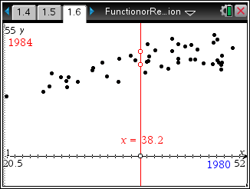
After reading the definitions of relation and function, students are asked which term they think represents the voter data.  Then, they need to decide whether to use a vertical or horizontal line to determine if the relation is a function.  On page 1.10, the students are told that the data represents a positive correlation. Some teachers may need to go over this concept if they have not already.  - No, some x-values are assigned more than one y-value.  - Vertical  - x = 38.2, 42.3, 48.1, 48.7 | 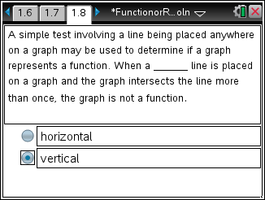
Problem 2 – Average Height
This problem involves age and height data for children in an Egyptian village. For Problems 2, students are asked to assess the data using either the sorted data in the spreadsheet or the scatter plot to determine if the data represents a function or a relation.  - Yes, each x-value is assigned to one and only one y-value.  - Yes | 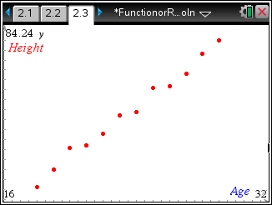

Problem 3 – Retained Impressions
This problem provides marketing effectiveness data for a variety of companies. Students will need to use the spreadsheet to determine if the data is a function because some of the points on the scatter plot are very close together. This data set is not a function.  6. No, 26.9 is mapped to 50.7 and 38. | 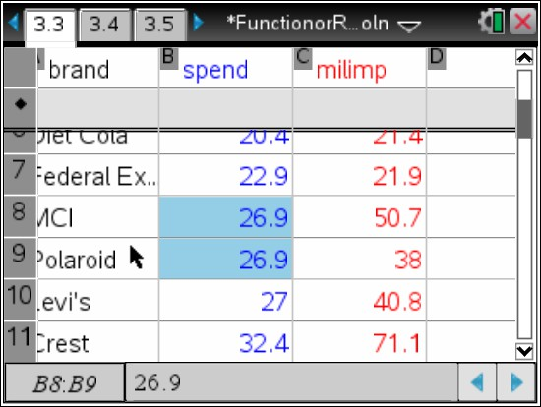
Problem 4 – Extra Practice
In problem 4, students click the slider for a random question. Students are given a domain and a range in a matrix and asked if the relationship between the domain and range is a function or not. Students will move the empty circle point to Yes or No to answer. Each time they answer they will see correct or incorrect. They can try as many problems as they would like. Students can click on the slider for a new problem.  - a) Yes  - No  - Yes | 