Introduction
Mathematics can be used to predict and replicate reality. Businessmen want to predict next quarter’s profits. Politicians want to predict unemployment rates. Physicists want to use mathematics to show how objects move. What equation will match the motion of a bouncing ball?

Objectives  In this activity you will:  - Create a Height-Time plot for a bouncing ball.  - Use an equation to describe the ball’s motion. | 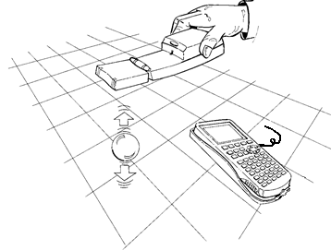
You'll Need

- TI 84 Plus CE, with Vernier EasyData™ App
- CBR 2™ motion sensor unit with mini-USB connecting cable
- A bouncing ball (either a racquetball or basketball work well)

Using the CBR 2™ motion sensor and EasyData™ App  Connect the handheld with the CBR2 using the USB cable. EasyData will immediately open, and the CBR2 will begin collecting distance data every time it clicks. In the EasyData app, the tabs at the bottom indicate the menus that can be accessed by pressing the keys directly below the tab. For example, to go to File to select New, press o. To change the Setup, press p. To Start, press q. To see the Graph, press r. To Quit the app, press s. | 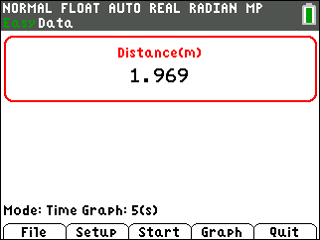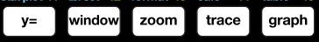
Collecting the Data  1. Change the and select Ball Bounce. You will see a series of messages shown below.  The mode is Ball Bounce. Hold the CBR 2 at about one meter above the floor and the ball no closer than 0.15 meters (6 inches) below the CBR2. Then you may disconnect the CBR 2 to collect the data. When you reconnect to the calculator, the CBR 2 transfers the data to the calculator. | 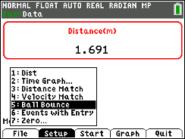
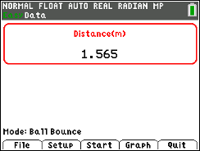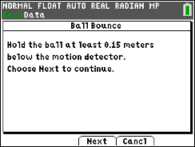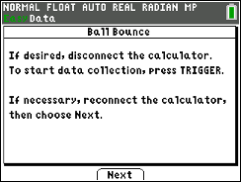

2. Whether you are doing this alone or with a partner, the hand that releases the ball needs to get out of the way of the CBR 2 immediately. The hand that is holding the CBR 2 needs to hold it at a constant height above the floor. If the ball travel across the floor as it bounces, follow it with the CBR 2 holding it at the original height. When you think you have good data, reconnect to the calculator and select . The CBR 2 will transfer the data. Look at your graph, if you have two or three good bounces, continue to the next step.
3. Use the arrow keys to move through your height-time plot. Choose one of your bounces, and find the coordinates of the vertex and the x-intercepts. Record them below. Make a sketch of your graph to the right.  Vertex (h, k) x-intercepts (zeroes)  h = __________ k = __________ ______ and ______ | 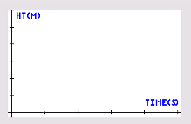
Looking at the Results
1. For any one bounce, a plot of Height-Time has a parabolic shape. One type of quadratic equation that describes this motion is the vertex form:

y = A (x – h)2 + k

Where A affects the width of the parabola and (h, k) is the vertex of the parabola. In this activity, x represents time and y represents height.
After Quitting the EasyData App, press o and enter the equation above in Y1 substituting the coordinates for the vertex that you found previously for h and k. To find the value for A, start the Guess-and-Check method by storing 1 into the variable A on the home screen (1¿ ƒ A). Check your guess by pressing s. Store a new value to A and check your guess. Keep experimenting until you get a good fit. Record your equation here:
_____________________________
2. Describe the relationship of the value of A with the shape of the parabola. (What happens when A changes from negative to positive? What happens if you increase the absolute value of A?)
3. Another form of quadratic equation uses the x-intercepts or zeroes of the equation. Using the x-intercepts that you recorded, put the equation into Y2:

y = A (x ‒ )(x ‒ )

What do you notice about the resulting graph?
4. What value for A did your classmates use? Explain what you discovered.
5. Find an equation in either form for the next bounce to the right of the bounce you used previously. Record here.

___________________________

How does this equation compare with the equation for the previous bounce in question 1 or 3?
Going Further
1. If a ball that was more or less bouncy was used instead, how would it affect the value of A in the equation?
2. The graph of the vertex form of the parabola matched the graph of the equation using the x-intercepts. Give an algebraic reason why these two forms of a parabola are equivalent equations.
3. What quadratic equation does the calculator give to match your first bounce? Follow these steps:

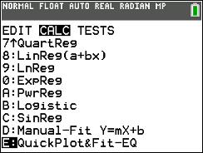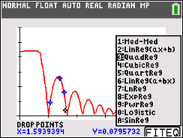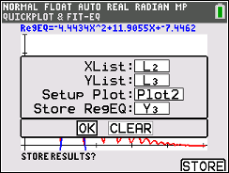

Press … and select QuickPlot. Drop at least 3 points on the graph. Select Quadratic Regression. Store the points in empty lists (L₂, L₃), and choose the rest of the settings avoiding Plot1, Y1, and Y2. The equation is in the form y=ax²+bx+c (Standard form). How does this equation compare with the vertex form and the x-intercept form (Factored form) of the bounce that you transformed into standard form in question 2?

