Two questions will drive this lesson. Think about them in your groups for about three minutes. Discuss them. You will have the opportunity to answer these questions in more detail at the end of the lesson.

Question 1:
Provide an equation containing at least one radical function where the algebraic solution yields one real solution and two extraneous solutions.
There are an infinite number of equations that satisfy this problem.
Explain your reasoning.

Question 2:
Without working out this problem with paper and pencil, predict how many real and extraneous solutions would be obtained when proceeding to solve the following radical equation algebraically.
Multiple responses exist. Answers will vary.
Explain your reasoning.
PROBLEM 1:
This lesson on radical equations is designed for examining real and extraneous solutions. As you progress through the activity, you will discover and understand both types of solutions conceptually, graphically, and algebraically. Traditionally, radical equations tend to be problems solved only with a paper and pencil focusing almost entirely on the algebraic steps to find solutions. Because we can introduce the possibility of extraneous solutions when the algebraic steps are followed to solve some radical equations, students sometimes lose sight as to "WHY" extraneous solutions are a possibility.

This lesson will empower you to make mathematical connections within the realm of solving radical equations. Further, as you progress through this lesson, you will be able to answer the difficult conceptual questions concerning radical equations like questions 1 & 2 above with ease.

Below (figures 1 and 2), you see two different (basic) radical equations solved algebraically using the functionality of the TI-Nspire CAS. Examine each and discuss both solutions in your assigned group. Record your responses and notes on this lesson worksheet in your groups.
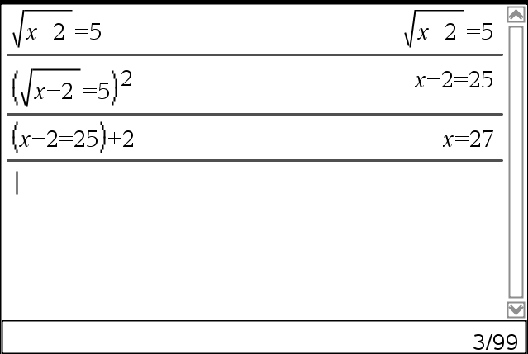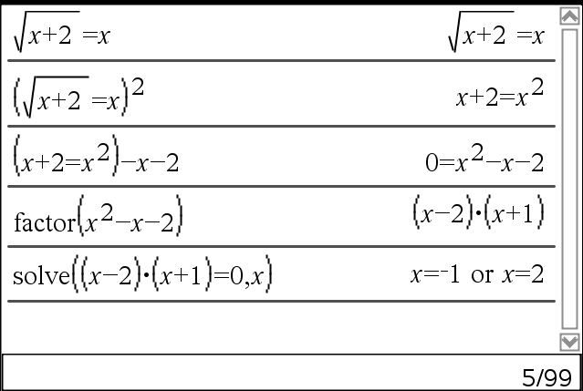
Figure 1. Figure 2.

What do you notice differently about each solution?

Would you have solved them differently? Why or why not? Explain.

Is there anything missing? Explain why or why not.

After recording your responses to these questions, proceed to open the file on the TI-Nspire CAS handheld file titled ExtraneousSolutions.tns, read the introduction on page 1.2. Complete page 1.3 and then check your understanding with a question on page 1.4.
It is ok if you are not 100% correct, we will examine further.

Proceed to page 1.5 and answer this question. What do you notice at the bottom of the CAS screen after you complete the first algebraic step in solving the problem on page 1.5?

Discuss why this warning “pops up” in your group. Record your discussions.

Problem 1 summary:
Throughout problem 1, the focus was almost entirely skill-based following the algebraic steps to solve radical equations. Once your group is finished, move to problem 2, page 2.1.

PROBLEM 2:
Examine the problem below in figures 3 & 4. You see both the algebraic and graphical solutions to an equation similar to the problem on page 1.3. Discuss in your groups, what do you see "graphically" that may not have been discovered during the solution on page 1.3.
Record your group’s thoughts in the space below as to why each of the two methods do not yield identical solutions to the equation .
RESPONSE:

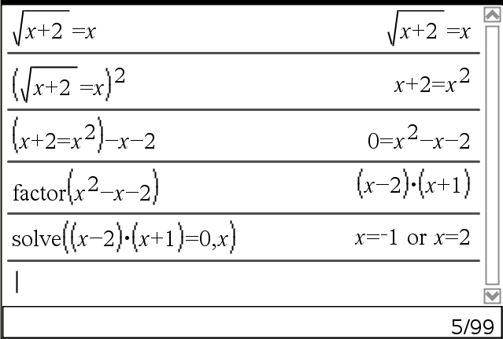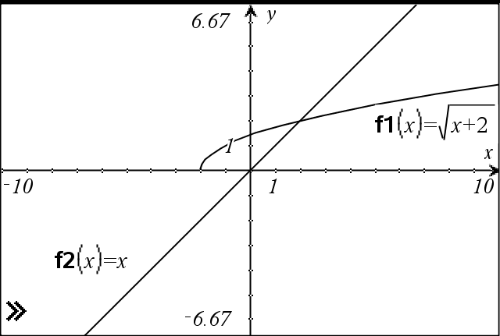
Figure 3. Figure 4.

Above, you see the algebraic solution has two solutions and a graphical equation shows only one solution. In problem 1, you made the discovery that squaring both sides of the equation introduces the possibility of false (extraneous) solutions. Let's examine a "math fact" that we often forget or take for granted. That is, .

Proceed to page 2.2, you see f1(x) and f2(x) as in figure 4. Using the math fact above, graph the 'other' part of f1(x) so that the extraneous solution x=-1 appears graphically. Then, proceed to page 2.3 and check your understanding. Discuss this in your group until everyone understands. Record your group’s concern, questions, and explanation.
RESPONSE:

Problem 2 summary:
You now "see" the possibilities of solution types (real & extraneous) to square root radical equations. So far, you've been working mostly with the square root of a linear function set equal to a linear function. For example, was one of the first equations we saw in this lesson. By understanding the graphical representation of this equation, we can easily predict how many real solutions and extraneous solutions we will have if we proceed algebraically in solving the equation. You now know the "WHY" behind extraneous solutions from a graphical point of view that exist when solving square root equations algebraically.

In space provided, give a radical (square root) equation involving only linear functions (as we've seen) that would have no real solution and two extraneous?

Equation:______________________________________

Discuss your equations in your group. Arrive at a consensus.
Give supporting evidence of your equation.
If you are still trying to conceptualize this lesson, indicate where you would like more explanation.
RESPONSE:

PROBLEM 3:
Proceed to problem 3 on the CAS handheld. Complete page 3.2 and 3.3 in your groups. Discuss and record any questions, comments, or concerns you group members may have with these two problems. Proceed to page 3.4. The class will then discuss the differences between square root and cube root radical equations.
Questions, comments, concerns:

PROBLEM 4:
Proceed to problem 4 on the CAS handheld. Read page 4.1.

Transformation instructions: The graph on page 4.2 has sliders inserted that allow for the parameters to be changed dynamically for the function . The linear function can have the slope and y-intercept modified by grabbing the line near the end (circled arrows symbol appears) or grabbing near the y-intercept (cross-hair symbol appears), respectively.
These two features allow both functions to be transformed.

On page 4.2, see which different types of solution sets you can obtain for the radical equation
Record and discuss the possibilities in your group. Then, proceed to check your understanding on page 4.3.
RESPONSE:

PROBLEM 5:
Proceed to problem 5 on page 5.1. Members within your group should attempt to complete page 5.1 differently. That is, do different steps to solve the problem. Record the differences in solutions you may obtain. Discuss and then proceed to page 5.2, read the problem and then use page 5.3 to check your understanding on page 5.2. Then, move to page 5.4. Record responses below.
After completing page 5.5, discuss why you answered page 5.2 as you did. Clarify your correct or incorrect response.
RESPONSE:

For homework, now answer questions 1 and 2. Provide written explanations, algebraic and graphical solutions that support your responses. We will discuss next time.

Question 1:
Provide an equation containing at least one radical function where the algebraic solution yields one real solution and two extraneous solutions.
There are an infinite number of equations that satisfy this problem.
Explain your reasoning.

Question 2:
Without working out this problem with paper and pencil, predict how many real and extraneous solutions would be obtained when proceeding to solve the following radical equation algebraically.
Multiple responses exist. Answers will vary.
Explain your reasoning.

