Physical Science Presentation

- Open Navigator and Activity Center.
Load “intro settings”.
Show examples of distance/time graphs. Discuss why each looks the way it does.
  - What makes the graph have a positive slope? Ans: Movement away from the motion detector
  - What makes the graph have a negative slope? Ans: Movement toward the motion detector
  - What makes the graph have a zero slope (horizontal line)? Ans: No motion (standing still)

Intro settings intro set 2
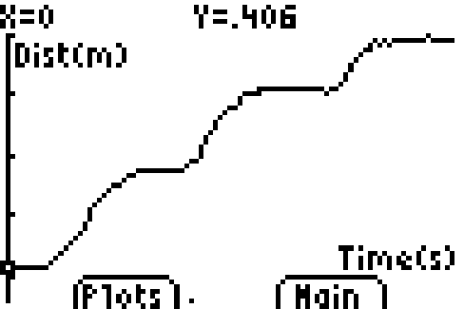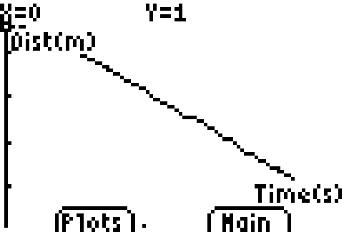

- Show examples of velocity/time graphs. Discuss why each looks the way it does.
  - What makes the graph have a positive slope? Ans: increasing speed
  - What makes the graph have a negative slope? Ans: decreasing speed
  - What makes the graph have a zero slope (horizontal line)? Ans: Constant velocity –not increasing or decreasing speed

Intro set 3 (not saved –show how to call up pict)

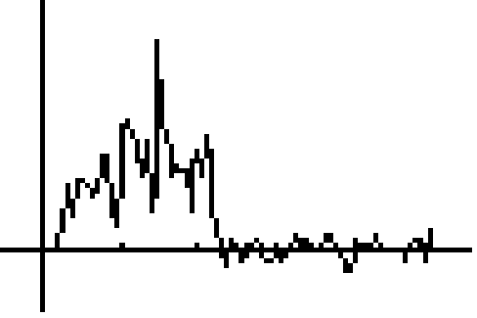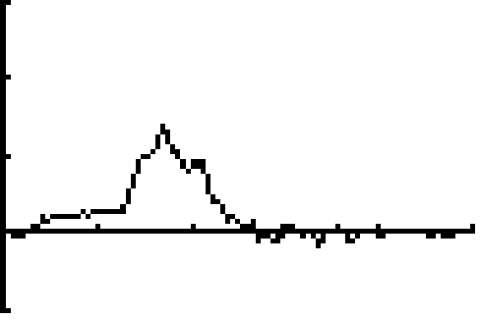

- Break students into groups and assign a problem from the worksheet (1 through 8).
- When students have graphs on screen have them plug into navigator and capture their screens.
- Each group should explain how they created their graphs and any problems they had. Student groups should also discuss why their “real life” graphs do not look exactly like the model in the hand out.
- Have student groups complete 9-13 in their group.

