# Math Objectives

* Students will define and identify central angles, major and minor arcs, intercepted arcs, and inscribed angles of a circle.
* Students will determine and apply the following relationships:
* Two inscribed angles intercepting the same arc have the same measure.
* An inscribed angle measure of 90° results in the endpoints of the intercepted arc lying on a diameter.
* The measure of an angle inscribed in a circle is half the measure of the central angle that intercepts the same arc.
* Students will try to make a connection with how to understand these topics in IB Mathematics courses on their final assessments

# Vocabulary

* central angle • major, minor, and intercepted arc
* inscribed angle

# About the Lesson

* This lesson is aligning with the curriculum of IB Mathematics Applications and Interpretations SL/HL and IB Mathematics Approaches and Analysis SL/HL
* This falls under the IB Mathematics Core Content Topic 3 Geometry and Trigonometry:
* **3.4** The circle, length of an arc, area of a sector (*The AA course also includes radian measure in this section as well)
* As a result, students will apply this to real world situations.

# TI-Nspire™ Navigator™

* Use Class Capture to monitor student progress.
* Use Live Presenter to discuss examples as a class.
* Use Quick Poll to assess understanding throughout the lesson.

# Activity Materials

Compatible TI Technologies: TI-Nspire™ CX Handhelds,



 TI-Nspire™ Apps for iPad®, TI-Nspire™ Software

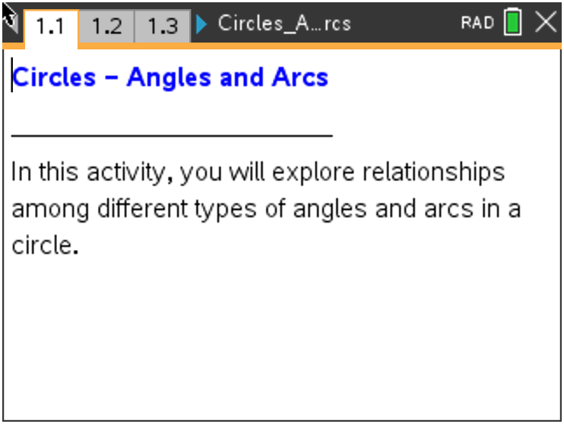

**Tech Tips:**

* This activity includes screen captures from the TI-Nspire CX II handheld. It is also appropriate for use with the TI-Nspire family of products including TINspire software and TINspire App. Slight variations to these directions may be required if using other technologies besides the handheld.
* Watch for additional Tech Tips throughout the activity for the specific technology you are using.
* Access free tutorials at [http://education.ti.com/calcu lators/pd/US/OnlineLearning/Tutorials](http://education.ti.com/calculators/pd/US/Online-Learning/Tutorials)

**Lesson Files:**

*Student Activity*

Circles_Angles_and_Arcs_

Student.pdf

Circles_Angles_and_Arcs_ Student.doc

*TI-Nspire document*

Circles_Angles_and_Arcs.tns

# Discussion Points and Possible Answers

|  |
| --- |
| **Tech Tip:** If students experience difficulty dragging a point, check to make sure that they have moved the cursor until it becomes a hand (÷) getting ready to grab the point. Press / x to grab the point and close the hand ({). |

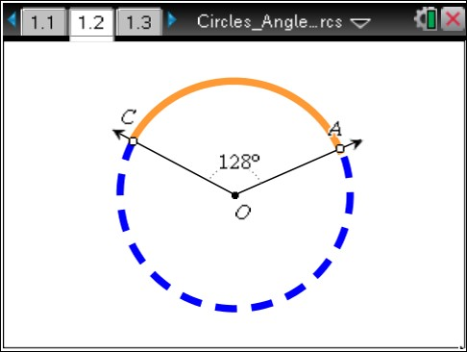**Move to page 1.2.**

1. Drag point *A* or point *C*. Describe the changes that occur in the figure as you drag the point.

**Answer:** The angle measurement changes but is never

more than 180°. The solid part of the circle is always in the interior of the angle.

1. Angle *AOC* is called a central angle**.** Explain why you think this is so.

**Answer:** Thevertex is at the center of the circle.

An angle intercepts an arc of a circle if each endpoint of the arc is on a different ray of the angle and the other points of the arc are in the interior of the angle.

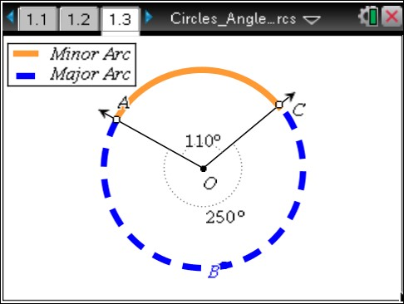**Move to page 1.3.**

As you move point *A* or point *C*, the central angle *AOC* intercepts a minor arc *AC*. The measure of the minor arc equals the measure of the central angle. The larger remaining arc, *ABC*, is called a major arc.

**Teacher Tip:** On the TI-Nspire, arcs are measured using Length, not Angle. Therefore, if a student uses the built-in measuring tool, TI-Nspire will report arc length rather than arc measure. Also, sometimes in order to get the exact angle in the chart, both point A and point C may need to be moved.

1. a. Move point *A* or point *C* to help you complete the table.

**Sample answer:** The completed table is below. The final row of students’ tables will vary.

|  |  |  |  |
| --- | --- | --- | --- |
| $∠$***AOC*** | **arc *AC*** | **arc *ABC*** | **arc *AC* + arc *ABC*** |
| 50° | 50° | **310°** | **360°** |
| 100° | 100° | **260°** | **360°** |
| **110°** | **110°** | 250° | **360°** |
| (Choose an angle.) **60°** | **60°** | **300°** | **360°** |

b. With a classmate, discuss what is true about the measure of arc *AC* + arc *ABC*, the sum of the measures of the minor and major arcs. Share your results with the class.

**Answer:** The measure of arc *AC* + arc *ABC* always equals 360°.

1. In a circle, the measure of a central angle $∠$*AOC* is *n*°.
   1. Find the measure of the minor arc that is intercepted by the central angle. Explain to a classmate how you know this to be true.

**Answer:** The minor arc measures *n*° because an intercepted arc has the same measurement as its central angle.

* 1. Find the measure of the major arc. Explain to a classmate how you know this to be true.

**Answer:** The major arc measures (360 – *n*)° because the sum of the measures of the major and minor arcs is 360°.

|  |
| --- |
| **TI-Nspire Navigator Opportunity: *Quick Poll* See Note 1 at the end of this lesson.** |

5. Now that you have found the measure of the central angle and the degree measures of both minor   
 and major intercepted arcs, discuss with a classmate how you may be able to find the “length” of   
 those arcs. Discuss the information you would need to find these lengths and the process this would   
 entail.

**Answer:** One method to be discussed is setting up a proportion between the measure of the   
 central angle and the full rotation of the circle (360°), and the length of the intercepted arc and   
 the circumference of the circle. Depending on the level of student, you can also discuss the use   
 of the arc length formula $l= θr$, as long as $θ$ is in radians. For both of these methods, the   
 radius of the circle would have to be known.

**Move to page 1.4.**

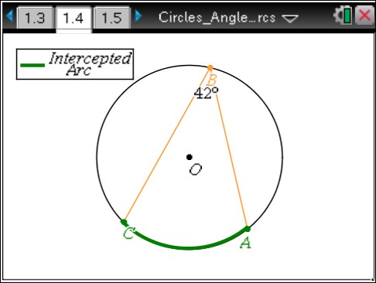6. Angle *ABC* is called an inscribed angle because $\overline{BA}$ and $\overline{BC}$ are chords of the circle and vertex *B* is on the circle. Drag point *B* around the circle.

1. As point *B* is moved around the circle, discuss with a classmate what you notice about the measure of $∠$*ABC*.

**Answer:** Angle *ABC* has the same measure until it intercepts the other arc. While point *B* is moved around on that arc, $∠$*ABC* will remain the same.

**Teacher Tip:** Some students may recognize that the two angles’ measures sum to 180°.

1. With a classmate, discuss why the *m $∠$ ABC* changes when point *B* is moved from one arc to the other. Share your reasoning with the class.

**Answer:** The angle measure changes because the intercepted arc changes. The intercepted arc is always in the interior of the inscribed angle.

1. Move point *A* or point *C* until $∠$*ABC* is a right angle. Discuss with a classmate what is special about the intercepted arc and $\overline{AC}$.

**Answer:** The arc measure is 180° and the arc is a semicircle. *AC* is a diameter.

**Teacher Tip:** When students reach the right angle, the diameter should show up as a dotted segment.

|  |
| --- |
| **TI-Nspire Navigator Opportunity: *Class Capture*  See Note 2 at the end of this lesson.** |

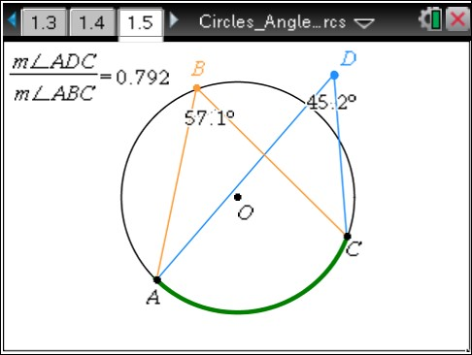**Move to page 1.5.**

Angle *ABC* intercepts arc *AC*. Drag point *D* to various locations outside the circle, on the circle, inside the circle, and at the center *O*.

7. Place point *D* on the circle so that $∠$*ADC* intercepts the same arc

as $∠$*ABC*.

1. Discuss with a classmate what you notice about the measures of $∠$*ABC* and $∠$*ADC*.

**Answer:** The angle measures are the same. The angles are congruent. The ratio of the angle measurements is 1.

|  |
| --- |
| **TI-Nspire Navigator Opportunity: *Quick Poll* See Note 3 at the end of this lesson.** |

**Teacher Tip:** Make sure both angles intercept the same arc. Some students may incorrectly place point *D* on the (bold) arc intercepted by

$∠$*ABC*. Point *D* should “snap” to the circle when it gets close.

1. Discuss with a classmate what happens to the angles if you move point *A* or point *C*.

**Answer:** The angle measures change. The angles are congruent and the ratio of the measure of $∠$*ADC* to the measure of $∠$*ABC* is 1 if the angles intercept the same arc. The angles are not congruent and the ratio is not 1 if the angles do not intercept the same arc.

**TI-Nspire Navigator Opportunity: *Class Capture***

**See Note 4 at the end of this lesson.**

**Teacher Tip:** Some students may note that the angle measurements are the same whenever *AD* and *BC* intersect or “criss-cross” and are not the same when they don’t. This observation is important but needs to be related to intercepted arcs. Some students may notice that the angles are supplementary when they do not intercept the same arc. This property is addressed in problem 10. If m $∠$*ABC* equals 90°, then m $∠$*ADC* equals 90° whether or not they share the same intercepted arc.

8. Place point *D* at the center of the circle, making sure that ∠*ADC* intercepts the same arc as ∠*ABC.*

* 1. Describe the relationship between the measures of inscribed $∠$*ABC* and central $∠$*ADC*.

**Answer:** The measure of the central angle is double the measure of the inscribed angle. The measure of the inscribed angle is half the measure of the central angle. The ratio of the measure of $∠$*ADC* to the measure of $∠$*ABC* is 2.

|  |
| --- |
| **TI-Nspire Navigator Opportunity: *Quick Poll* See Note 5 at the end of this lesson.** |

* 1. Discuss with a classmate what happens to the angles if you move point *A* or point *C*.

**Answer:** The measure of the inscribed angle is half the measure of the central angle (the ratio of the measure of $∠$*ADC* to the measure of $∠$*ABC* is 2), as long as both angles intercept the same arc.

|  |
| --- |
| **TI-Nspire Navigator Opportunity: *Class Capture and/or Live Presenter* See Note 6 at the end of this lesson.** |

c. Complete these conjectures:

* The measure of the inscribed angle is ________________ the measure of the central angle.
* The measure of the inscribed angle is ________________ the measure of the intercepted arc.

**Answer:** The measure of the inscribed angle is **half** the measure of the central   
 angle and **half** the measure of the intercepted arc.

**Teacher Tip:** For a proof of the Inscribed Angle Theorem: In the simplest case, one leg of the inscribed angle is a diameter of the circle so it passes through the center of the circle. Since that leg is a straight line, the supplement of the central angle equals 180° − 2*θ*. Drawing a [segment](http://en.wikipedia.org/wiki/Circular_segment) from the center of the circle to the other point of [intersection](http://en.wikipedia.org/wiki/Line-line_intersection) of the inscribed angle produces an [isosceles triangle,](http://en.wikipedia.org/wiki/Isoceles_triangle) made from two radii of the circle and the second leg of the inscribed angle. Since two angles in an isosceles triangle are equal and since the angles in a triangle sum to 180°, it follows that the inscribed angle equals θ, half of the central angle.

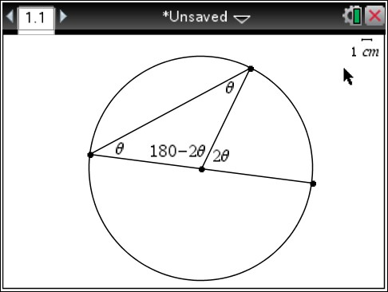

9. Leona said, “Since a central angle can never measure more than 180°, I know an inscribed angle   
 can never measure more than 90°.” Discuss with a classmate if you agree or disagree. Explain why.

**Answer:** I disagree because the central angle always intercepts a minor arc, but an inscribed angle can intercept a major arc.

10. Place point *D* on the circle so that *ABCD* is a quadrilateral.

* 1. Discuss with a classmate what you notice about the sum of the measures of $∠$*ABC* and $∠$*ADC*. Share your results with the class.

**Answer:** The sum of the measures of $∠$*ABC* and $∠$*ADC* is 180°.

* 1. Discuss with a classmate what you notice about the sum of the measures of the angles if you move point *A* or point *C*.

**Answer:** As long as *ABCD* remains a quadrilateral, the sum of the measures of $∠$*ABC* and

$∠$*ADC* remains 180°.

* 1. Discuss with a classmate what you notice about arcs *ABC*and *ADC*.

**Answer:** One is a major arc and one is a minor arc. Together the arcs make a circle. The measures of the arcs sum to 360°.

* 1. Describe how the relationship between arcs *ABC*and *ADC* explain the sum of the measures of inscribed $∠$*ABC* and $∠$*ADC*.

**Answer:** The sum of the measures of the major and minor arcs is 360°. Since the measures of the inscribed angles are half the measures of their intercepted arcs, the angles are supplementary.

**Teacher Tip:** A quadrilateral inscribed in a circle has the special name “cyclic quadrilateral.”

|  |
| --- |
| **TI-Nspire Navigator Opportunity: *Quick Poll* See Note 7 at the end of this lesson.** |

**Further IB Extension**

A surveyor standing on the bank of the Reedy River measures the equal distance to the far left end and the far right end of the Liberty Bridge in Greenville, South Carolina, at a central angle of 120°. She found this distance to be 160 ft. See the diagram below (not to scale).



120°

165 ft

165 ft

A sector is formed with these two equal distances and the bridge.

1. Find the arc length of the inner guardrail and the arc length of the outer guardrail.

**Answer:** Method 1 $\frac{120°}{360°}= \frac{arc}{2π(165)}$ arc (inner guardrail) $≈346 ft.$

Method 2 $l= θr$, $θ= 120∙\frac{π}{180}= \frac{2π}{3}$, $l= \left(\frac{2π}{3}\right)∙165 ≈346 ft.$

1. Find the arc length of the outer guardrail, given that the bridge is a uniform width of 12 ft. across.

**Answer:** Method 1 $\frac{120°}{360°}= \frac{arc}{2π(177)}$ arc (inner guardrail) $≈371 ft.$

Method 2 $l= θr$, $θ= 120∙\frac{π}{180}= \frac{2π}{3}$, $l= \left(\frac{2π}{3}\right)∙177 ≈371 ft.$

1. Find the area of the walkable portion of the bridge.

**Answer:** Subtract the larger sector (with outer guardrail) and the smaller sector (with inner   
 guardrail), using the formula: $A= \frac{1}{2}θr^{2}$

$\left(\frac{1}{2}∙\frac{2π}{3}∙{177}^{2}\right)- \left(\frac{1}{2}∙\frac{2π}{3}∙{165}^{2}\right) ≈4297.699…≈4300 {ft.}^{2}$

**Wrap Up:**

Upon completion of the discussion, the teacher should ensure that students understand:

* Two inscribed angles intercepting the same arc have the same measure.
* An inscribed angle measure of 90° results in the endpoints of the intercepted arc lying on a diameter.
* The measure of the inscribed angle is half the measure of the central angle that intercepts the same arc.

# TI-Nspire Navigator

## Note 1

**Questions 4a and 4b, *Quick Poll:*** Have students enter their answers to the first part of questions 4a and 4b in a *Quick Poll*. Ask students to answer, “Explain how you know this to be true.”orally.

## Note 2

**Question 6c, *Class Capture:*** As students complete question 6c, use *Class Capture* to view their screens. Discuss the following:

* Are all the right angles located in exactly the same place?
* What is true about the arc intercepted by the right angle?
* What is the measure of the intercepted arc?
* What is *AC* on each screen when a right angle is shown?

## Note 3

**Question 7a, *Quick Poll:*** Using the Open Response feature of *Quick Poll*, have students enter their answer to 7a.

## Note 4

**Question 7b, *Class Capture:*** Use *Class Capture* to look at students’ screens when they complete question 7b. Put the screens together where the angles intercept the same arc and the screens together where the angles do not intercept the same arc. Discuss the results.

## Note 5

**Question 8a, *Quick Poll:*** Using *Quick Poll*, students answer the following:

“The ratio of the measure of $∠$*ADC* to the measure of $∠$*ABC* is ____.” Discuss students’ responses.

## Note 6

**Question 8b, *Class Capture:*** Use *Class Capture* to discuss students’ answers to question 8b. *Class Capture* can also be used to help students answer the extension questions.

## Note 7

**Wrap Up, *Quick Poll:*** Use *Quick Poll* to be sure students understand the three statements listed under Wrap Up. The True/False feature would be a good choice.

*\*\*Note: This activity has been developed independently by Texas Instruments and aligned with the IB Mathematics curriculum, but is not endorsed by IB™. IB is a registered trademark owned by the International Baccalaureate Organization.*