Problem 1 – Intersecting Chords
1. Start Cabri Jr. and open a new file. Create a circle and hide the radius point.  2. Construct two chords in the circle. Label the chords and .  3. Create a point at the intersection of the two chords and label it P. | 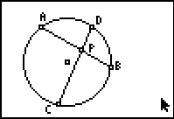
4. Measure the lengths of each segment and use the Calculate tool to calculate the product of the lengths of the segments of each chord. Record the data in the table.
length | length |  | length | length
5. What conjecture can you make about the products of the segments on each chord?
6. Drag an endpoint of either chord. Does this relationship hold when a chord endpoint is dragged?

Problem 2 – Chords and Secants
7. Hide the two values of the products of the segments. Drag point P outside the circle as shown. What type of segment would you call and ?  8. Observe the measured values of the segment lengths with P in its new location. Drag point P to different exterior locations. | 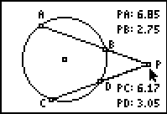
9. What is the relationship between the segments of the secants?
10. What happens to the segment lengths if point P is the center of the circle? Drag point P to confirm your conjecture.

Problem 3 – Secants and Tangents
11. Open a new file. Create a circle and construct a radius. Label it where O is the center of the circle.  12. Construct the line perpendicular to at point C. Why is this line tangent to the circle?  13. Place a point on the tangent line and label it P. Construct a secant line through point P that intersects the circle in two places. | 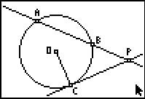
14. Create the intersection points of the secant line with the circle and label them A and B as shown.
15. Measure the lengths of , , and . Calculate the product of the lengths of and . Record the data in the table.
length | length |  | length
16. Drag points P, C and A. How do you think the length of is related to the product of the lengths of and ?
17. Perform a calculation on the calculator and then the empty column to confirm your conjecture.
Extension – Visualizing the Tangent-Secant Product Theorem
Open the Cabri Jr. file TANSEC. The figure shows a secant and a tangent from the same external point, as was explored in Problem 3. Rectangles have been constructed on the segments.
Measure the areas of the rectangles and their lengths and widths.
How does the figure model the Tangent-Secant Product Theorem? Explain.
Drag point P, C and A and observe.

