How do you get your calculator to show the graph on the page? Look at the question given below.

In the distance formula d =rt, r represents the rate of change, or slope. Which ray on the graph best represents a slope of 55 mph?

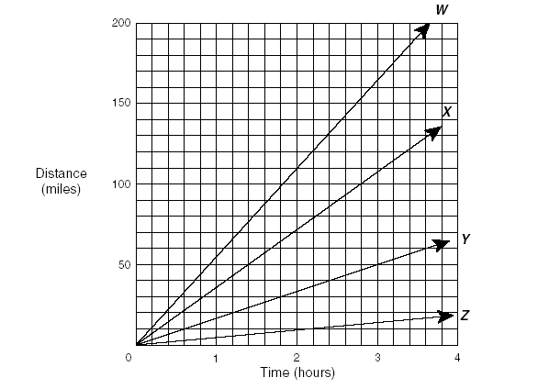
A W
B X
C Y
D Z

Writing the equation for the problem situation.____________
Look at the horizontal axis.

What is the minimum x value shown on the graph? ________
What is the maximum x value shown on the graph? ________
By what are you counting(x scale)? If you are not sure what the value is, can you see how you can enter what you see in the calculator? ______

What is the minimum y value shown on the graph? ________
What is the maximum y value shown on the graph? ________
By what are you counting(y scale)? If you are not sure what the value is, can you see how you can enter what you see in the calculator?______

Enter these values into the window of your graphing calculator and see if you can determine which of the multiple choice answers is correct.

