Introduction
The direction you move, the speed you travel, and the rate at which you change your direction and speed all have an effect on the shape of a Distance-Time plot. Would it be possible to use these factors to plot specific shapes on the calculator while using a CBR 2? Is it possible to plot any shape you desire on the screen? What determines if a shape can be plotted by your motion in front of the CBR 2?

Objectives
In this activity you will:
- Apply the effects of changing direction and changing speed in order to make different shaped distance-time plots.
- Observe which shapes can and cannot be made with a Distance-Time plot.
- Determine a rule for which shapes can be made by walking in front of the CBR 2.
You'll Need

- TI-84 Plus CE handheld with the Vernier EasyData™ App
- CBR 2™ motion sensor unit with mini-USB connecting cable

Using the CBR 2™ motion sensor and Vernier EasyData™ App  Connect the handheld with the CBR 2 using the USB cable. EasyData™ will immediately open, and the CBR 2 will begin collecting distance data every time it clicks. In the EasyData™ app, the tabs at the bottom of screen indicate the menus that can be accessed by pressing the calculator keys directly below. |  | 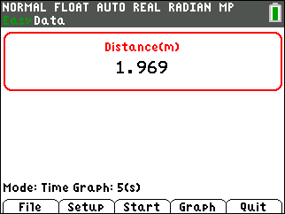  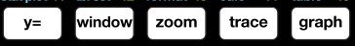
Collecting the Data  Your teacher will give you instructions on what Setup to use and what methods (stationary CBR 2 or moving with the CBR 2 at a target) you are to use. |  | 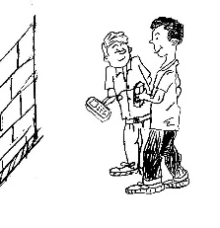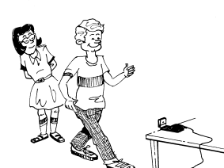
After the plot is displayed, if you are not satisfied with your graph, press s to go back to . When you select , you will get a warning message. Be ready because as soon as you select , the CBR 2 will immediately start collecting data. To find the coordinates of any data point, use the right arrow key ~ to move along the plot. The coordinates appear at the top of the screen. |  | 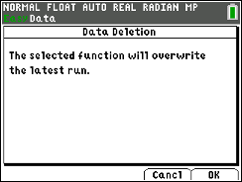
Looking at the Results
1. Describe how you would have to move in order to create a distance-time plot that resembles a mountain with a plateau on top.
2. Create the plot that you described above by walking as you described in your answer to question 1. If you are satisfied with the resulting plot, sketch it on the axes to the right. |  | 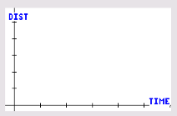
3. Did the plot in question 2 produce the desired shape? Describe any problems that you encountered while trying to make the plot and how you eliminated the problem.
4. Describe the way you would move to create a mountain with a sharp peak.
5. Using the method described in question 4, walk to create a mountain range consisting of at least two mountains, both with sharp peaks of equal heights. Make the sides of the second mountain steeper than those of the first. Describe how you walked.
6. How would your motion change if you wanted the second peak to be only half as high as the first peak?
7. Suppose you wanted to make a plot of the uppercase letter V. Describe how you would walk to create this plot.
8. Describe a difficulty that you had, and describe what you did to correct the issue. Use the axes at the right to sketch one of your first attempts.
9. What change in your motion would result in a U rather than a V?
10. Suppose you wanted to make the lowercase letter m. Describe how you would walk to create this plot. Be sure to discuss the speed as well as the direction of your motion.
11. What problems did you have in making the m? What did you do to resolve them? Sketch you results to the right.
12. How could you change your motion to make a W?
Going Further
1. Some of the figures you plotted had sharp corners and others had rounded edges. What was the key factor in your movement that determined which type was plotted? Explain why this factor affects the plot in this way. (Be sure to use the word “rate” in your answer.)
2. Make a distance-time plot in the shape of a circle. Describe a difficulty that you had, and describe what you did to correct the issue. Use the axes at the right to sketch one of your first attempts.

3. Make a list of letters (uppercase or lowercase) that you would want to try to make with a distance-time plot. Briefly explain your choices.
4. Think of a shape or letter. Write a description of a walk that would make that shape. Have a classmate tell you what the shape is based only on your verbal description. Then ask your classmate to walk the graph with the CBR 2. Make a sketch of the walk.

5. What determines which shapes are possible to make with the CBR 2?

