Algebra -- Transformations
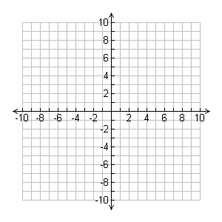
Graph y = x².

Sketch the graph of y = x² Sketch the graph of y = x²
shifted up 3 units. Shifted down 2 units.

Now predict the equation that will give you the above graphs.

____________________________ _____________________________

Verify using the graphing calculator.

