TI Workshop Presentation Guide for “Calculating the Area of a Triangle Using Heron’s Formula”

- Before class lay out three triangles as shown below. If outside they need to be fairly large in order for the acreage to be meaningful. If inside use a scale of 1 inch = 1 foot or ½ inch = 1 foot.

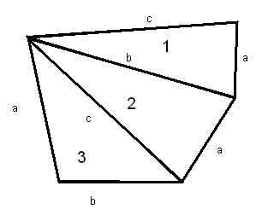
- Discuss finding the area of triangles using A= ½ bh and that sometimes it is difficult to determine the actual height (must be perpendicular to the base).
- Discuss irregular lots in real estate sometimes present a problem in determining the area—sketch an example as shown above.
- Discuss Heron’s formula $A=\sqrt{S(S−a)(S−b)(S−c)}$ where S is the semi-perimeter
- Have students do an example using Heron’s formula: a=9, b= 12, and c= 15 and send the answer via learning check or quick poll on the Navigator when they have finished. A screen capture may be used to be sure students are using the proper formula and not just ½ bh since this is a right triangle whose area is 54 square units. Analyze the answers and make corrections.
- In pairs or triads have students measure the triangles then apply the formula. They will need to add the 3 areas for the total area.
- Analyze the answers using Navigator and fix any errors so everyone has the same answer.
- Calculate the acreage of the total figure

