Math Objectives  - Students will recognize the similarities and differences among power and polynomial functions of various degrees.  - Students will describe the effects of changes in the leading coefficient on the end behavior of graphs of power and polynomial functions.  - Students will use appropriate tools strategically (CCSS Mathematical Practice).  - Students will look for and make use of structure (CCSS  Mathematical Practice).  Vocabulary  - degree of polynomial • end behavior • power function  - polynomial function • leading coefficient  About the Lesson  - This lesson involves determining the similarities and differences among functions. As a result, students will:  - Use a slider to scroll through the graphs of power functions with a coefficient of positive 1 and graphs of power functions with a coefficient of negative 1.  - Generalize the end-behavior properties of various power and polynomial functions.  - Write a possible equation of a polynomial function given the graph of the function.  TI-Nspire™ Navigator™  - Transfer a File.  - Use Class Capture to examine patterns that emerge.  - Use Live Presenter to demonstrate.  - Use Teacher Edition computer software to review student documents.  - Use Quick Poll to assess students’ understanding  Activity Materials  Compatible TI Technologies:  TI-Nspire™ CX Handhelds,   TI-Nspire™ Apps for iPad®,  TI-Nspire™ Software | 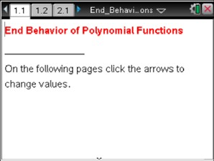  Tech Tips:  - This activity includes screen captures taken from the TI-Nspire CX II handheld. It is also appropriate for use with the TI-Nspire family of products including TI-Nspire software and TI-Nspire App. Slight variations to these directions may be required if using other technologies besides the handheld.  - Watch for additional Tech Tips throughout the activity for the specific technology you are using.  - Access free tutorials at http://education.ti.com/calculators/pd/US/Online-Learning/Tutorials  Lesson Files:  Student Activity  End_Behavior_of_Polynomial_Functions_Nspire_Student.pdf  End_Behavior_of_Polynomial_Functions_Nspire_Student.doc  End_Behavior_of_Polynomial_Functions.tns
In this activity, you will examine several power and polynomial functions to determine their similarities and differences and the characteristics of their end behavior. You will then make connections between these power functions and polynomial functions and write their end behaviors using limit notation. | 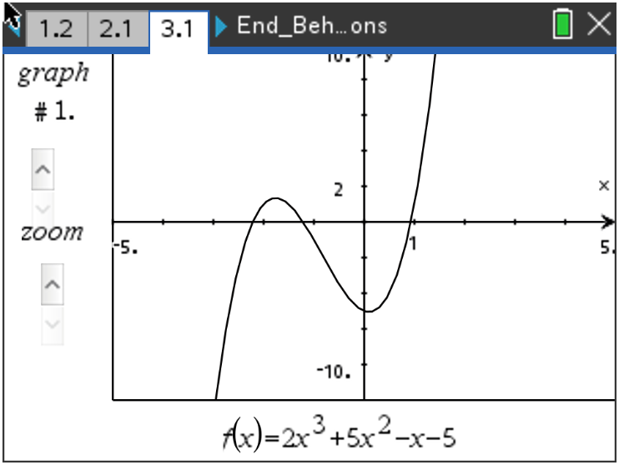
______________________________________________________________________________
Move to page 1.2.  - Click the slider arrows on the left side of the screen to see the graphs of various power functions in the form y = xª. | 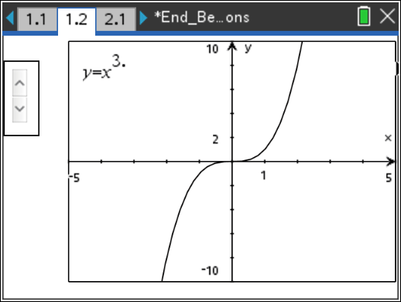
Teacher Tip: All the power functions on this page have a leading coefficient of positive 1.

  - As you scroll through the functions, describe the similarities and differences that you see.

Sample Answers: When the exponent of the function is even, the “arms” of the graph are both up. The graph lies in quadrants one and two. When the exponent of the function is odd, the graph goes up and to the right and down and to the left; the graph lies in quadrants one and three. All the functions pass through the origin.

Students might also notice that as the powers increase, the function values get closer to the x-axis (approach zero as x approaches zero) on the interval [–1, 1].

  - As you look at the various graphs of the power functions, answer the following.
i. What happens to the value of the function as x increases without bound (x → ∞)?

Sample Answers: Answers might vary depending on students’ previous knowledge. Even and odd functions: y → ∞
ii. Give a mathematical explanation to describe the behavior of the graph.

Sample Answers: Even and odd functions increase without bound (y → ∞)

iii. Write your explanation using limit notation.

Sample Answers: $\lim_{x→∞}\left(y\right)= ∞$

  - Again, look at the various graphs, and as x decreases without bound (x → –∞), answer the following.
i. What happens to the y-values?

Sample Answers: Answers might vary depending on students’ previous knowledge.

ii. Explain this behavior mathematically.

Sample Answers: Even functions increase without bound (y → ∞); Odd functions decrease without bound (y → –∞)

iii. Write your explanation using limit notation.

Sample Answers: Even functions $\lim_{x→-∞}\left(y\right)= ∞$; Odd functions $\lim_{x→-∞}\left(y\right)= -∞$

Move to page 2.1.

- Click the slider arrows on the left side of the screen to see the graphs of additional power functions.

Teacher Tip: All the polynomial functions on this page have a leading coefficient of negative 1.

  - How do these power functions differ from the functions with a positive coefficient on page 1.2?

Sample Answers: When the exponent of the function is even, the arms of the graph are both down; the graph lies in quadrants three and four. When the exponent of the function is odd, the graph goes up and to the left and down and to the right; the graph lies in quadrants two and four. All the functions pass through the origin.

  - As x increases without bound (x → ∞), what happens to the y-values?

Sample Answers: Answers might vary depending on students’ previous knowledge. Even and odd functions, y decreases without bound (y → –∞)

  - As x decreases without bound (x → –∞), what happens to the y-values?

Sample Answers: Even functions, y decreases without bound (y → –∞); Odd functions, y increases without bound (y → ∞).

- Using limit notation, write a general statement about the end behavior of power functions.

Answers:
Positive even functions: | $$\lim_{x→-∞}\left(y\right)= ∞$$
 | $$\lim_{x→∞}\left(y\right)= ∞$$
Positive odd functions: | $$\lim_{x→-∞}\left(y\right)= -∞$$
 | $$\lim_{x→∞}\left(y\right)= ∞$$
Negative even functions: | $$\lim_{x→-∞}\left(y\right)= -∞$$
 | $$\lim_{x→∞}\left(y\right)= -∞$$
Negative odd functions: | $$\lim_{x→-∞}\left(y\right)= ∞$$
 | $$\lim_{x→∞}\left(y\right)= -∞$$

TI-Nspire Navigator Opportunity: Quick Poll See Note 1 at the end of the lesson.

Move to page 3.1.  - A polynomial function is a sum of power functions whose exponents are non-negative integers. For graph #1, what parent power function, with the same end behavior, do you expect this polynomial function to resemble? Why? | 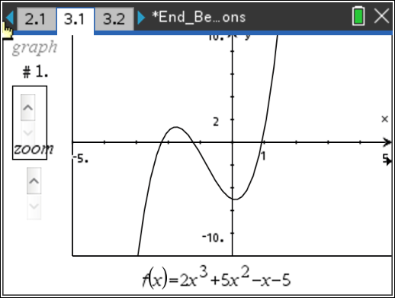
Answer: The given function is a third-degree polynomial. Therefore, the graph of the function should resemble the graph of y = x³. Because the leading coefficient is positive and the exponent is odd, as x increases without bound (x → ∞), y increases without bound (y → ∞) and as x increases without bound (x → –∞), y decreases without bound (y → –∞).

- Click the slider arrows labeled “zoom” and zoom out.

  - As you zoom out, what do you predict will happen to the shape of the graph?
Was your prediction correct?

Sample Answers: The graphs look more and more like that of y = x³

  - Discuss the similarities and differences between the polynomial function and the power function.

Sample Answers: The power function goes through the origin, while the polynomial function does not. The polynomial function has “bumps,” while the power function does not. As students zoom out, they will observe the end behavior is the same for both functions.

- Click the slider arrows labeled “graph.” Zoom out each of the graphs. By looking at the equation of a polynomial function, how do you determine which power function the graph will resemble? Explain your reasoning.

Sample Answers: The term with the highest degree determines the end behavior of the graph of the polynomial. Therefore, the graph of the polynomial function will resemble the graph of the power function that corresponds to the term with the highest degree in the equation. As students zoom out, they will observe the end behavior for both functions is the same.

7. Does the end behavior of each graph follow the limit notation general statements written in number
three? Explain your answer.

Sample Answers: Yes the end behavior should be the same. The students should be discussing
the initial terms of each polynomial (term with highest exponent and its leading coefficient) and
comparing them to the parent power function to get the same end behavior.

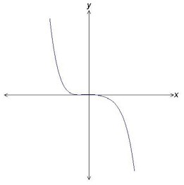
8. The graph of a polynomial function is shown.

  - Write a possible equation that models the function.

Sample Answer: Answers might vary. The students should have a polynomial function with a leading term that contains a negative coefficient and an odd exponent.

TI-Nspire Navigator Opportunity: Screen Capture See Note 2 at the end of the lesson.

  - Explain your reasoning.

Answer: Students cannot determine the exact equation for the function given in this window; however, the equation of the function shown is:
y = –0.01x⁵ + 0.07x⁴ – 0.37x³ – 2.83x² + 0.12x + 12.6
Zoomed to a window [–20, 20] × [–2,000, 2,000]
When zoomed to a window [–10, 10] × [–20, 40], the zeros and “bumps” become visible.

9. For a polynomial function $f$, $\lim_{x→-∞}{f\left(x\right)= -∞}$ and $\lim_{x→∞}{f\left(x\right)= -∞}$. Describe the degree and
leading coefficient of $f(x)$.

Sample Answers: To match this end behavior, the power must be an even degree and the
leading coefficient must be negative.

TI-Nspire Navigator
Note 1
Question 1, Quick Poll
After students have had time to respond to item 3, pose the following question.
What is the end behavior of the function
y = –3x⁵ – 7?
A. $\lim_{x→-∞}\left(y\right)= ∞$ ; $\lim_{x→∞}\left(y\right)= ∞$
    - $\lim_{x→-∞}\left(y\right)= -∞$ ; $\lim_{x→∞}\left(y\right)= ∞$
    - $\lim_{x→-∞}\left(y\right)= -∞$ ; $\lim_{x→∞}\left(y\right)= -∞$
    - $\lim_{x→-∞}\left(y\right)= ∞$ ; $\lim_{x→∞}\left(y\right)= -∞$

Note 2

Question 4, Screen Capture
After students have had time to respond to item 8, have students graph their function. Use Screen Capture to post some of the results. Make sure the function line is showing so students can see the different possibilities.

