Logging In  ID: 12180 | Time required  15 minutes

Activity Overview
In this activity, students will use integration by parts to integrate ln x. In the homework/extension problems, they will use a similar process to integrate tan^{–1}x. Additionally, students will review integration using substitution.

Topic: Integration
- Integration by Parts
- Integration using substitution

Teacher Preparation and Notes
- Integration by parts is a topic in the AP* Calculus BC curriculum. Students should be familiar with the technique before completing this activity. The suggested activity below may be used prior to this activity to teach integration by parts.
- To download the student TI-Nspire document (.tns file) and student worksheet, go to education.ti.com/exchange and enter “12180” in the quick search box.

Associated Materials
- CalcWeek20_IntegratingLogs_Worksheet_TI89.doc

Suggested Related Activities
- Integration by Parts (TI-89 Titanium) — 9850

*AP, College Board, and SAT are registered trademarks of the College Board, which was not involved in the production of and does not endorse this product.

Part 1 – Explore Integrating ln x
Present students with the problem . Discuss techniques of integration that could be used, such as direct integration, substitution, or integration by Parts.
Students should eliminate the first two options. Have students recall the formula for integration by parts. Note: there are a variety of notations. This activity will use the following notation:
Investigate the different choices for u and v′. Together discover . Verify the result by taking the derivative. (The CAS commands can be used.) | 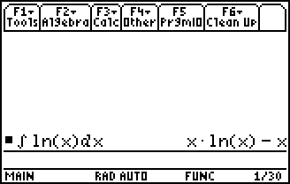
Students will graph y = ln(x) and their solution. With a partner they will discuss the relationship between the two graphs.  Student Solutions  - Direct integration, substitution, integration by parts, others that have been taught  - u = ln x, v′ = 1 | 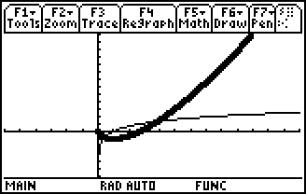

Part 2 – Extension/Homework
Note: When doing indefinite integration, the CAS handheld does not include + C. Emphasize to students the importance of including this in their solutions. | 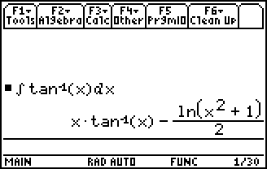
This section has problems that allow students to practice techniques of integration. Students can check their answers using their graphing calculators. Answers on their calculators may appear different than the answers students get by hand. This can allow for students to see different forms of the answer and verify (either algebraically by hand or using logic on the CAS system). The methods described below are only one possible way to solve the given problems.
Student Solutions
1. Involves integration by parts first and then substitution.
2. Involves substitution first and then integration by parts.
3. Involves straight integration by parts—typical multiple-choice question.
4. Involves integration by parts twice.
5. Involves straight integration by parts.

