Investigate Angle Bisectors
1. Draw an angle. Bisect the angle.
Describe how you bisected angle ‘ABC’.
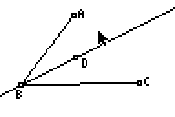
- Explain how you know ray BD is an angle bisector. (Note: due to platform limitations on the calculator there is no actual ray command, I use the term ray even though the segment tool or line tool is used a figure or construction.) Would any measurements help confirm or dispel the notion that ray ‘BD’ is an angle bisector? If so, which measurements?

_____________________________________________________________________________
- Measure any objects listed above.

- Describe what happens to both the diagram and the measurements made in question 3 as you drag:
A

B

C

D

‘AB’

‘AC’

- Explain how these measurements support or debunk the idea that ray ‘AD’ is an angle bisector. Discuss any inconsistencies you observe.

Construct the perpendicular from D to ray BA and from D to ray BC.
- Place a point at the point of perpendicularity with the side of each angle. (Use the Point-Intersection command to guarantee points ‘E’ and ‘F’ are at the point of perpendicularity.)
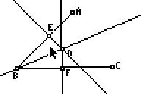
- Describe what you did to construct the perpendiculars ‘DE’ and ‘DF’.

- Describe how you used the Point-Intersection command to anchor points at the intersections.

- Hide lines ‘ED’ and ‘DF’. Remind me: How did you hide the lines? 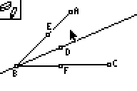

- Draw segments ‘ED’ and ‘DF’. Measure and record the measure of each segment.

ED = _________ and DF = ________

- Grab and drag ‘D’. Watch the measurements; is there anything noteworthy? If so, make your observation into a conjecture.

7. Draw an enlargement of your figure. Think about what parts of the figure must be congruent. List the congruent parts and develop a mathematically convincing argument to support your conjecture.

