Transformation of the Radical Function

Part 1:

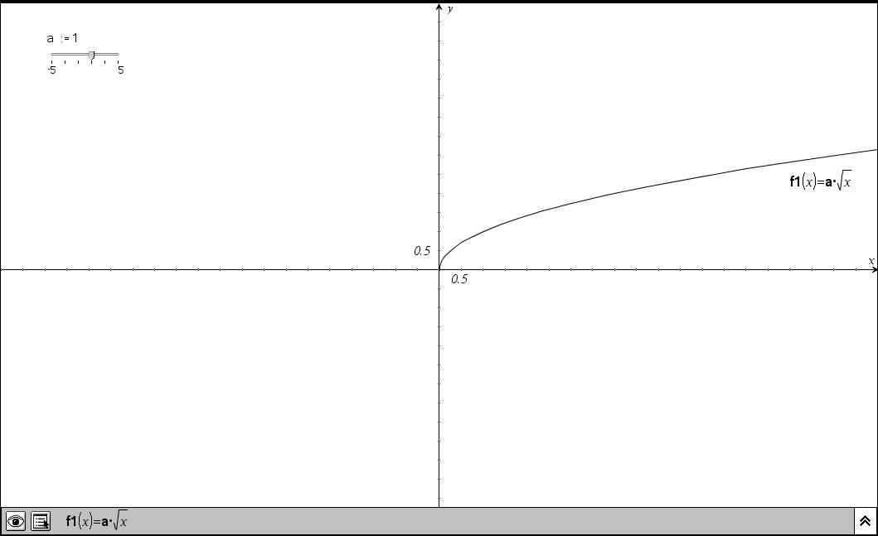

To open the document “ radical transformations,” press c. Choose 7:My Documents. Arrow down until “absolute value transformations,” is highlighted and press ·. On this first screen, you will see the function f1(x) =a* √(x). You are going to discover what the “a” value does to this function. In the top left corner of the screen, you will see a slider bar, ranging in values for the “a” from -5 to 5. This function is animated on the graph. Watch the numbers in the slider and the effect they have on the graph. When you think you know the pattern, press / and arrow right to get to the next page and try predicting and moving the slider on your own.

To move the slider on your own, use the Navpad to move the arrow å up to the slider until it is pointing on top of marker above the value of zero. You should see a hand appear ÷ .Hold the clicker x to create a grabby hand and begin to drag the marker on the slider line. Each time you drag the marker, notice how the line is adjusting. Drag the marker at least 10 times, making sure to look at the zero, positive, and negative values.

Discuss with your partner/group what happens to the parabola as you are dragging the marker, how the “a” value affects the absolute value function, and what happens to the direction of the graph as you are dragging the marker. Write your conclusions. ______________________________________________________________________________
______________________________________________________________________________

Part 2:

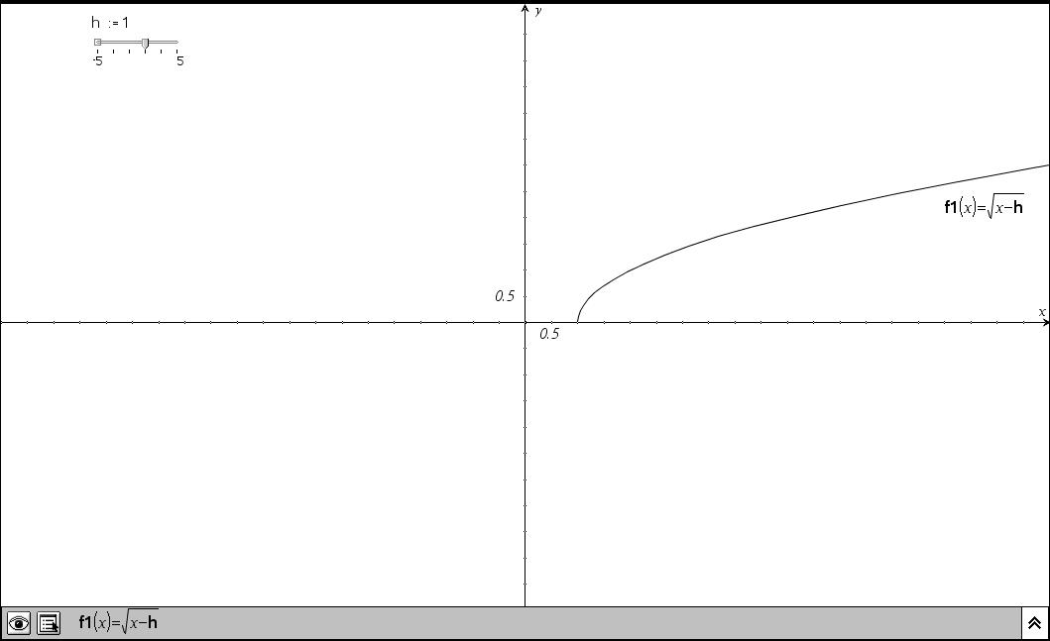

Press / and arrow right to get to the next page. You now see a graph of f(1)= √(x-h). In the top left corner of the screen, you will see a slider bar, ranging in values for the “h” from -5 to 5. This function is animated on the graph. Watch the numbers in the slider and the effect they have on the graph. When you think you know the pattern, press / and arrow right to get to the next page and try predicting and moving the slider on your own.

To move the slider on your own, use the Navpad to move the arrow å up to the slider until it is pointing on top of marker above the value of zero. You should see a hand appear ÷ .Hold the clicker x to create a grabby hand and begin to drag the marker on the slider line. Each time you drag the marker, notice how the graph is adjusting. Drag the marker at least 10 times, making sure to look at the zero, positive, and negative values.

Discuss with your partner/group what happens to the parabola as you are dragging the marker, how the “h” value affects the absolute value function, and what happens to the direction of the graph as you are dragging the marker. Write your conclusions. ______________________________________________________________________________
______________________________________________________________________________
Part 3:
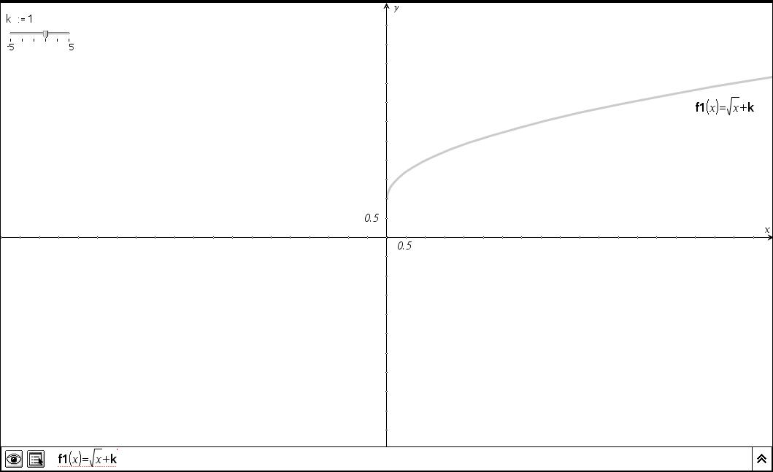
Press / and arrow right to get to the next page. You now see a graph of f(1)= √(x)+k. In the top left corner of the screen, you will see a slider bar, ranging in values for the “k” from -5 to 5. This function is animated on the graph. Watch the numbers in the slider and the effect they have on the graph. When you think you know the pattern, press / and arrow right to get to the next page and try predicting and moving the slider on your own.

To move the slider on your own, use the Navpad to move the arrow å up to the slider until it is pointing on top of marker above the value of zero. You should see a hand appear ÷ .Hold the clicker x to create a grabby hand and begin to drag the marker on the slider line. Each time you drag the marker, notice how the graph is adjusting. Drag the marker at least 10 times, making sure to look at the zero, positive, and negative values.

Discuss with your partner/group what happens to the parabola as you are dragging the marker, how the “k” value affects the absolute value function, and what happens to the direction of the graph as you are dragging the marker. Write your conclusions. ______________________________________________________________________________
______________________________________________________________________________
Part 4:

Predict what the following will look like and sketch on your paper. Then, press c and choose 2:Graphs and Geometry. A coordinate plane appears. The cursor is flashing behind the f2(x) =. Type each problem to check your guess. Press · after each problem. Suggestion: repeat this process for each problem, so there is a fresh coordinate plane for each graph.

1.F(x)= 6√(x) 2. F(x)= -6√(x) 3. f(x)= √(x+6) 4.f(x)= √(x-6)

5. f(x)= √(x)+6 6. f(x)= √(x)-6 7. f(x)= 2√(x)+5 8. f(x)=-2(√(x+5)

9. f(x)= - √(x-4)+ 6 10. f(x)= 4 √(x+2)– 3 11. f(x)= -1/2 √(x-1)+3

