Open the TI-Nspire document Bounded_Areas.tns.  The goal of this activity is to practice and discuss the applications of finding the area bounded by a curve and the  x-axis. Further investigation will be made with similar applications of finding the area bounded by two curves. Ultimately, you will try to make a connection with how to understand these topics in both IB Mathematics and AP Calculus courses and on their final assessments. | 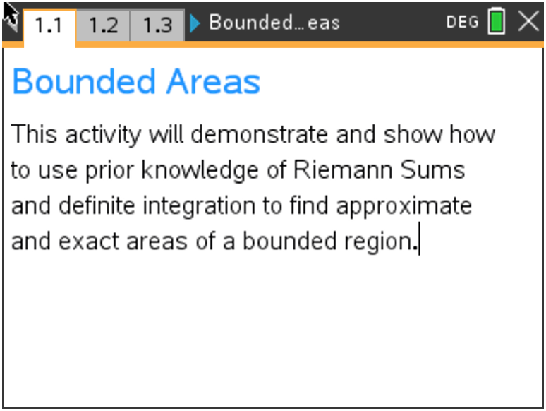

Move to page 1.2.

On this page, the function $f\left(x\right)= x^{2}+2$ is being discussed. You will use the subsequent pages to refresh your skills on left-hand rectangle, right-hand rectangle, midpoint rectangle, and trapezoidal Riemann Sums given the bounded area between $f(x)$, the x-axis, and the vertical lines x = 1 and
x = 3. For the remainder of this activity, we will call this bounded area $A(x)$.

Move to page 1.3.

This is a visual of the bounded area, $A(x)$.

Move to page 1.4.

1. Using the four left-endpoint rectangles provided on this page, find their sum total area between the
curve and the x-axis. State if this is an underestimate or overestimate of the bounded area A(x).
Explain your reasoning.

Move to page 1.5.

2. Using the four right-endpoint rectangles provided on this page, find their sum total area between
the curve and the x-axis. State if this is an underestimate or overestimate of the bounded area
$A(x)$. Explain your reasoning.

Move to page 1.6.

3. Using the four midpoint rectangles provided on this page, find their sum total area between the
curve and the x-axis. State if this is an underestimate or overestimate of the bounded area $A(x)$.
Explain your reasoning.

Move to page 1.7.

4. Using the four trapezoids provided on this page, find their sum total area between the curve and the
x-axis. State if this is an underestimate or overestimate of the bounded area $A(x)$. Explain your
reasoning.

Move to page 1.8.

5. Looking back on the last four questions, pages 1.4 - 1.7, state which you think is the most accurate
for the area, $A\left(x\right).$ Explain your reasoning.

Move to page 1.9.

6. With your classmates, explain how we can use integration to find the exact bounded area.

Move to page 1.10.

7. On page 1.11, use your handheld to find the exact area on the graph page and on the calculator
page. Explain why the answers are or are not the same.

Extension

Move to Page 1.12.

Discuss with one another what would happen if:

8. The function was $f\left(x\right)= {-x}^{2}+2$ instead;

9. The number of rectangles/trapezoids doubled;

10. The function was $f\left(x\right)= {-x}^{2}- 2$;

11. The x-axis and vertical lines were no longer the boundaries, but a second function,
$g\left(x\right)= {-x}^{2}+4$, was. Describe how you would find this area.

Application

A couple building a house want to make a statement with their front door. They are considering multiple
shapes for the entrance. They find the standard rectangular doorway to be boring. One shape that piqued their interest was an arch. The door is the shaded region modeled by the function
$f\left(x\right)=\frac{1}{3}(8-x)(x-2)$, bounded by the x-axis and $f\left(x\right)$. It is shown below.
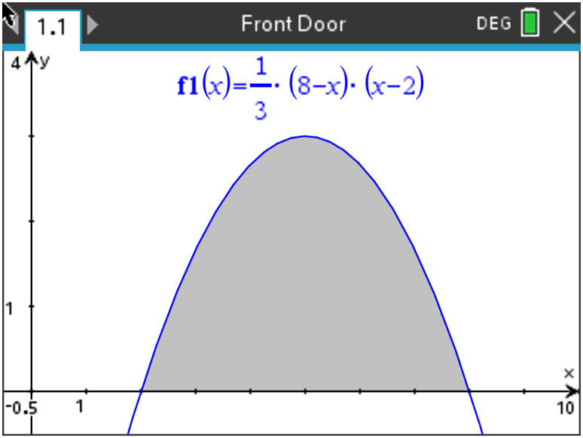

(a) Write down an integral for the shaded region.

(b) Find the area of this shaded region.

The couple have always been fascinated by triangles. Below is the rendering of how a triangular entrance would look. The three vertices are given as P(0, 2.5), Q(5, 4), and R(c, 0).

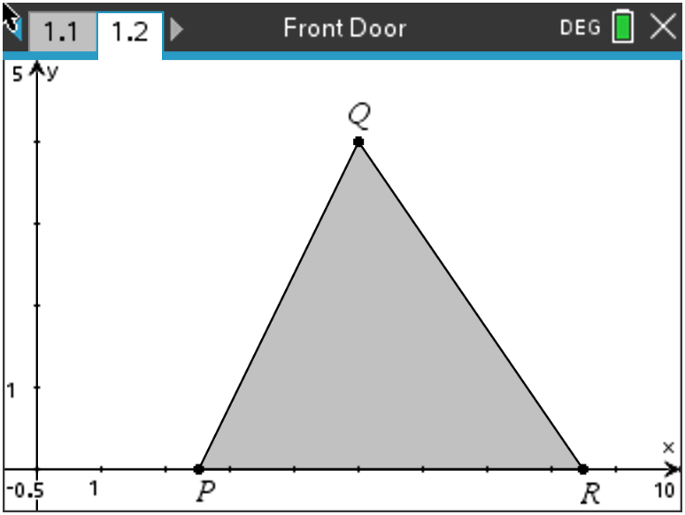

(c) Find the value of c, the x-coordinate of R, such that the area of the triangle is equal to the area of the region found in part (b).

