Goal: Understand the equation to find the volume of a solid of revolution formed by rotating the area bounded by two curves.
Problem 1 – dx vs dy
Consider a thin disk with a hole in the middle. This shape is like a washer that goes on a bolt or screw. On page 1.2, explore the washer by changing:
- outer radius — drag the slider
- inner radius — drag the point on the inside edge of the washer
- height — drag the point in the center of the washer
On page 1.3, clicking the arrows up or down will show dx or dy.
- Grab point dx (on the x-axis) to change the location of the slice.
- Grab point dy (on the y-axis) to change the location of the slice.
1. Find the volume of the area bounded by and
a. when it is rotated about the x-axis.

b. when it is rotated about the y-axis.

Be sure to write the set up for the definite integral and your answer to show your work for each part.
On page 1.9, the solid formed by the two curves rotated about the y-axis is given. Explore the 3D solid; press A to rotate and d to stop, r to zoom in and p to zoom out.
3. Write the equation of the line and the parabola that when rotated forms the 3D volume shown. The x-value of which function will form the outer radius? Solve for x for function.

On page 1.11, the system of equations that formed the 3D solid has been solved.
4. Using the intersection coordinates, find the volume of the region bounded by and rotated horizontally. Use the Fundamental Theorem of Calculus to show your work in finding this volume.

Problem 2 – Region bounded by sin(x)
5. Find the volume of the area bounded by f1(x) = sin(x) and f2(x) = x² when it is rotated about the x-axis. Write the set up for the definite integral and your answer.

Problem 3 – Rotation around a vertical line
6. When a function is rotated about a vertical line, such as x = 2, will the slices of the 'washer' be dx or dy?

The Geometry Trace tool created the figure on the right. On the page 3.2, press Menu >Trace> Geometry Trace. Click once on what you want to see leave a trail, such as the outer circle and inner circle. Then move the point attached to the thin slice. | 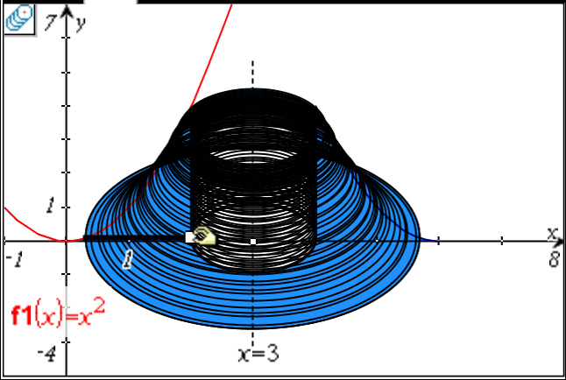
7. A solid is formed by rotating an area bounded by y = x², y = 0, and x = 2, about the line x = 3. What is the volume of this solid? Show the set up of the definite integral.

