ACTIVITY EXCHANGE

LET’S PLAY  BALL  with Box and Whisker Plots | 
NCTM Principles for School Mathematics
- Equity, Curriculum, Teaching, Learning, Assessment, and Technology

NCTM Standards for School Mathematics
- Formulate questions that can be addressed with data and collect, organize, and display relevant data to answer them.
- Select and use appropriate statistical methods to analyze data.
- Organize and consolidate mathematical thinking through communication.
- Build mathematical knowledge through problem solving.
- Monitor and reflect on the process of mathematical problem solving.
- Analyze and evaluate the mathematical thinking and strategies of others.

Overview:
This activity is designed to help students make decisions about what and how information could be displayed graphically. The data set deals with salaries of professional baseball players. It is designed for students to determine if the data should be represented as one-variable or two-variable statistics. The teacher will generate the data (salaries) via the web browser in TI-InteractiveTM and send all (and select parts) of the data for groups of students to analyze, represent, and compare.

Materials/Software:
- TI-83plus/84 graphing calculator family
- TI-NavigatorTM Learning System and TI-InteractiveTM Software

Student Objectives:
- To collect, organize and display data using technology.
- To graph data in a Box and Whisker Plot.
- To make and compare conclusions.
- EXTENSIONS
  - To graphically represent two-variables using the data sets given.
  - To connect to ideas in statistics by applying percentages (inflation) to bring the salaries up to today’s standards.

Warm-Up Problems/Activities: (Review Pre-requisite Skills)
Answer to #1

2 | 0 8
3 | 0
5 | 5
6 | 0 4 5 6 8
7 | 0 0 2 4 4 8

1. Create a stem-leaf plot using the heights of a doctor’s
patients given in inches:

20, 28, 55, 30, 74, 70, 60, 65, 64, 68, 66, 70, 72, 78, 74

2. Graph , .

Motivating the Lesson:
What type of graph of would you use for the data shown in the table? Explain your choice.
Day | Attendance
Sun. | 45,643
Mon. | 16,347
Tues. | 19,346
Wed. | 26,477
Thurs. | 36,545
Fri. | 42,463
Sat. | 48,658
Generate a discussion about displaying one-variable data. What could this data represent? (Possible response: yearly salaries)

Activity Procedures:

Step 1: Open TI-Interactive. Use the Web-Browser to locate, collect, and manipulate data related to salaries of professional baseball players.

Web Browser

Step 2: Select data sites.
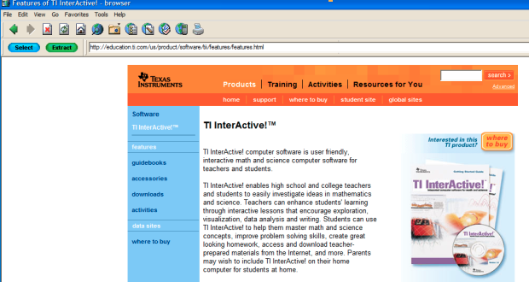
data sites

Step 3: Select the Sports Category (Math). Note that there are seven sports sites as well as many other interesting sources of data.
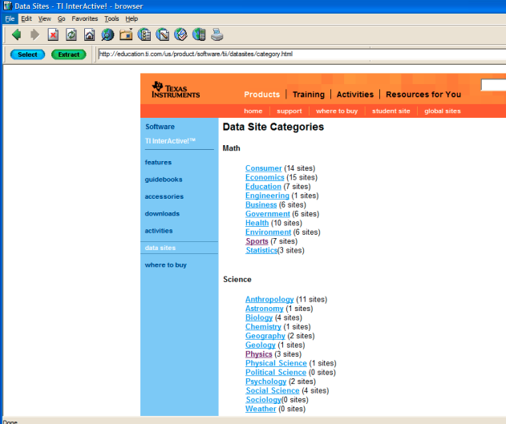
There are 7 Sport sites.

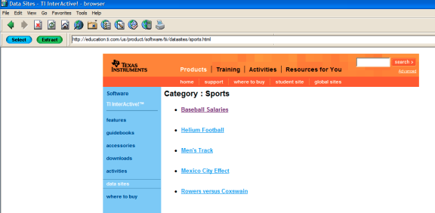
Let’s look at
Baseball Salaries.

When you select “Baseball Salaries”, you will receive 747 data entries. You may need to reorganize the data before you will be able to send the appropriate list to your students. Note that some of the numerical entries may not “line up” as you may like. So, adjust as desired. A sample of what you may view is soon as follows:

The 1994 salaries of all major league baseball players as reported in USA Today on April 5, 1994. Salaries include pro-rated signing bonuses. The list includes 747 data entries. A sample of that list is shown below:
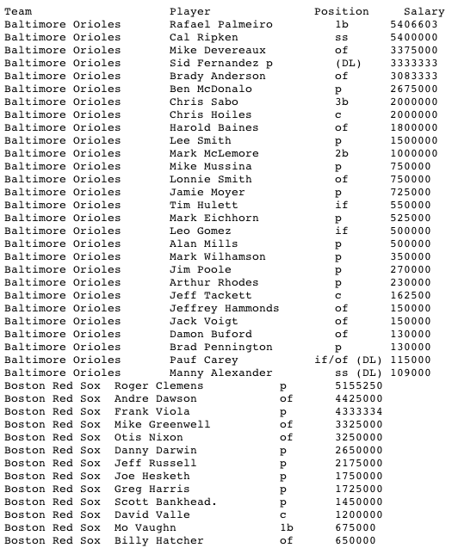

Step 4: Choose “Select” and then “Extract” to transfer the desired information to the Data Editor of TI Inter-Active.
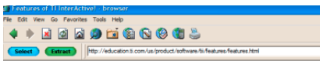

Step 5: At this point you will want to manipulate the data. You may delete information, change list numbers, or move lists about. See the TI-Interactive document (attached) for the interactive version of the data set.
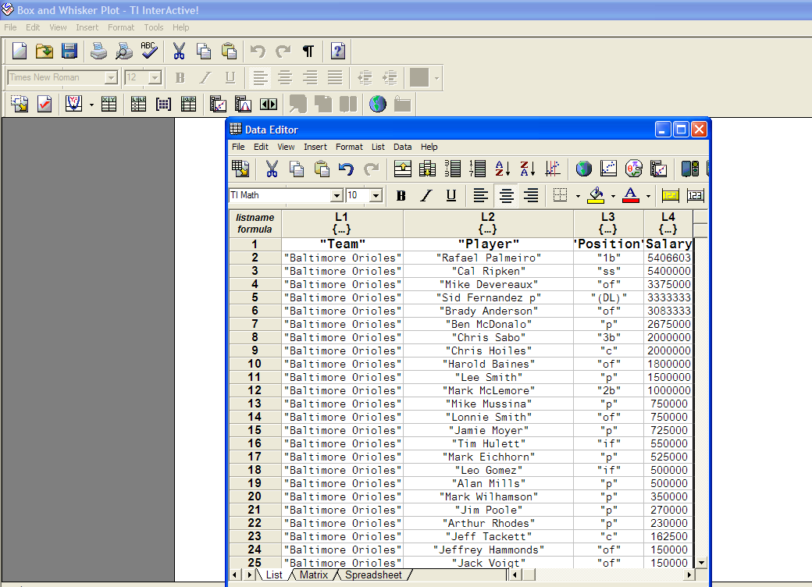

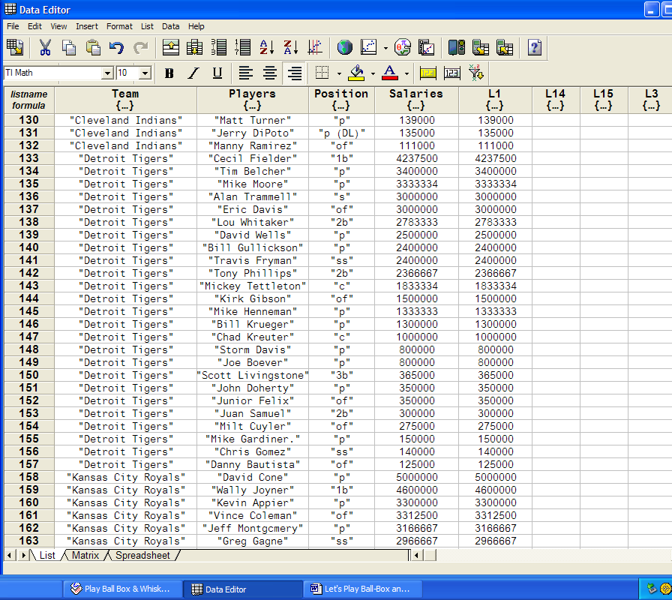
Note that you can change the name of the lists. You may send the data as “Salaries” OR as L1.

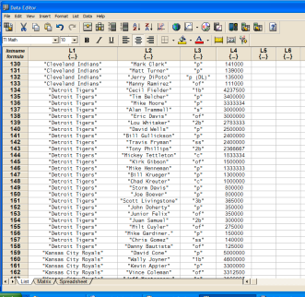

Step 6: Send data to students using TI-NavigatorTM. The salaries of one team
may be sent to different student groups for comparisons. Go to File (from the Data Editor) in TI-InteractiveTM and Export to the class.
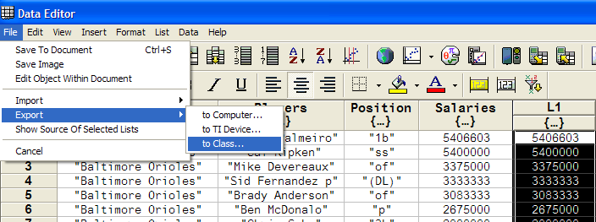

You may also use the icon to export to the class.
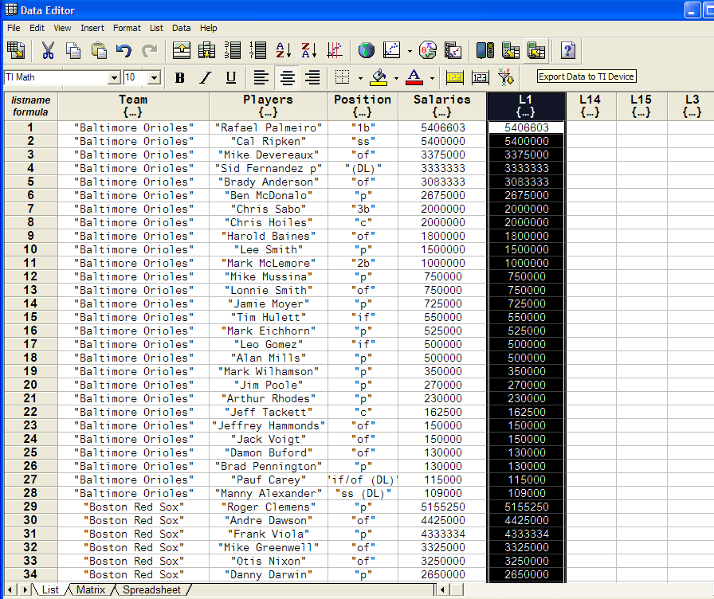

Lists can be renamed and their positions can be changed.

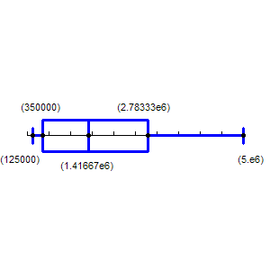
Assignment:

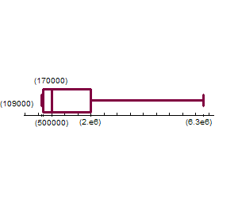
Using their TI83+/84+ graphing calculator, students will:

  - Create one box plot to represent all baseball teams AND one box plot to represent the team assigned to their group.

All Baseball Team Salaries Detroit Tiger Salaries

  - Analyze the data (mean, median, maximum, minimum).
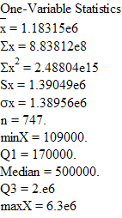
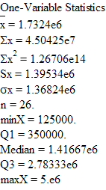

  - Compare results of their group team statistics with that of all teams.
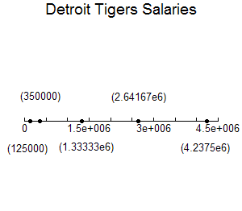
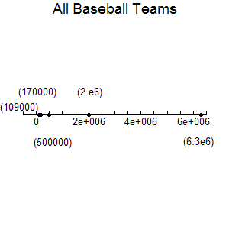

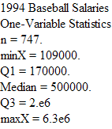
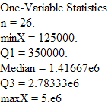

Assessment (On-Going)
Generate student discussions. See connections to Blooms Taxonomy.

Sample Questions for the Activity based on Bloom’s Taxonomy:

KNOWLEDGE
- How would you describe the data?
- How could the data be displayed?
- What does it mean to have one-variable data?
- What team has the baseball player with the highest/lowest salary?

COMPREHENSION
- State/interpret the objectives of this activity in your own words.
- What facts verify the salary most popular?
- What is the main idea of this activity?
- Can you explain what happened when the teacher sent the data to you?
- What is the mean value? Median value? Q1? Q2? Q3? Q4?

APPLICATION
- How did you calculate the mean value? Median value? Q1? Q2? Q3? Q4?
- How would you explain the activity to a student who was absent?
- What would you do to substantially increase/decrease the mean? Median?
- What other way(s) could the data have been received?

ANALYSIS
- How would you categorize/organize the data?
- What is the relationship between the varied ways to display the data, i.e., box-and-whisker, histogram, etc.?
- Explain the parts of the graph (box-and-whisker) as it relates to the data?
- What inference can you make about the salaries per team?

SYNTHESIS
- How could you make changes in your graph? How would changes in the data affect the graph?
- Suppose you could determine the salary of the next new baseball player, how would you use the data and your results to determine his/her salary?
- What would result (on the graph) if there was a player whose salary was 0$?
- How would you explain what happens when you do not “see” the graph (after working with the data)?

EVALUATION
- Why was it better to use a box-and-whisker to display the data?
- How would you prioritize your procedures in this activity?
- How would you rate this activity and why?

