Focus: Collect data and use it to make a picture graph.
Making Picture Graphs
Collecting and Organizing Data
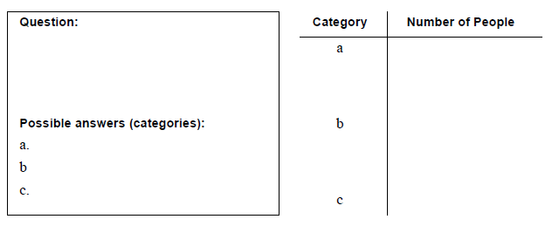
Graph Title ______________________________________
Each ______________ (picture) represents _____ pieces of data.

