Problem 1 – Ride the Rollercoaster
The “Superman - Ride of Steel” rollercoaster in Darien Lake, New York reaches a maximum height of about 208 feet.  Lists L1 and L2 contain the horizontal and vertical distances in feet, respectively, of a segment of rollercoaster track. | 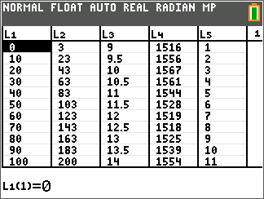
To display a scatter plot of the data, press y o [statplot] and select Plot1. Match the screen to the right.  Next, press q and select 9:ZoomStat to view the resulting graph.  It may be necessary to modify your viewing window if you wish to use the GridLine feature. Press p and change the values of Xscl: and Yscls: each to 30. | 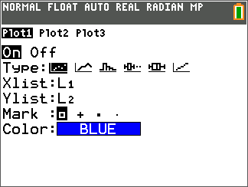
1. Based on the scatter plot’s appearance, what type of polynomial equation might reasonably be chosen to represent these data?

To have the graphing calculator perform this regression, first turn on the diagnostics (this allows the correlation coefficient to be displayed.) To turn on the diagnostics, press y Ê  [catalog] and use the arrow keys until Diagnostics On is displayed.  Note: You can quickly advance to the catalog options beginning with the letter “D” by pressing ƒ — [D].  Select it by pressing Í and press Í again. | 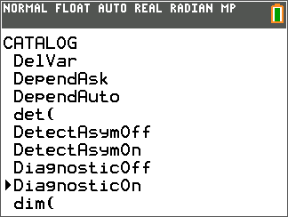
Now, from the calculator screen press … and arrow right to the CALC menu. From there, choose the regression type you chose for Question 1.  Now you need to enter L1, L2, Y1 into the Xlist:, Ylist: and Store RegEQ: fields respectively To enter L1, press y À [L1], to enter L2, press y Á [L2], and to enter Y1, press ½, arrow over to Y-VARS and press Í and then press Í again. Move down to Calculate and press Í.  To view the graphs of the scatter plot and the regression equation, press . | 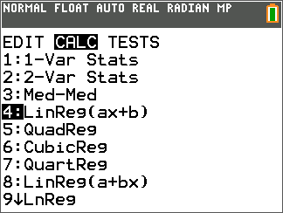
2. What equation resulted from your first regression choice? How did it fit the data?

Sometimes the best choice is not obvious at first. Try a second type of polynomial regression and graph these results also.
When you calculate a different regression equation, store it into a different location in the Store RegEQ: field. Use Y2 as the location for your second equation.

3. What equation resulted from your second regression choice? How did it fit the data?

4. After viewing the two equations graphed on top of the scatter plot, which appears to best fit the data?

Look back to the two regression equations. Compare the values for R², the coefficient of determination.
0 ≤ R² ≤ 1
The closer the value of R² is to 1, the better the fit of the equation to the data.

5. Compare the values of R² for the two regressions. Based on these values, which equation provides the best fit to the rollercoaster data?

6. Calculate the maximum height you can expect to reach on this portion of the rollercoaster track by pressing y r [calc] and selecting maximum.
Note: You may need to press to move to the desired graph after selecting maximum.

Now, use the arrow keys to move the cursor to  - the left of the maximum and press Í  - the right of the maximum and press Í  - the guess of the maximum’s location and press Í | 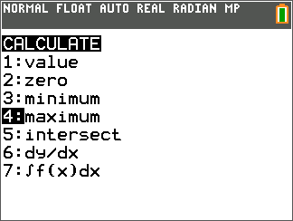
7. When you’ve travelled 500 feet horizontally, what height do you expect according to your equation? Does this make sense? Explain.

8. If the rollercoaster were to roll backward, what would you expect the height to be 20 feet back (x = –20)? Does this make sense? Explain.

Problem 2 – The Financial “Rollercoaster”
The United States, along with many foreign countries, has been experiencing what some might call a financial rollercoaster ride.  Lists L3 and L4 contain data (time in hours after 9:00 a.m. and number of shares traded, respectively) which model the NASDAQ stock market performance indicator data for one day in November of 2008.  Create a scatter plot and regression equation/graph for the data and answer the questions below. |  | 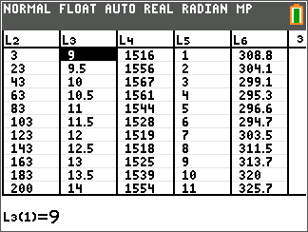

9. Based on the scatter plot appearance, what type of polynomial equation might reasonably be chosen to represent these data?

10. What regression equation best fits the given NASDAQ data? Why?

11. A high NASDAQ index value generally indicates economic health. At what time during this day was the index most favorable? What was the approximate index value at this time?

12. If this data set gave index values for today, based on the graph and the equation you found to represent the data, what kind of values should be expected for tomorrow? How about yesterday? Is this reasonable? Explain.

Problem 3 – The Gas Prices “Rollercoaster”
The following weekly price data for regular gasoline in 2008 were obtained from www.eia.doe.gov.  Lists L5 and L6 contain the price per gallon of regular gasoline in cents beginning with the first week of January 2008.  Create a scatter plot and regression equation/graph for the data and answer the questions below. | 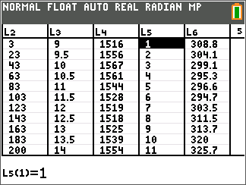

13. Based on the scatter plot appearance, what type of polynomial equation might reasonably be chosen to represent these data?

14. What regression equation best fits the given gasoline price data? Why?

15. Based on your equation model, what price might be expected for gasoline during the last week of the year (week 52)?

16. Based on this model, what would the price of gas been at the beginning of 2007 (x = –52)?

17. While the regression equation obtained may provide a reasonable fit to the given data, what problem(s) would be involved with extrapolating beyond the given data values?

