In Round Numbers: First Things First
Focus: Rounding whole numbers and decimals
The Problem: What do rounded numbers look like?
Working the Problem
Enter each number in the TI-15 and round it to the tens place, then to the hundreds place. Record your results in the tables.
- Press 539 . Record the result in Table 1. Press .
Record the result in Table 1.
Press 653 . Record the result the TI-15 shows in Table 1.
Press Record what the TI-15 shows. Clear the rounding feature by pressing .

2. Choose another 3-digit number and record it in the table. Enter it in the calculator and press . Record the result in the table.
Press . Record what the TI-15 shows. Clear the rounding feature.

Choose several more 3-digit numbers and repeat the procedure to round for the tens place and the hundreds place.

Make conjectures about the results that you will get when you press
Use yo or Test your conjectures with different 3-digit numbers.

Table 1
Number
539
653
3. Press 3482 . What do you think the TI-15 will show when you press
? ? ? Try them and record your results in
Table 2. Clear the rounding feature by pressing .
4. Choose several 4-digit numbers and use the different rounding keys. Predict what will happen, and then press and a rounding key. Make sure you clear the rounding feature before trying a different number.
Table 2
Number
3482

5. Press 6.487 and then press . What do you think the TI-15 will show when you press ? ? ? Try them and record all of the rounded numbers on Table 3. Clear the rounding feature by pressing
.

6. Choose several more numbers with 3 decimal places and predict what will happen when you use the rounding keys shown in Table 3. Make sure you clear the rounding feature before trying a different number.
Table 3
Number
6.487

7. With your group, answer these questions. Be prepared to share your answers with the class.
- If a number is rounded to the tens place where do you expect to find zeros?

- If a number is rounded to the hundreds place where do you expect to find zeros? How do you know?

- If a number is rounded to the tenths place where are the zeros?

- If a number is rounded to the hundredths place where are the zeros? How do you know?

- How does the TI-15 round numbers? How do you know?

In Round Numbers- Part 2
The Problem: How much money do the players in the Tuesday Morning Bridge Club earn?
Miss Petunia Littlefield is the treasurer for the Tuesday Morning Bridge Club. Each week the club members meet and play bridge. At the end of each session each player receives cent for each point earned during the games. Miss Littlefield often has to settle arguments about how much each player should get. Some players think the earnings should be rounded to the nearest cent. Other players think it should be rounded to the nearest dollar. Miss Littlefield wants your group to help her decide to which place she should round the amounts so that each player gets her fair share.
The Facts
- Four tenths of a cent is keyed into the TI-15 as .
- Players earn points as partners.
- Points are totaled for each individual.
- Each session has three games of bridge. For each game, the players have different partners.
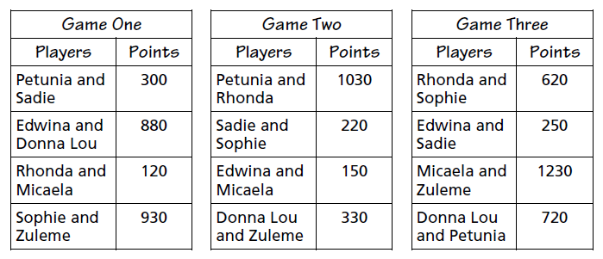

The Task
1. Your team will
- calculate the number of points earned by each player.
- calculate the amount of money earned by each player.
- use and a rounding key to help determine the amount of money to the nearest cent and to the nearest dollar.
- make a table showing all of this information.
- decide to which place Miss Littlefield should round when calculating the amounts each player earns.

2. Each person on the tam will write an explanation of the team’s solution. This explanation will answer the following questions:
- How did your team calculate each individual player’s score? Was there another way the calculations could have been done? Why do you think so?

- When the group calculated the amount each player should earn, did the answers make sense to you? Why or why not?

- Did you agree with the rounding place selected by the team?
Why or why not?

3. Your team will present the table to the class and explain how you chose to which place Miss Littlefield should round.

Using the TI-15
In Round Numbers
