Student Worksheet for G.G. 30

After turning on your handheld press  | Select CabriJr.  
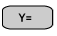scroll down to Open |  scroll to TRISUM  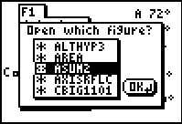
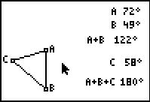 | Now position the cursor over any vertex. The vertex will become “active” and the cursor will change to a hollow arrow.  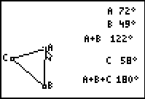

  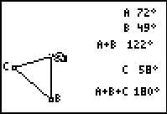 | You have now selected a vertex and grabbed the vertex. Now use your cursor to drag the vertex and observe what happens on your calculator.  Answer the questions below.

- As you dragged the vertex what measures were changing? ____________________________________________________________
- As you dragged the vertex what measures remained the same? ____________________________________________________________
- Press CLEAR and select a second vertex to drag. As you dragged the vertex what measures were changing? ____________________________________________________________
- As you dragged the vertex what measures remained the same? ____________________________________________________________
- Press CLEAR and select a third vertex to drag. As you dragged the vertex what measures were changing? ____________________________________________________________
- As you dragged the vertex what measures remained the same? ____________________________________________________________
- From your observations and answers to the previous questions what seems to be true regarding the sum of the angles of a triangle? _________
- Write a statement which summarizes your observations. _____________________________________________________________

