Introduction
Generally, when we in the United States talk about weather and temperature, we use the Fahrenheit scale. Scientists, however, often use a different scale—the Celsius scale. This scale is also used outside of the United States for everyday temperatures. In addition to the Celsius scale, scientists use the Kelvin scale. On the Kelvin scale, 0 K is called absolute zero. Nothing can be colder than absolute zero. (Note that temperature in the Kelvin scale is not given in degrees.)

Objectives
In this activity, you will:
- review the different temperature scales
- use the List Editor … to convert from one temperature scale to another
You’ll Need
- TI-84 Plus CE calculator
Entering the Data
- Start by clearing all existing lists from your calculator. To do this, press `, ´, then use the arrow keys to scroll to ClrAll Lists. Press e, e. | 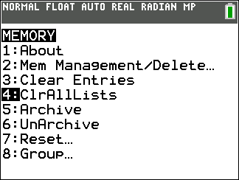
- Press S, e. Now enter into list L1 the temperatures in degrees Fahrenheit from the data table (below). | 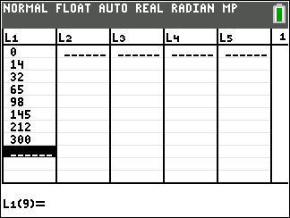
- Use the arrow keys to highlight the header of L2. This column is for degrees Celsius. Enter the conversion equation for degrees Fahrenheit to degrees Celsius:  ( 5 / 9 ) (` Ω‒32 ). Then press Í and record the values from L2 into the second column of the data table. | 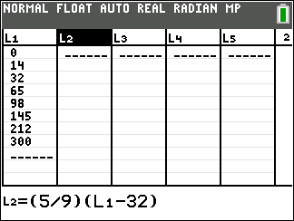
- Use the arrow keys to highlight the header of L3. This column is for kelvins. Enter the conversion equation for degrees Celsius to kelvins: ` æ + 273 e. Record the values from L3 into the third column of the data table. | 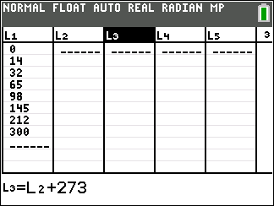
- To compare the different temperature scales, graph your values for °F and °C using the SciTools App. Press A and scroll to highlight SCI TOOLS. Press e, e. Scroll to DATA/GRAPHS WIZARD and press e. | 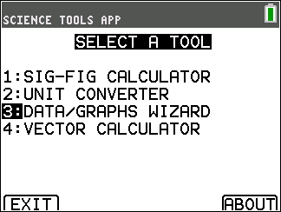
- Press @ to select PLOT DATA. Press o to select SCATTERPLOT. Select L1 as the INDEPENDENT Variable and press e. Select L2 as the DEPENDENT Variable and press e. | 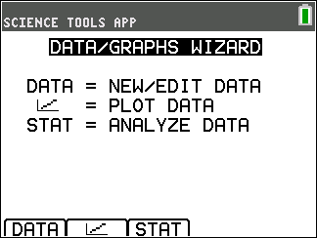  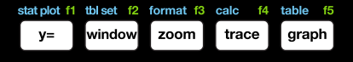
- Press Œ and choose a line fit. Highlight LIN REG for a linear regression, and press e. Your graph should look similar to the one shown here. You can use this graph to convert other temperature values. Press $:. and use the left and right arrow keys |~ to move the cursor along the linear model. Ordered pairs along the bottom of the screen give you equivalent temperatures on the Fahrenheit and Celsius scales. | 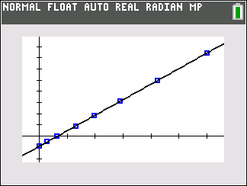
Data Table

Degrees Fahrenheit (°F) | Degrees Celsius (°C) | Kelvin (K)
0
14
32
65
98
145
212
300

Data Analysis
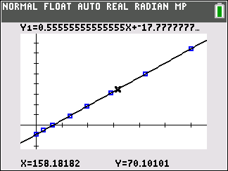
- In the graph below, what is the temperature in °F? What is the temperature in °C? (Round to one decimal place.)
- How would you find the Celsius temperature shown above in Kelvins? Calculate this value.

3. Why do you think it is helpful for scientists to use the Celsius scale rather than the Fahrenheit scale?

4. What advantage does the Kelvin scale offer over the Celsius scale in science?

