Teacher Preparation and Notes  - Load the Binompdf.tns file onto student handhelds.  - Remind students to use / + ¢ to move to the next page and / + e to move between parts of split screens.  - Note: This activity may be done with non-CAS TI-Nspire technology, but the expansion cannot be performed as illustrated on the non-CAS handheld.  TI-Nspire™ Navigator™  - Transfer a File.  - Use Class Capture to examine patterns that emerge.  - Use Live Presenter to demonstrate.  - Use Teacher Edition computer software to review student documents.  - Use Quick Poll to assess students’ understanding  Activity Materials  Compatible TI Technologies: TI-Nspire™ CX Handhelds,  TI-Nspire™ Apps for iPad®, TI-Nspire™ Software | 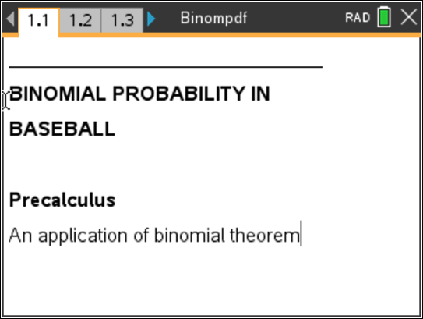  Tech Tips:  - This activity includes screen captures taken from the TI-Nspire CX II handheld. It is also appropriate for use with the TI-Nspire family of products including TI-Nspire software and TI-Nspire App. Slight variations to these directions may be required if using other technologies besides the handheld.  - Watch for additional Tech Tips throughout the activity for the specific technology you are using.  - Access free tutorials at http://education.ti.com/calculators/pd/US/Online-Learning/Tutorials  Lesson Files:  Student Activity  •Binompdf_Student.doc  •Binompdf.tns  •Binompdf_Soln.tns

Exploring the Problem
In this activity, students will explore the link between Pascal’s Triangle, the Binomial Theorem, and Binomial Probability Experiments.
Introduce the activity on pages 1.2 and 1.3. Students will be asked questions regarding p and q on pages 1.4 and 1.5. | 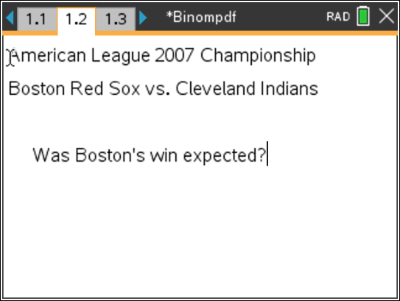
On page 2.1, the requirements of a binomial experiment are stated and then on the following page, the variables n and x are defined. | 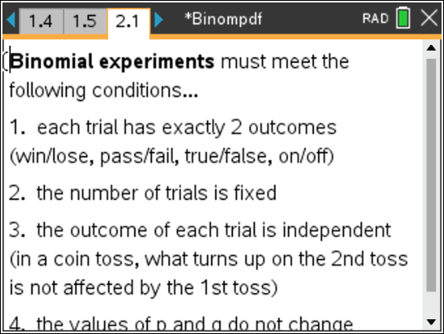
On page 2.3, a basic binomial probability situation is described. | 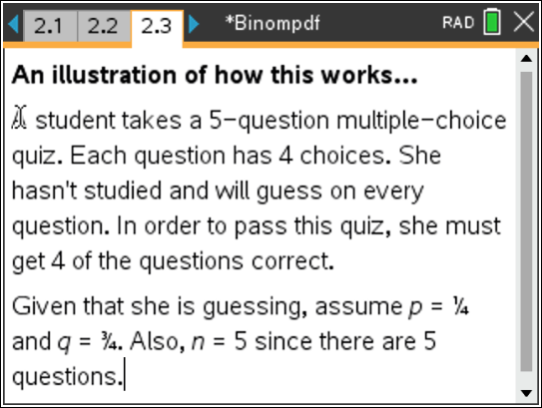
Developing the Pattern  On page 2.4, students are instructed to perform the binomial expansion as indicated to help students identify the link between the binomial expansion and both the formula to be used as well as the calculator method used for finding binomial probabilities. If CAS technology is unavailable, then students should perform the expansion by hand. | 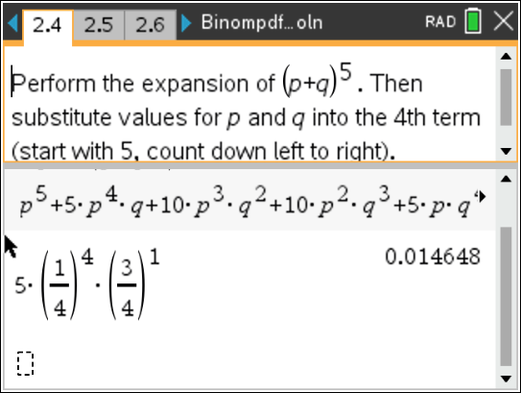
Pages 2.5 through 2.9 are devoted to the link between Pascal’s triangle and the expansion found at the bottom of page 2.4. Because the triangle is symmetrical, the variable x may be shown as either increasing or decreasing in value as one moves left to right.  Page 2.9 introduces the formula _{n}C_{x}p^{x}q^{(n-x)}, and students are instructed to perform this calculation for the quiz problem in the bottom half of the page. MENU  > Probability > Combinations is used to get _{n}C_{x}. Students must enter the values of n and x in parentheses, _{n}C_{x}(5, 4).  On page 2.10, students are directed to use the  Binomial Pdf command to find the probability again. | 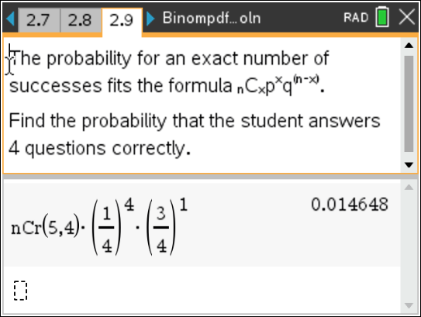
Extending the Pattern  The remaining pages of the document direct the student back to the baseball problem introduced at the beginning. Students are to use what they’ve learned to perform calculations and evaluate the results. | 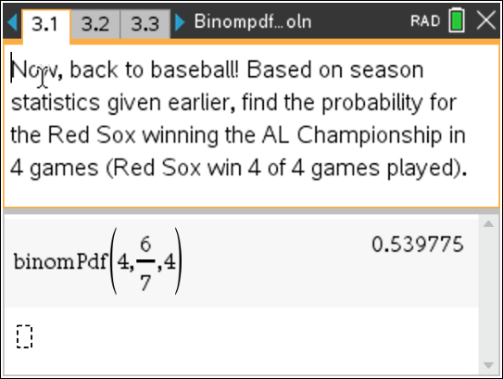

Solutions – student worksheet

1. p =
6 ≈ 0.857 2. q =
7
1 ≈ 0.143 3. Always
7

- p⁵ + 5p⁴q +10p³q² + 10p²q³ + 5pq⁴ + q⁵
⎛ 1⎞ 4 ⎛ 3 ⎞ 15
- 5 ⎜⎝ 4 ⎟⎠ ⎜⎝ 4 ⎟⎠ = 1024 ≈ 0.0146
⎛ 1⎞ 4 ⎛ 3 ⎞ 15

- 5 C4 ⎜⎝ 4 ⎟⎠
⎜⎝ 4 ⎟⎠ = 1024 ≈ 0.146

- binomPdf(5, 1 , 4) ≈ 0.0146
4
- Yes
- binomPdf(4, 6 , 4) = 0.5398
7
- Sample answer: No. I would have expected the Red Sox to have won the Championship earlier. The probability of them winning in 4 games was higher than 50%, so it would have been very reasonable for them to have won in 5 games if expectations are based on past performance.
- binomPdf(7, 6 , 4) = 0.055079
7
- No, this isn’t the best model. Winning 4 of 7 doesn’t explain anything about the order of the wins. The Red Sox could have won the first 4 games, they could have won 2, lost 2, then won 2. The championship games stop once the first team wins 4 games. In the winning four of four games, this order is not a concern, but it is a concern once you go beyond 4 games.
- This is an open-ended question. Reasonable answers might include 5 or 6 games given that the probability calculated for the Red Sox winning the first 4 games was over 50%.
- Injured players, team psychology, weather, umpire calls, home field advantage, etc.

