Activity Overview
Students will write augmented matrices for systems of equations and then solve the system by writing the augmented matrix in reduced row-echelon form.

Topic: Linear Algebra: Vectors & Matrices
- Convert a matrix to reduced row echelon form.
- Solve a linear system by converting the coefficient matrix to reduced row echelon form.

Teacher Preparation and Notes
Solving a system of equations can take a considerable amount of time—especially when the system has more than three variables/equations. One way to handle these larger systems is by using augmented matrices to represent the systems and then solving by finding the reduced row-echelon form of the augmented matrix. This is accomplished in this activity first by using elementary row operations and then by using the rref command.
  - Students should already be familiar with solving 2×2 and 3×3 systems by graphing and using elimination and substitution. The methods explored in this activity are useful for solving larger systems, but are equally applicable to smaller systems as well.
  - Students should also be familiar with entering matrices on the graphing calculator.
  - This activity is intended to be teacher-led. It is recommended that you guide students through the beginning of the problems in a whole-class setting, and then allow them to complete the remainder of the activity as individuals or small groups with your assistance.
  - Students should begin by clearing out any functions from the o screen and turning off all Stat Plots.

Associated Materials
  - ReduceIt_Student.doc

Problem 1 – Augmented matrices and reduced row-echelon form
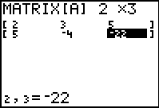
This problem walks students through how to use the reduced row-echelon form of an augmented matrix to solve a 2 × 2 system of equations. The first step is to translate the system of equations to an augmented matrix, as shown to the right.

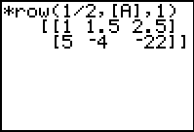
Next, students use elementary row operations to write the matrix in reduced row-echelon form. They are guided to use the following commands (available from the catalog or the y > > MATH menu) in order to obtain the solution:
…row(1/2,A,1)
…row+(–5,Ans,1,2)
…row(–2/23,Ans,2)
…row+(–3/2,Ans,2,1)
Note: To enter [A] (matrix A), press y > Í.
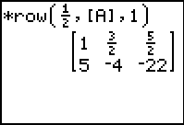
If using Mathprint OS:
When entering the row operations, students should press ƒ ^ and select n/d to set up the fraction. Enter the value of the numerator, press † to move to the denominator, and enter the value of the denominator. Then press ~ to move out of the fraction template.
Finally, they use the rref command as shown here to confirm their answers and then extract from the matrix the solution to the system.
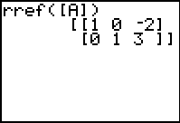
Guide students in doing so as needed. Here, the solution is x = –2 and y = 3.
You may wish to provide additional examples for students to solve using reduced row-echelon form before proceeding to Problem 2, where they will encounter a 3×3 system.
The student worksheet prompts students to think about the reduced row-echelon form of augmented matrices for systems in which there are infinitely many or no solutions. You might want to have them return to earlier work on systems and reduce the augmented matrices of systems they already know to be inconsistent or consistent with infinitely many solutions.

For 2 × 2 systems:
Consistent w/ infinitely many solutions: ⎡1 a b⎤ , for real numbers a and b.
⎢0 0 ⎥
⎣
0
⎦
Inconsistent (no solutions): ⎡1 a b⎤ , for real numbers a, b, and nonzero c.
⎢0 0 ⎥
⎣
c
⎦

Problem 2 – A 3 × 3 system
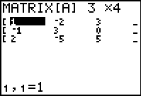
For this problem, students are challenged to perform the elementary row operations to reduce the augmented matrix for a 3 × 3 system to reduced row-echelon form.
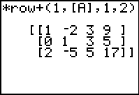
One possible such “path” to the solution is as follows:

Row Operation | Command
r1 + r2 → r2 | …row+(1, A, 1, 2)  or  row+(A, 1, 2)
−2r1 + r3 → r3 | …row+(–2, Ans, 1, 3)
2r2 + r1 → r1 | …row+(2, Ans, 2, 1)
r2 + r3 → r3 | …row+(1, Ans, 2, 3)  or  row+(Ans, 2, 3)
- r → r  - 3 3 | …row(1/2, Ans, 3)
−9r3 + r1 → r1 | …row+(–9, Ans, 3, 1)
−3r3 + r2 → r2 | …row+(–3, Ans, 3, 2)
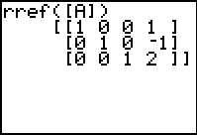
They should then check their work using the
rref command.
Solution to the system: x = 1; y = –1, z = 2

Problem 3 – Larger systems
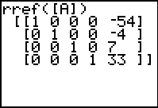
This problem has students use the rref command to find the solution of a 4 × 4 system, exposing the power of the rref command.

The solution is w = –54, x = –4; y = 7, z = 33.

Problem 4 – Curve fitting
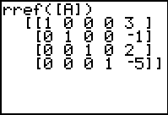
Students have likely written and solved a system of equations to fit a quadratic equation to a set of points. However, they might not think to do the same for a cubic function because the resulting system of equations is a bit unwieldy. This is where the rref command can be quite powerful.
The system of equations that represents this situation is
−8a + 4b − 2c + d = −37
−a + b − c + d = −11
d = −5
8a + 4b + 2c + d = 19
and it has a solution of a = 3, b = –1, c = 2, and d = –5. This results in the cubic equation y = 3x3 − x2 + 2x − 5 .

Solutions – Student Worksheet Exercises

⎛ ⎡1
⎜ ⎢
−3 1
1 ⎤ ⎞
⎥ ⎟
⎡1 0
⎢
7 0⎤
5 ⎥
−
The last row indicates that 0 = 1. Since this equation is false, the system is

- rref ⎜ 2 −1 −2 2 ⎟ = ⎢0 1 − 4 0⎥

⎜ ⎢ ⎥ ⎟ ⎢
5 ⎥ inconsistent and has no solutions.

⎝ ⎢⎣1 2 −3 −1⎥⎦ ⎠ ⎢⎣0 0 0 1⎥⎦

⎛ ⎡2 4 1
1 ⎤ ⎞ ⎡1 0 0 5 ⎤
The solution is x = 5, y = –3, and z = 3.

- rref ⎜ ⎢1 −2 −3
2 ⎥ ⎟ = ⎢0 1 0
−3⎥

⎜ ⎢
⎜ ⎢⎣1 1
⎝
⎛ ⎡1 2
⎥ ⎟
−1 −1⎥⎦ ⎟
⎠
−7 −4 ⎤ ⎞
⎢
⎢⎣0 0 1
⎡1 0 3
⎥
3 ⎥⎦
10⎤

The last row indicates that 0 = 0, which is

- rref ⎜ ⎢2 1 1 13 ⎥ ⎟ = ⎢0 1 −5 −7⎥ always true. This signifies that as long as x

⎜ ⎢
⎜ ⎣⎢3 9

−36
⎥ ⎟
−33⎥⎦ ⎟
⎢
⎢⎣0 0 0
⎥
0 ⎥⎦
and y behave as described by their

⎝ ⎠ equations, we can choose any value for z. This system has infinitely many solutions.

- System of equations:
1 a + v0 + s0 = 48
2

⎛ ⎡ 1
⎜ ⎢ 2

1 1 48⎤ ⎞
⎥ ⎟

⎡1 0 0
⎢

−32⎤
⎥

2a + 2v0 + s0 = 64
→ rref ⎜ ⎢2 2 1
64⎥ ⎟ = ⎢0 1 0
64 ⎥

9 a + 3v
+ s = 48
⎜ ⎢⎣ 9
3 1 48⎥⎦ ⎟
⎢⎣0 0 1
0 ⎥⎦

2 0 0
⎝ 2 ⎠

So, a = –32, v₀ = 64, and s₀ = 64, and therefore h = −16t 2 + 64t + 0 .

