Math Objectives  - Students will understand the role of the values of a and b in the equation $r=a±b*sin\left(θ\right)$ and $r=a±b*cos\left(θ\right)$ where $a>0$ and $b>0.$  - Students will discover the four different types of limaçon curves and their relationship to the ratio of $\frac{a}{b}.$  - Students will understand the relationship between the equation of a polar curve, called a limaçon, and the equation of a corresponding sinusoidal function.  Vocabulary  About the Lesson  - Students will investigate the effect of changing the values of a and b in the equation $r=a±b*sin\left(θ\right)$ and $r=a±b*cos\left(θ\right).$  - Students will generalize the roles of a and b in the equation $r=a±b*sin\left(θ\right)$ and $r=a±b*cos\left(θ\right).$  - Students will compare the graphs of the sinusoidal function, $f\left(x\right)=a±b*sin\left(x\right),$ and the polar curve, $r=a±b*sin\left(θ\right)$ and make generalizations about the relationship between the graphs.  - Students will compare the graphs of the sinusoidal function, $f\left(x\right)=a±b*cos\left(x\right),$ and the polar curve, $r=a±b*cos\left(θ\right)$ and make generalizations about the relationship between the graphs.  Teacher Preparation and Notes.  - This activity is done with the use of the TI-84 family as an aid to the problems.  Activity Materials  - Compatible TI Technologies: TI-84 Plus*, TI-84 Plus Silver Edition*, TI-84 Plus C Silver Edition, TI-84 Plus CE  * with the latest operating system (2.55MP) featuring MathPrintTM _{functionality.} | 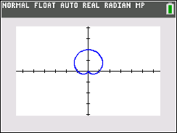  Tech Tips:  - This activity includes screen captures taken from the TI-84 Plus CE. It is also appropriate for use with the rest of the TI-84 Plus family. Slight variations to these directions may be required if using other calculator models.  - Watch for additional Tech Tips throughout the activity for the specific technology you are using.  - Access free tutorials at http://education.ti.com/calculators/pd/US/Online-Learning/Tutorials  Lesson Files:  Student Activity  Limacon_Curves_84_Student.pdf  Limacon_Curves_84_Student.doc
  - limaçon | - cardioid
  - sinusoidal function | - dimpled limaçon
  - convex limaçon | - inner loop limaçon
In this activity, you will investigate the effect of changing the values of a and b in the polar equations $r=a±b*sin\left(θ\right)$and $r=a±b*cos\left(θ\right)$, where $a>0$ and $b>0$. You will also explore the relationship between the polar curve $r=a±b*sin\left(θ\right)$ (or $r=a±b*cos\left(θ)\right)$and the sinusoidal function $f\left(x\right)=a+b*sin\left(x\right)$ (or $f\left(x\right)=a±b*cos\left(x\right)$).

Discussion Points and Possible Answers
Tech Tip: The default setting for θstep for polar graphs is π/24 (0.1308996939). The value may need to be adjusted to π/48.

To set your calculator to Polar mode, press z and select POLAR as shown to the right. Also set your graphing calculator to Radian mode by selecting RADIAN on this screen as well.  To graph a polar equation on your graphing calculator, press o  and enter your equation. The „ key produces θ in your equation when you are in Polar mode. |  | 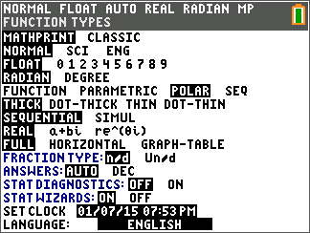
- Graph the following by editing $r1$ to observe each graph. Press q and select 4: ZDecimal.  $i) r1=1+1*sin\left(θ\right)$ $ii) r1=1-1*sin\left(θ\right)$  $iii) r1=2+2*sin\left(θ\right)$ $iv) r1=2-2*sin\left(θ\right)$  $v) r1=3+3*sin\left(θ\right)$ $vi) r1=3-3*sin\left(θ\right)$  Why do you think these graphs are called cardioids?  Answer: The graphs form a curve that looks somewhat like a heart. |  | 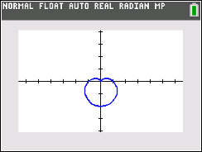  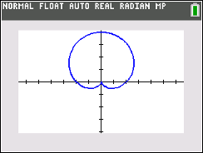  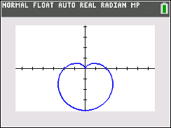  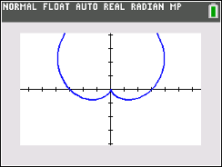  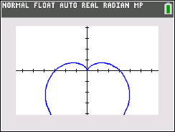
Teacher Tip: The purpose of these sets of graphs is for students to see:
1) how the addition and subtraction signs affect the graph, 2) when a and b are equal the shape of the graph stays the same, and 3) when the value of the numbers increase, the size of the graph also increases.

- What similarities do you notice about the equations of the six graphs?

Sample Answer: Answers may vary. Students should notice that in each equation the values of a and b are the same. Also, each equation contains the trigonometric function sine.

- How do the addition and subtraction signs affect the graphs?

Answer: In the graphs with equations containing the addition sign, the heart shape is pointing down. In the graphs with equations containing the subtraction sign, the heart shape is pointing up.

- Graph the following by editing $r1$ to observe each graph. Press q and select 4: ZDecimal.  $i) r1=1+1*cos\left(θ\right)$ $ii) r1=1-1*cos\left(θ\right)$  $iii) r1=2+2*cos\left(θ\right)$ $iv) r1=2-2*cos\left(θ\right)$  $v) r1=3+3*cos\left(θ\right)$ $vi) r1=3-3*cos\left(θ\right)$  How are the equations different from those in Problem 1? How does this difference affect the graph?  Answer: The difference between these equations and the ones in Problem 1 is the trigonometric function sine has been replaced with trigonometric function cosine. Now the heart shape is pointing either left or right depending on the sign, instead of up or down. If the equation contains an addition sign, the heart shape points left. If the equation contains a subtraction sign, the heart shape points right. | 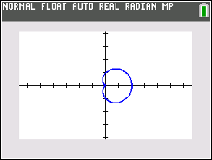  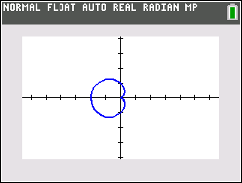  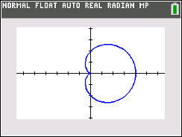  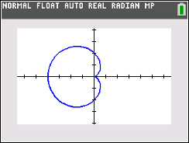  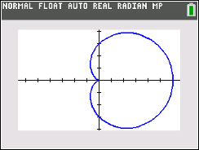  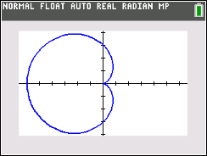
Teacher Tip: The purpose of these graphs is for students to see how replacing the sine function with cosine affects the graph of the limaçon.

Limaçons have different shapes depending on the ratio $\frac{a}{b}$. We have already seen the cardioid graph that is the result when $a=b$ (or $\frac{a}{b}=1$).

- Graph the following by editing $r1$ to observe each graph. Complete the table with the values of $a$, $b$, and $\frac{a}{b}$ as you observe each graph.
- If the ratio $\frac{a}{b}<1$, the limaçon has a special feature. Describe the shape of the limaçon.  Answer: Equations and descriptions may vary. A limaçon in which the ratio of a and b is less than 1 results in an inner loop.  - One of the polar curves in the table above has a ratio which satisfies $1<\frac{a}{b}<2$. Write an equation of another polar curve for which $1<\frac{a}{b}<2$. Graph your limaçon and describe the shape of the limaçon.  Answer: Equations and descriptions may vary. A limaçon in which the ratio of a and b is between 1 and 2 results in a dimpled shape or, it may be described as a kidney bean shape.  Sample equation: $r=4+3*cos\left(θ\right)$  - Write an equation of a limaçon in which the ratio $\frac{a}{b}>2$. Graph your limaçon and describe the shape of the limaçon.  Answer: Equations and descriptions may vary. A limaçon in which the ratio of a and b is greater than or equal to 2 results in a convex shape that is almost circular.  Sample equation: $r=5+2*cos\left(θ\right)$ |  |  | 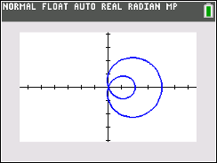  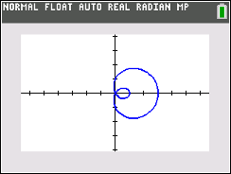  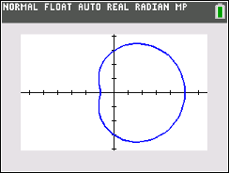  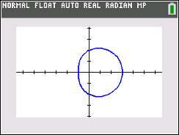  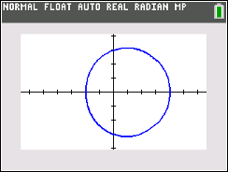
  Limaçon | $$a$$ | $$b$$ | $$\frac{a}{b}$$
  $$i) r1=1+3*cos\left(θ\right)$$ | 1 | 3 | 0.333
  $$ii) r1=1+2*cos\left(θ\right)$$ | 1 | 2 | 0.5
  $$iii) r1=3+2*cos\left(θ\right)$$ | 3 | 2 | 1.5
  $$iv) r1=2+1*cos\left(θ\right)$$ | 2 | 1 | 2
  $$v) r1=3+1*cos\left(θ\right)$$ | 3 | 1 | 3
Teacher Tip: The purpose of these graphs is for students to see how the values of a and b affect the graph of the limaçon. You may want the students to graph some of these with the sine function. The cosine function was used because the graph fits better on the Zoom Decimal window.

- The graph of the sinusoidal function $f\left(x\right)=2+2*sin\left(x\right)$ is shown below. The x-scale for the gridlines is π/6.

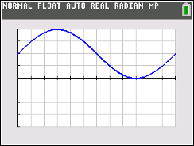

Graph the limaçon given by $r1=2+2*sin\left(θ\right)$. Press yq to access format. In the first row, use the right arrow to highlight PolarGC and press Í. Press r and then the right arrow to move your cursor. Observe the change in the r and θ values.
On the interval from x = 0 to x = 2π of the sinusoidal function, the maximum occurs at $x=\frac{π}{2}$ and the minimum occurs at $x=\frac{3π}{2}$.
How do the $y-$values at these two points correspond to the $r-$values on the cardioid?

Answer: The maximum of the sinusoidal function graph is located at the point $\left(\frac{π}{2},4\right)$ and this point corresponds to the point on the cardioid that is furthest from the pole. The minimum of the sinusoidal function graph is located at the point $\left(\frac{3π}{2},0\right)$ and this corresponds to the point at the pole.

- The graph of the sinusoidal function $f\left(x\right)=1+2*sin\left(x\right)$ is shown below. The x-scale for the gridlines is π/6.

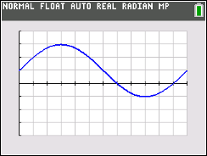

Graph the limaçon given by $r1=1+2*sin\left(θ\right)$. Press r and then the right arrow to move your cursor. Observe the change in the r and θ values. Explain why the polar curve $r=1+2sin\left(θ\right)$ has an inner loop in the interval $\frac{7π}{6}≤ θ ≤\frac{11π}{6}.$

Answer: The graph of the sinusoidal function has negative y-values in the interval $\frac{7π}{6}< θ<\frac{11π}{6}$. These correspond to the negative r-values of the polar function and form the inner loop of the limaçon. The limaçon graph passes through the pole at $θ=\frac{7π}{6}≈3.665…$ and $θ=\frac{11π}{6}≈5.759….$

Teacher Tip: While tracing around the limaçon, $r=0$ may not appear. Mention that a display of a value such as R = 7.252E-10 is approximately zero.

- The graph of the sinusoidal function $f\left(x\right)=2+1*sin\left(x\right)$ is shown below. The x-scale for the gridlines is π/6.

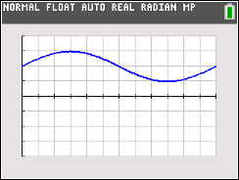

Graph the limaçon given by $r1=2+1*sin\left(θ\right)$. Press r and then the right arrow to move your cursor. Observe the change in the r and θ values. Explain why the polar curve does not contain the point located at the pole.

Answer: The graph of the sinusoidal function has positive y-values for the entire interval $0≤ θ ≤2π$. These correspond to the positive r-values of the limaçon. Since $r≠0$, the limaçon does not pass through the pole.

Wrap Up
Upon completion of the discussion, the teacher should ensure that students understand:
- The general form of the equation for polar limaçon curves.
- How each of the parameters of the equation affects the graph of the limaçon curve.
- That the type of limaçon curve can be determined by the ratio of a and b.
- There are four different shapes of limaçon curves.
- How the equation of a limaçon curve is related to the equation of a sinusoidal function.

