Focus: Show a number pattern by skip counting.
Vocabulary
Write the meaning of the words.
Skip counting __________________________________________________
Pattern
__________________________________________________

Use the hundred chart.
Skip count by 5s to 100.
Color the count by 5 numbers on the hundred chart.
The first row is done.
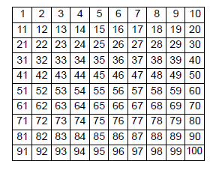
Write the numbers you colored.

_____, _____, _____, _______, _____, _______,

_____, _____, _____, _______, _____, _______,

_____, _____, _____, _______ _____, _____, _____, _____
Using the calculator
Use the TI-10 (or TI-15) to show skip counting by 5s.
Press 0 + 5 =
Write what the TI-10 shows.

Press + 5 =
Write what the TI-10 shows.

Keep pressing + 5 = until you get a sum of 100.
Write the sums that the TI-10 shows.

_________________________________________________

Compare the pattern from question 1 to the pattern in
question 5. What do you see?

_________________________________________________

