Select the F2 @ key and ; to select a triangle.

Use the : and ; keys to move the pencil to the lower left of the screen. Press e to establish the first vertex of the triangle and > until you have the first side of the triangle drawn as a horizontal line. Press e to establish the second vertex.

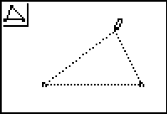

Move the : and < and e to establish the third vertex. Press the C key to stop drawing a triangle.

Select F5 % and use the : or ; to select Measure. Use the > and ; to select the Area. You should note the change in the icon in the upper left corner of the screen indicates units of area measure. The segments of the triangle will be “twinkling”.

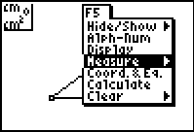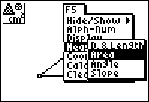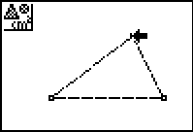

Press e and the area of the triangle will appear held by the “hand”. Use the : and < to move the area measurement above the figure.

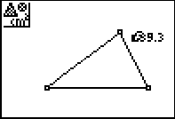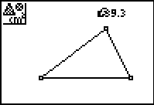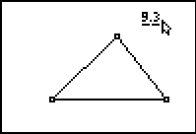

When you have a location that is outside the triangle, press the C twice to end this task.

Move the pointer to the vertex at the top of the triangle (it will twinkle) and press the green a key to “grab” the top vertex.

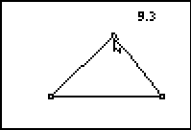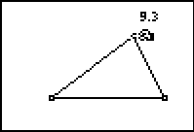

Use the > and < keys to move the vertex back and forth horizontally and watch what happens to the area of the triangle.

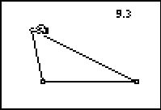

What changes and what stays the same?

__________________________________________________________________________________________________________

Use the : and ; keys to move the vertex vertically and watch what happens to the area of the triangle.

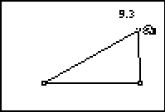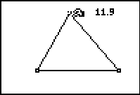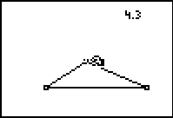

What changes and what stays the same?

__________________________________________________________________________________________________________________

Explain why the area changes sometimes but not all the time when you move the top vertex.

__________________________________________________________________________________________________________________

EXTENSION: Test Your Conjecture

Use the construction tool F3 # to construct an altitude or height to the base of the triangle using a perpendicular line construction.

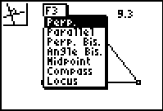

Select the point through which the perpendicular is to go and select the base to which it is to be constructed.

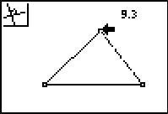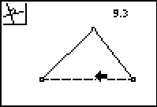

Use F2 @ and put the point of intersection on the base of the triangle. (Both the perpendicular line and the base segment of the triangle should twinkle before you press e.)

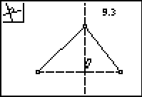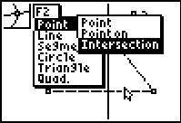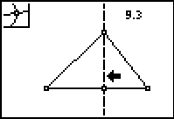

Use the measurement tool in F5 % and measure the length of this altitude and the length of the base of the triangle. Be certain to highlight the endpoints of the segments to measure.

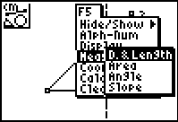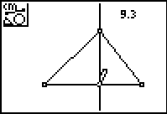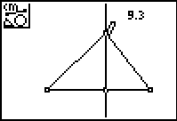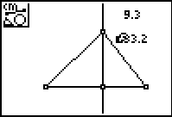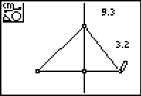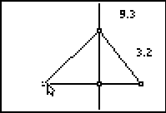
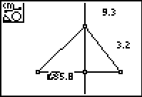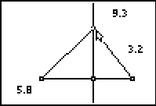

Press C.

Grab the top vertex of the triangle as in the earlier part of the exercise.

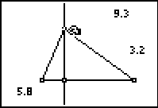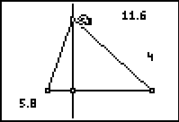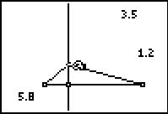

Describe what happens to the area, height and base as you move the vertex vertically and horizontally.
________________________________________________________________________________________________________________________________

Were your conclusions correct about why area changes sometimes but not always?

Did this test confirm your conjecture? ________________________________________________________________________________________________________________________________

Use what you have learned to answer the following questions.

43. A triangle is inscribed in a square, as shown below.

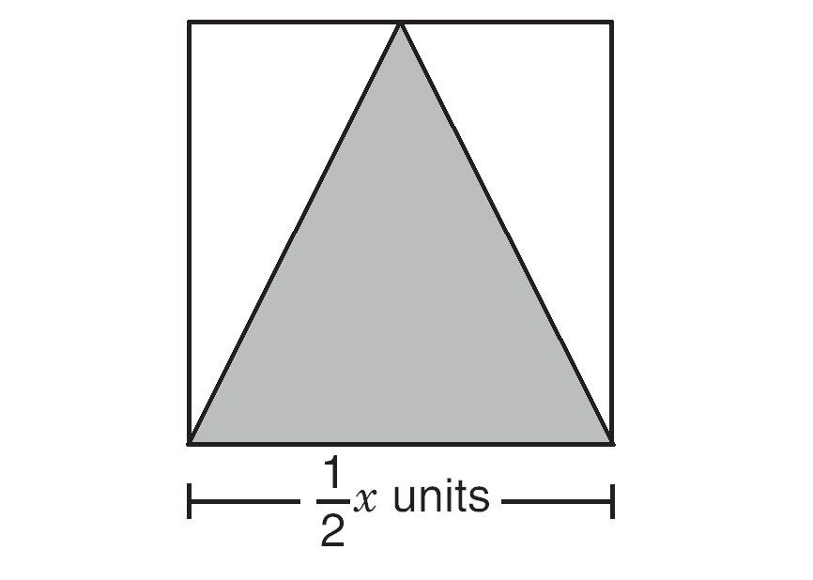

What is the area of the shaded triangle inscribed in the square?

