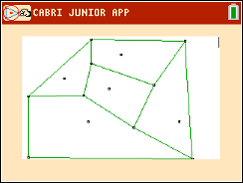
Math Objectives
- Students will create Voronoi Diagrams and apply them
to real world situations.
- Students will draw triangles and find their
circumcenters using perpendicular bisectors.
- Connect the use of Voronoi Diagrams with finding the
Equations of lines in the form ax + by + c = 0 form,
Where a, b, and c are all integers.

Vocabulary
- Voronoi Diagrams • circumcenter • seeds
Tech Tips:
- This activity includes screen captures taken from the TI-84 Plus CE. It is also appropriate for use with the rest of the TI-84 Plus family. Slight variations to these directions may be required if using other calculator models.
- Watch for additional Tech Tips
throughout the activity for the specific technology you are using.
- Access free tutorials at
http://education.ti.com/calculato rs/pd/US/Online- Learning/Tutorials
- Any required calculator files can
be distributed to students via handheld-to-handheld transfer.
- perpendicular bisector • Delaunay Triangulation

About the Lesson
- This lesson involves the creation and application of Voronoi
Diagrams in IB Mathematics Applications and Interpretations.
- This falls under the IB Mathematics Core Content Topic 3
Geometry and Trigonometry:
3.6 Voronoi Diagrams, sites, vertices, edges, cells
- As a result, students will:
- Perform Delaunay Triangulation given a set of coordinates or
seeds.
- Find the circumcenter of each triangle created, using
perpendicular bisectors.
- Use the circumcenters to separate regions or cells in the
Voronoi Diagram.
- Apply Voronoi Diagrams to real world situations.
Lesson Files:
- Voronoi_Diagrams_Student_Activity-84.pdf
- Voronoi_Diagrams_
Student_Activity-84.doc

Teacher Preparation and Notes
- This activity is done mainly by hand, but uses the TI-84 family as an aid to the problems. If you are skilled at using Cabri Jr. you can also share with the students how to create a Voronoi Diagram in the handheld.
- Students will need a ruler and pencil to complete the activity. Having colored pencils when the Voronoi Diagram is created will help distinguish the cells that are created

Activity Materials
- Compatible TI Technologies: TI-84 Plus*, TI-84 Plus Silver Edition*
TI-84 Plus C Silver Edition, TI-84 Plus CE
* with the latest operating system (2.55MP) featuring MathPrint TM functionality.

Problem 1 – The Circumcenter

1. Define a circumcenter.

Sample Answers: The circumcenter is the center of a triangle's circumcircle, the circle that contains all the vertices of the polygon, if such a circle exists. It can be found as the intersection of the perpendicular bisectors. This is the backbone of the Voronoi Diagram.

2. Follow the directions below to create a circumcenter in the space provided.

Step 1: With a ruler, create a triangle using three segments.
Step 2: With a ruler, find the midpoint of each side of the triangle.
Step 3: With a ruler, draw a perpendicular line (perpendicular bisector) through each of the midpoints.
Step 4: Place a point on the intersection of the three perpendicular bisectors.

Sample Answer:

3. Discuss with a classmate what you have made and what possible uses there may be outside of the math classroom.

Sample Answer: There are three cities, and you want to build a factory in a location that is equidistant from all three. Draw a triangle connecting those cities on a map, and the circumcenter is the point that is equidistant from all three.

Problem 2 – Equations of Lines
Another skill we will need to review is finding the equation of a line given two points.

1. On the graph below, select three coordinate pairs, (x, y), and plot them. Connect the points and create a triangle.

Sample Answer:
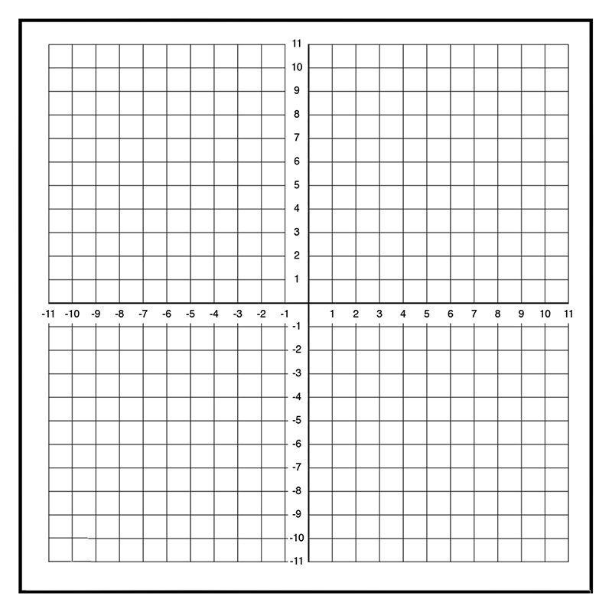

2. You have now created a triangle using 3 coordinates. Find the equation of each line that would pass through each side using the coordinates you selected. Write your equations in the form ax + by + d = 0 where a, b, d ∈ ℤ.

Answer: There will be many possible answers to this questions. Students must find the slope between any of the two points they selected and then find the equation of this line. An example would be between points (2, 1) and (4, 5). Using the slope formula m = (y₂ – y₁) / (x₂ – x₁), to get a slope of 2. Then students will plug this into either slope intercept or point slope form to find an equation, such as (y – 1) = 2(x – 2) and then converting this to standard form of 2x – y – 3 = 0.

Problem 3 – Sample Voronoi Diagram

1. Let us now practice by creating your own Voronoi
Diagram on the following coordinate plane. Follow the directions below.

Step 1: Space out five (5) random points on the coordinate plane.

Sample points: (5, 7), (1, 1), (7, -3), (-3, -2), (-5, 5)

Step 2: Connect each of the five points creating triangles. Do not cross any of the lines.

Step 3: With a ruler, find the midpoint of each side of each triangle.

Step 4: With a ruler, draw a perpendicular bisector through each of the midpoints.

Step 5: Draw a point at each of the circumcenters.

Step 6: Connect the circumcenters with segments. There should be three line segments coming from each circumcenter. The third line may not connect to another circumcenter but may be drawn along one of the perpendicular bisectors.

Sample Answer:
2. Discuss with a classmate what you have created. Give several examples of what you think the singular point located in each region you created represents.

Sample Answers: The points or seeds that you have created can represent school buildings, hospitals, airports, fire stations, etc., and how they are placed in certain locations around cities, towns, etc.

Application

1. There are five hospitals, A, B, C, D, and E in the city. The coordinates of the hospitals are A(2, 3), B(1, -1), C(5, 4), D(3, 1), and E(4, -2). In order for each hospital to accommodate an equal amount of the population, how should the city be divided into regions so that there is one hospital in each region and this hospital is centrally located for each region? Use the graph paper below to answer this problem.

Sample Answer:

2. Explain why or why not the location (1, 6) would be a good choice for the city to add another hospital.

Sample Answer: This question is meant to encourage discussion on why this point would or would not be a good choice. Students could talk about population sizes, where that population is spread in different regions, and why this region (or others) may be better.

**Note: This activity has been developed independently by Texas Instruments and aligned with the IB Mathematics curriculum, but is not endorsed by IB™. IB is a registered trademark owned by the International Baccalaureate Organization.

