Math Objectives  - Students will use the second derivative test to find and verify maxima and minima in word problems.  - Students will solve optimization in functions and further explore, as time and teacher permit, using parametric functions as well.  - Students will try to make a connection with how to understand these topics in IB Mathematics courses and on their final assessments.  Vocabulary  - Maximize • Minimize • Constraint  - Critical Points  About the Lesson  - This lesson is aligning with the curriculum of IB Mathematics Applications and Interpretations SL/HL and IB Mathematics Approaches and Analysis SL/HL (further focus on HL)  - This falls under the IB Mathematics Content Topic 5 Calculus:  AI 5.7: (a) Optimization problems in context.  AA 5.8: (a) Local maximum and minimum points.  (b) Testing for maximum and minimum points.  (c) Optimization  As a result, students will:  - Apply this information to real world situations.  TI-Nspire™ Navigator™  - Transfer a File.  - Use Class Capture to examine patterns that emerge.  - Use Live Presenter to demonstrate.  - Use Teacher Edition computer software to review student documents.  - Use Quick Poll to assess students’ understanding  Activity Materials  Compatible TI Technologies: TI-Nspire™ CX Handhelds,  TI-Nspire™ Apps for iPad®, TI-Nspire™ Software | 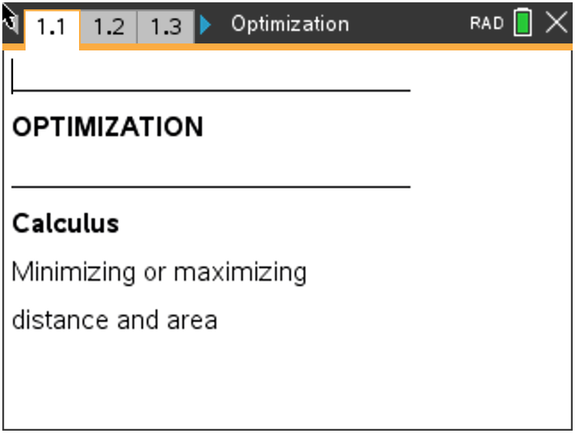  Tech Tips:  - This activity includes screen captures taken from the TI-Nspire CX II handheld. It is also appropriate for use with the TI-Nspire family of products including TI-Nspire software and TI-Nspire App. Slight variations to these directions may be required if using other technologies besides the handheld.  - Watch for additional Tech Tips throughout the activity for the specific technology you are using.  - Access free tutorials at http://education.ti.com/calculators/pd/US/Online-Learning/Tutorials  Lesson Files:  Student Activity  Optimization-Student-Nspire.pdf  Optimization-Student-Nspire.doc  Optimization.tns  Optimization_Soln.tns
In this activity, students will learn how to use the second derivative test to find maxima and minima in word problems and solve optimization in functions and parametric functions. Students will be finding a function’s critical points by hand and through the handheld.

Open the file Optimization.tns to help guide you through this activity.
Teacher Tip: Although there is a file to download to the handheld, this activity can be done without it. The file does provide helpful visuals at times, but this can activity can also be done with the students creating their own pictures/diagrams.

Move to page 1.2.
Problem 1 – Optimization of distance and area

On page 1.3, graph the line y = 4x + 7. Place a point on the line and then construct a segment from the point to the origin. Discuss with a classmate how you would find the length of the segment and the coordinates of the point.
1. Explain what point you think minimizes the distance from the point to the origin.
Possible Discussion: Students should discuss how the segment connecting the origin and the line should be perpendicular for the shortest distance.
2. State the function you are trying to minimize.
Solution: $d= \sqrt{x^{2}+ y^{2}}$

3. State the constraint.
Solution: $y=4x+7$

4. Write the function to minimize using one variable.
Solution: $d= \sqrt{17x^{2}+56x+49}$

On page 1.8, find the exact coordinates that minimize the distance using the Derivative and Numerical Solve commands. To do this, find the first derivative, solve to find the critical value(s), and then find the second derivative to confirm a minimum.
5. Find the x- and y-coordinates of the point.
Solution: $\left(\frac{-28}{17}, \frac{7}{17}\right) or (-1.65, 0.412)$
6. Find the minimum distance.
Solution: $\frac{7\sqrt{17}}{17} ≈1.698$

Teacher Tip: This is an excellent moment to select one or more students to demonstrate the use of the Derivative (menu, Calculus, Derivative, or use the math template button) and Numerical Solve (menu, Algebra, Numerical Solve) commands as the presenter. If the CAS version of the handheld is use, the Solve command can be used. Students can also demonstrate the use of the Function Minimum/Maximum (CAS) or the Numerical Function Minimum/Maximum (non-CAS) to help as well.

Your goal in this next part is to find the dimensions of a rectangle with perimeter 200 meters whose area is as large as possible.
On page 1.12, construct a rectangle and use the Length tool to find the perimeter. Adjust the size of the rectangle until the perimeter is 200 m. Then, use the Attributes tool to lock the measurement of the perimeter.
Teacher Note: There may need to be some demonstration needed if the Length and the Attributes tools have not been used before.

7. State the dimensions that you think maximize the area.
Solution: Student answers may vary, but make sure this generates discussion on the
possibilities.
8. State the function you are trying to maximize.
Solution: $A=l ∙w$
9. State the constraint.
Solution: $2l+2w=200$
10. Write the function to maximize using one variable.
Solution: $A=100w- w^{2}$
Find the dimensions that maximize the area using the Derivative and Numerical Solve commands.
11. Find the dimensions of the rectangle.
Solution: $50 m by 50 m$

Move to page 2.1.

Problem 2 – Optimization of time derivative problems (HL only)

A boat leaves a dock at 1 pm and travels north at a speed of 20 km/h. Another boat has been heading west at 15 km/h. It reaches the same dock at 2 pm. Your goal is to find the time when the boats were closest together. Use t for time.

12. Find the position function for the boat heading north.
Solution: $y=20t$
13. Find the position function for the boat heading west.
Solution: $x=15-15t$

Teacher Note: Some time may need to be spent on how these two parametric equations were created with respect to the given information.

14. State the function you are trying to minimize.
Solution: $d= \sqrt{x^{2}+ y^{2}}$

15. State the constraints.
Solution: $x=15-15t and y=20t$
16. Write the function to minimize using one variable.
Solution: $d= \sqrt{{\left(15-15t\right)}^{2}+ {\left(20t\right)}^{2}}$
17. State why there is a domain restriction.
Solution: $0<t<1$ because the boats are only moving for 1 hour.

Find the time at which the distance between the two boats is minimized using the Derivative and Solve commands.
18. Find the minimum distance.
Solution: 12 km

19. Find the time at which this occurs. Remember to convert the value of t to minutes.
Solution: 21.6 minutes after 1 pm, or about 1:22 pm

Teacher Tip: Problem 2 is a great place to have some student lead discussion and listen to their thoughts and explanations about parametric equations and optimization.

Extension – Parametric function (HL only)
A projectile is fired with the following parametric functions:
x = 500cos(30°)t, y = 500sin(30°)t – 4.9t ²
Teacher Note: Make sure students graph these parametric equations and have an accurate window to help find the solutions in this problem.

20. Find the time when the projectile hits the ground.
Solution: t ≈ 51.02

21. Find how far the projectile travels horizontally.
Solution: 22,092.48 units

22. Find the maximum height that the projectile achieves.
Solution: 3,188.78 units

Further IB Application

A company selling frozen concentrated orange juice needs to manufacture a can that will save them money. This cylinder shaped can will be modelled after the image below where r represents the radius of the circular base and h represents the height of the can.
Diagram not to scale.
r

h

The sum of the radius and height for this cylinder needs to be 20 cm. The company is trying to maximize the area of the curved surface.

(a) Find an equation for the area of the curved surface in terms of the radius (r).
Solution: $A=2πr\left(20-r\right) or A=40πr-2πr^{2}$

(b) Find any critical points of the equation you found in part a. Verify if these critical points are local
minimums or maximums.
Solution: $\frac{dA}{dr}=40π-4πr$
$0=40π-4πr$
$r=10$ (student can use the first and second derivative tests to verify)

(c) Find the maximum area of the curved surface.
Solution: $r=10$
$A=2π(10)(20-10)$
$A=200π or 628.3185…or 628 {cm}^{3}$

TI-Nspire Navigator Opportunity: Quick Poll (Open Response)
Any part to any Problem in the activity would be a great way to quickly assess your student’s understanding of optimization.

Teacher Tip: Please know that in this activity there is a lot of time dedicated to students talking with one another and sharing their thoughts with the class. The goal here is to not only review and apply optimization, but also to generate discussion.

**Note: This activity has been developed independently by Texas Instruments and aligned with the IB Mathematics curriculum, but is not endorsed by IB™. IB is a registered trademark owned by the International Baccalaureate Organization.

