UNDERSTANDING CONFIDENCE INTERVALS

Robert Lochel
Hatboro-Horsham High School
Horsham, Pennsylvania 19044

OBJECTIVE: Confidence Intervals are integral in the study of statistics. The correct interpretation of a confidence interval is often a trouble spot in AP Statistics. The objective of this activity is to provide a visual understanding of confidence intervals, when every student contributes their own result.

MATERIALS: Each student should receive supply of M&M’s. Purchasing large bags, and having students count out 100 candies will work. Providing each student with a small pack is also acceptable. Also, each student should be provided a student number, starting at 1 and going until every student has a number.

ACTIVITY CENTER SETTINGS: The x-axis counts from .01 to .5, counting by .001. The y-axis counts from -1, up to 25 (this can be adjusted, depending on the size of the class). Also, under “view”, the “show x= entry” should be selected. Students should be able to contribute 2 points. On the y-axis, the step size is 1, while on the x-axis, the step size is .001. These settings are included in the file “RLochel_activity_2B”

PROCEDURE:

Before the activity, use quick poll to gather information, and start the discussion:

- In the population of all (regular) M&M’s, what proportion do you believe are blue?
- Use the strongly agree – agree - …. Feature to gather responses to the statement “I believe my guess is close to the actual proportion”

The next step is for each student to gather data, based on their sample of M&M’s. Two numbers must be recorded: the total # of M&M’s in the sample, and the number of blue M&M’s.

Discuss the proportion (# of blue) / (# of candies) as a point estimate for the population proportion, and why it may or may not be an accurate estimator of the population.

A discussion of the concept of a confidence interval should then follow, and each student should compute their 95% confidence interval in one of two ways:

- If this is a new concept, step students through the formula

$p±2\sqrt{\frac{p\left(1−p\right)}{n}}$, where p is our sample proportion of blue M&M’s

- If students have been exposed to the confidence intervals of the TI calculators, use the One-Proportion Z-interval function, under the stats, tests menu.

ACTIVITY CENTER:

The activity center will be used to allow students to contribute endpoints of their confidence interval, allow the class to view all of the intervals, and finally discuss the significance of these intervals.

Use the file RLochel_activity_2B to load the settings. When the activity starts, students will be able to contribute 2 points to the coordinate axis. Recall that all students need to be given a unique student number, which will be used here. The two points each student will contribute should have the form:
( left endpoint of CI, student number ) and ( right endpoint of CI, student number )

A sample of student-contributed points is given here:
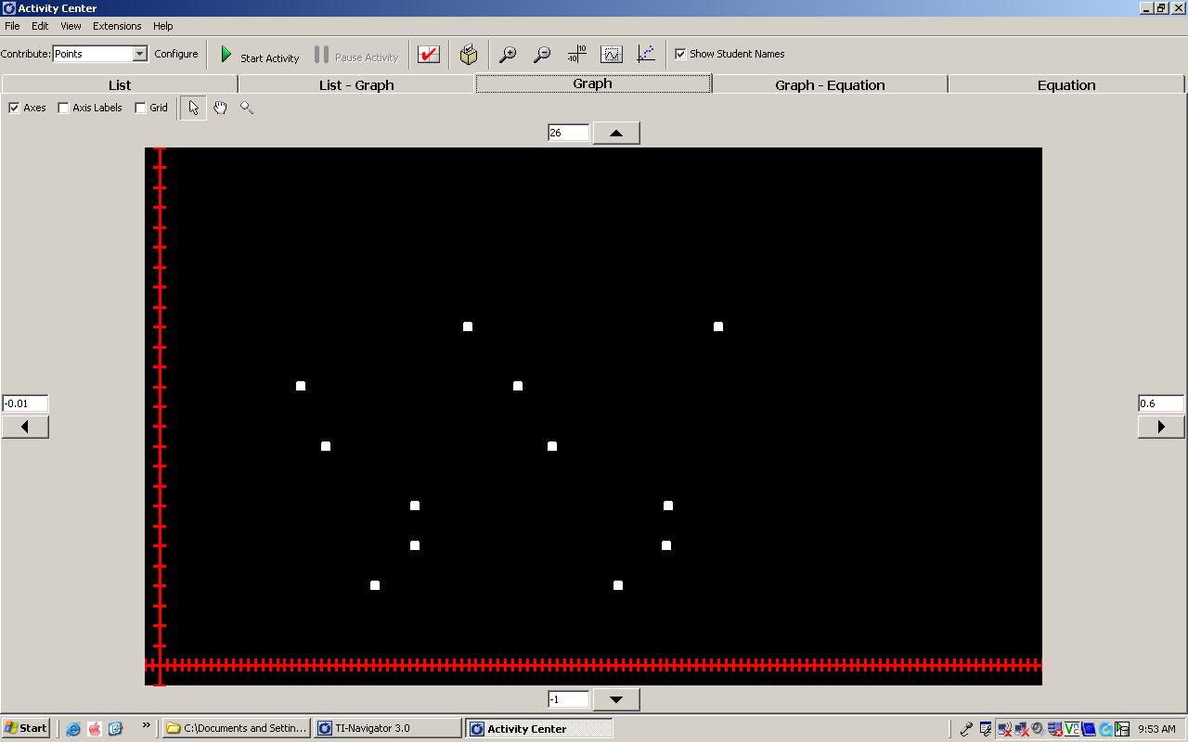
As students complete their intervals, lead a discussion regarding observations. Some points of discussions should be:

- Is there any common overlap with all of the intervals?
- Comment on the widths of these intervals.
- Are we confidence that these intervals provide an accurate estimate for the population proportion of blue M&M’s?

Re-do the quick-poll questions from earlier, this time armed with our new information. It may be difficult for students to identify the x-axis landmarks, so using the graph feature to include vertical lines at .10, .20, .30, .40, etc might be helpful.

- In the population of all (regular) M&M’s, what proportion do you believe are blue?
- Use the strongly agree – agree - …. Feature to gather responses to the statement “I believe my guess is close to the actual proportion”

Finally, we can include the actual population proportion (which is 24%, from mms.com) in our activity by using the graph-equation feature:

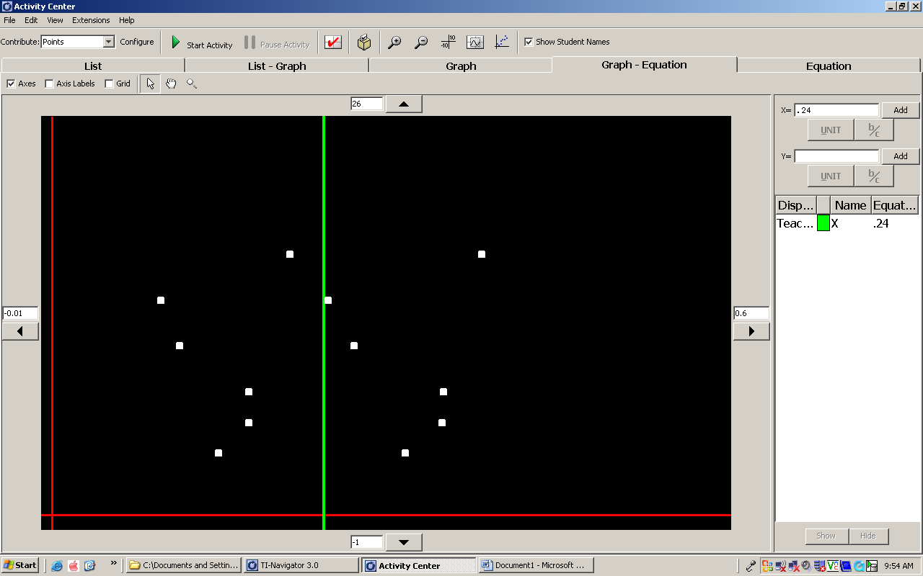

INTERPREATATION OF CONFIDENCE INTERVALS

How many of the student-generated CI’s capture the true population proportion? At this point, it is important to stress that approximately 95% of intervals constructed in this manner will capture the population proportion. Certainly, this activity will work better with larger classes (20-30), but could also work for smaller classes, if each student were 2 intervals from independent sample.

