Algebra -- Transformations

Sketch the graph of y = x² Sketch the graph of y = x²
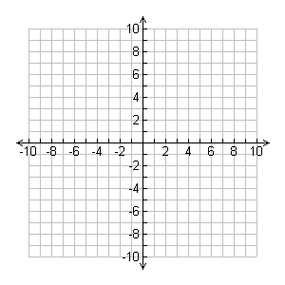
shifted right 4 units. Shifted left 5 units.

Now predict the equation that will give you the above graphs.

____________________________ _____________________________

Verify using the graphing calculator.

Sketch the graph of y = x² reflected over the x-axis.

Predict the equation that will give you this graph.

_________________________________

Verify with the graphing calculator.

