Graph the function y = 2x³ – 5x – 3 by pressing  and entering it next to Y1. Press  and select ZStandard.  Use the ZBox command to take a closer look at the zeros.  Calculate the zero appearing to pass through the point (2, 0) by pressing  [Calc] and selecting zero.  Now, use the arrow keys to move the cursor to  - the left of the zero and press   - the right of the zero and press   - the guess of the zero’s location and press   Repeat this procedure for the other zero appearing on the graph. Record your calculated zeros in the table below. | 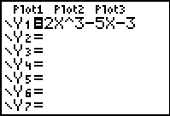  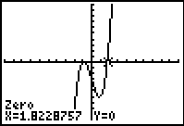
Use the graphing procedure to find the zeros for the other two functions listed in the table below.
Function | Zeros
Y1 =
Y2 =
Y3 =
What do the graphs have in common?

Repeat the procedure of graphically finding the zeros for the functions below.
Function | Zeros
Y4 =
Y5 =
Y6 =
What do the graphs have in common?
Run the program RATRACE by pressing  and selecting it.  - Enter the number 10. Press   to see the entire list. What does the output describe? | 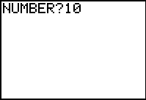
Enter the leading coefficient (2) and constant term (3) from the first function of this activity, .
- Can any combination of the values in these two sets produce a zero of the function? If so, what is the zero?  To test if a value results in a zero, press , arrow to the Y-VARS menu and select Y1. Enter the value as shown at the right. | 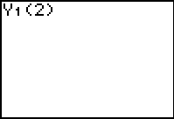
- Use the program to work through the other two equations in the first table entering the leading coefficient and the constant term. Try to find a general formula for determining a zero.

- Now use the program to work through the equations in the second table. Can any combination of the values in these two factor-sets produce a zero of the function? If so, what is the zero?

- When does the function have a zero but the sets do not produce one?

