Algebra Date _____ Hour ____ Name _____________________________

Croquet Game

1) Objective: On the next page, a croquet course is shown. Your goal is to find the nine linear equations on which the ball must travel to move from one wicket to the next. You may use this sheet for your calculations.

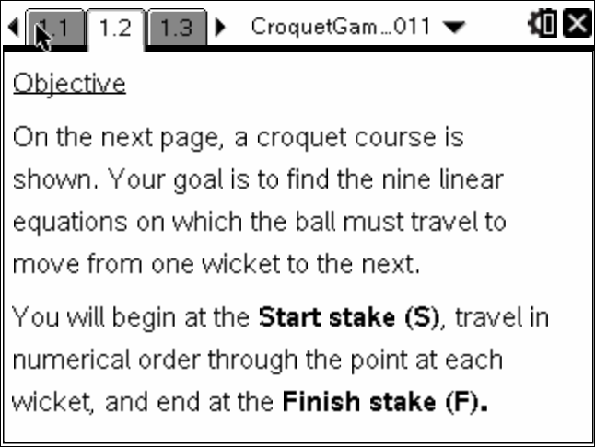 | 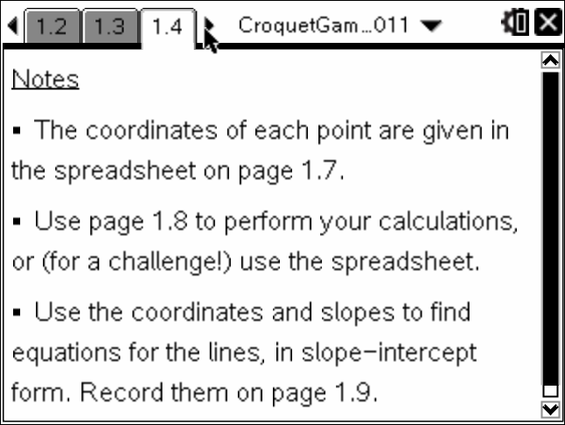
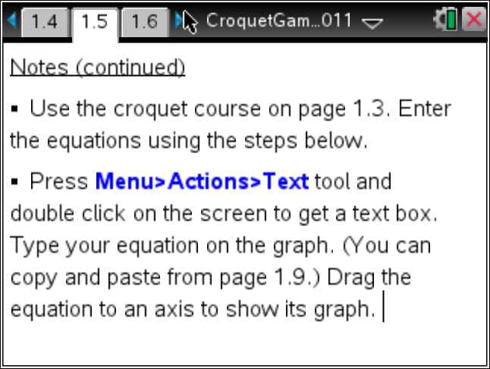 | 