Vocabulary  tiling:  unit square: | In this activity, you will use unit squares to name fractions and generate equivalent fractions.
Vocabulary  tiling:  unit square: | 1. Suppose you shaded unit squares to show an area representing and an area representing . Explain by reasoning about the fractions and the unit squares which is larger and why.
Vocabulary  tiling:  unit square: | 2. Make a prediction about an equivalent fraction for whose denominator is 12. Use the activity to verify your prediction.  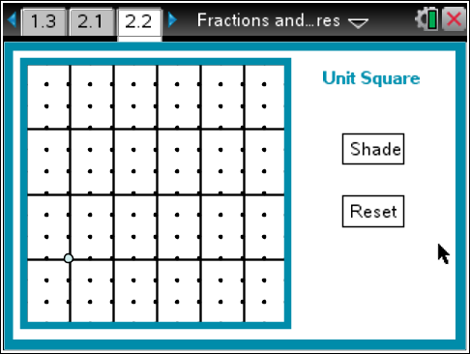
3. Shade 4 of the triangles. Give two names for the fraction of the unit square represented by the shaded area.
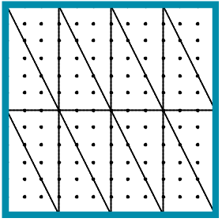

4.  Can be equivalent to some fraction with a denominator of 12? Explain your reasoning.

