In this activity, you will investigate the effect of changing the values of a and b in the polar equations $r=a±b*sin\left(θ\right)$and $r=a±b*cos\left(θ\right)$, where $a>0$ and $b>0$. You will also explore the relationship between the polar curve $r=a±b*sin\left(θ\right)$ (or $r=a±b*cos\left(θ)\right)$and the sinusoidal function $f\left(x\right)=a+b*sin\left(x\right)$ (or $f\left(x\right)=a±b*cos\left(x\right)$). | 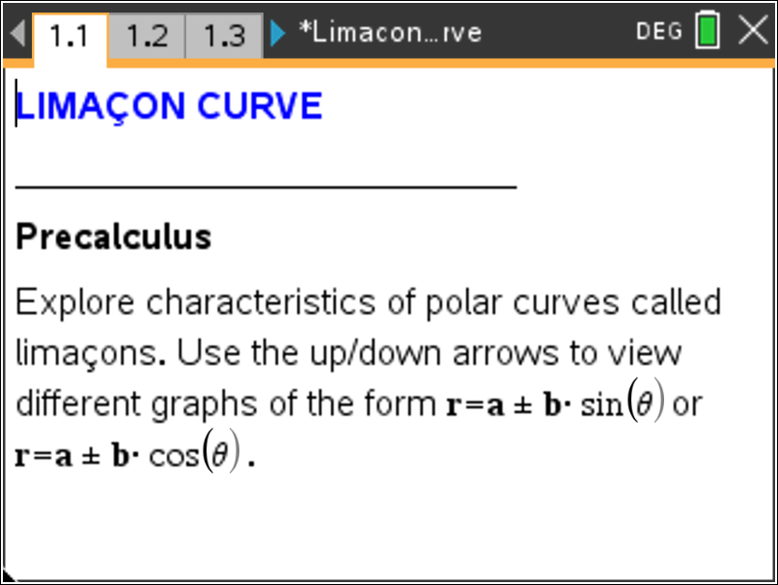
Polar curves called limaçons have equations of the form $r=a±b*sin\left(θ\right)$ or $r=a±b*cos\left(θ\right)$. On page 1.2 are special kinds of limaçon graphs called cardioids. Use the up/down arrows to see all the graphs.

Move to page 1.2.
- Why do you think these graphs are called cardioids?

- What similarities do you notice about the equations of the six graphs?

- How do the addition and subtraction signs affect the graphs?

Move to page 1.3.

Use the up/down arrows to see all the graphs.

- How are the equations different from those on page 1.2? How does this difference affect the graph?

Limaçons have different shapes depending on the ratio $\frac{a}{b}$. We have already seen the cardioid graph that is the result when $a=b$ (or $\frac{a}{b}=1$).

Move to page 1.5.

Graph the polar functions shown in the table by changing $a$ and $b$. Complete the table with the values of $a$, $b$, and $\frac{a}{b}$ as you observe each graph. Use the up/down arrows to change the values of $a$ and $b$.

Limaçon | $$a$$ | $$b$$ | $$\frac{a}{b}$$
$$i) r1=1+3*cos\left(θ\right)$$
$$ii) r1=1+2*cos\left(θ\right)$$
$$iii) r1=3+2*cos\left(θ\right)$$
$$iv) r1=2+1*cos\left(θ\right)$$
$$v) r1=3+1*cos\left(θ\right)$$

- Some of the limaçons in the table above have the ratio $\frac{a}{b}<1$. Write an equation of another polar curve for which $\frac{a}{b}<1$. Graph your limaçon and describe the shape of the limaçon.

- One of the polar curves in the table above has a ratio which satisfies $1<\frac{a}{b}<2$. Write an equation of another polar curve for which $1<\frac{a}{b}<2$. Graph your limaçon and describe the shape of the limaçon.

- Some of the limaçons in the table above have the ratio $\frac{a}{b}>2$. Write an equation of another polar curve for which $\frac{a}{b}>2$. Graph your limaçon and describe the shape of the limaçon.

Move to page 2.2.

- The graph of the sinusoidal function $f\left(x\right)=2+2*sin\left(x\right)$ on the interval $0≤x≤2π$ is shown below. The x-scale is π/6.

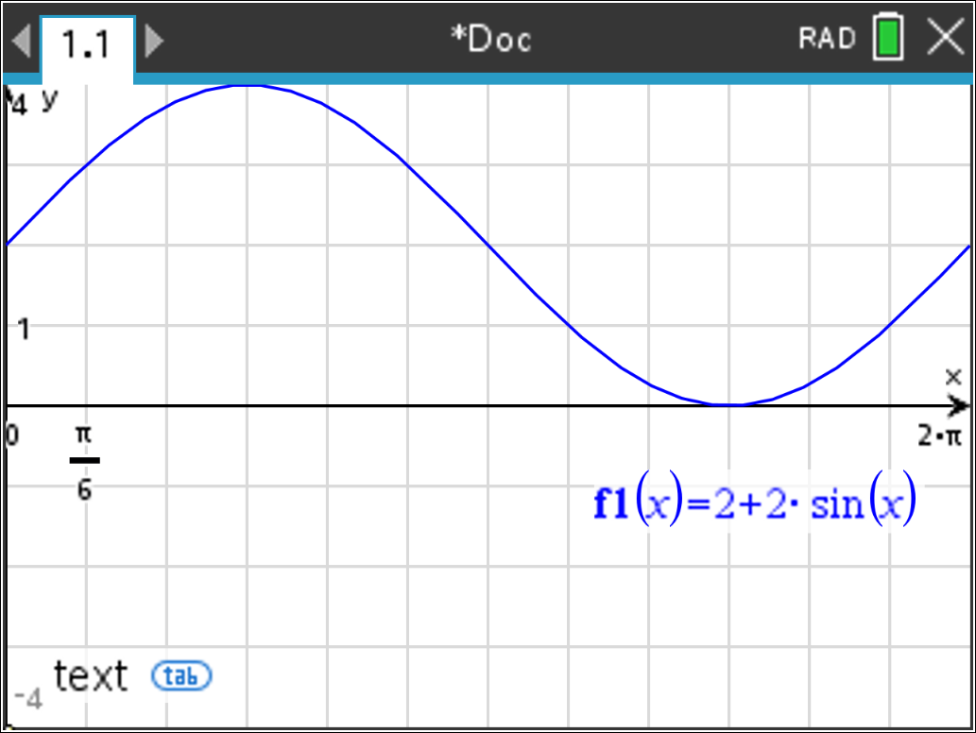

Graph the limaçon given by $r1(θ)=2+2*sin\left(θ\right)$. Press b and select 3 Graph Entry/Edit and then 5 Polar. Now press b and select 5 Trace and then 1 Graph Trace. Use the right arrow to move your cursor. Observe the change in the r and θ values.
On the interval from x = 0 to x = 2π of the sinusoidal function, the maximum occurs at $x=\frac{π}{2}$ ($≈1.6 rad)$and the minimum occurs at $x=\frac{3π}{2}$ ($≈4.7 rad).$
How do the $y-$values at these two points correspond to the $r-$values on the cardioid?

- The graph of the sinusoidal function $f\left(x\right)=1+2*sin\left(x\right)$ on the interval $0≤x≤2π$ is shown below. The x-scale is π/6.

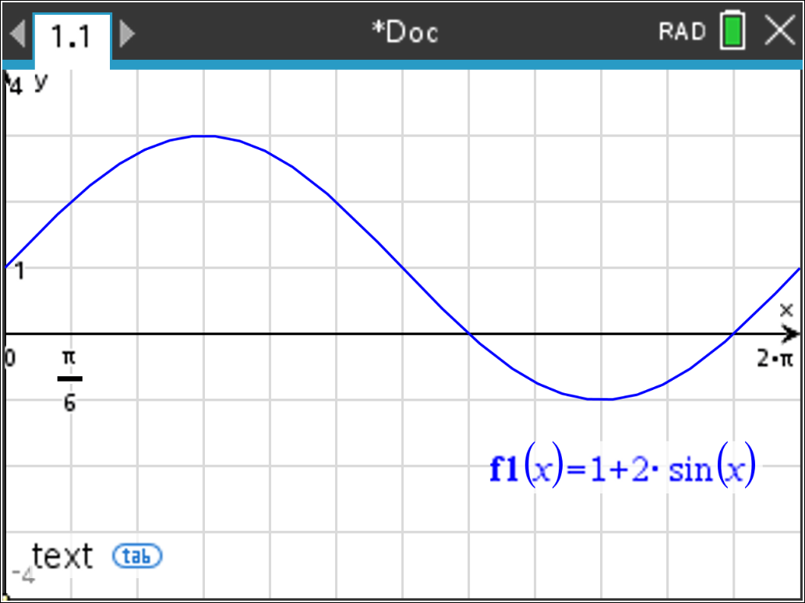

Graph the limaçon given by $r1(θ)=1+2*sin\left(θ\right)$. Trace along the graph of the limaçon. Observe the change in the r and θ values. Explain why the polar curve $r=1+2sin\left(θ\right)$ has an inner loop in the interval $\frac{7π}{6}≤ θ ≤\frac{11π}{6}$ ($θ$ between $≈3.7 rad$ and $≈5.7 rad)$.

- The graph of the sinusoidal function $f\left(x\right)=2+1*sin\left(x\right)$ on the interval $0≤x≤2π$ is shown below. The x-scale is π/6. 2+2*sin

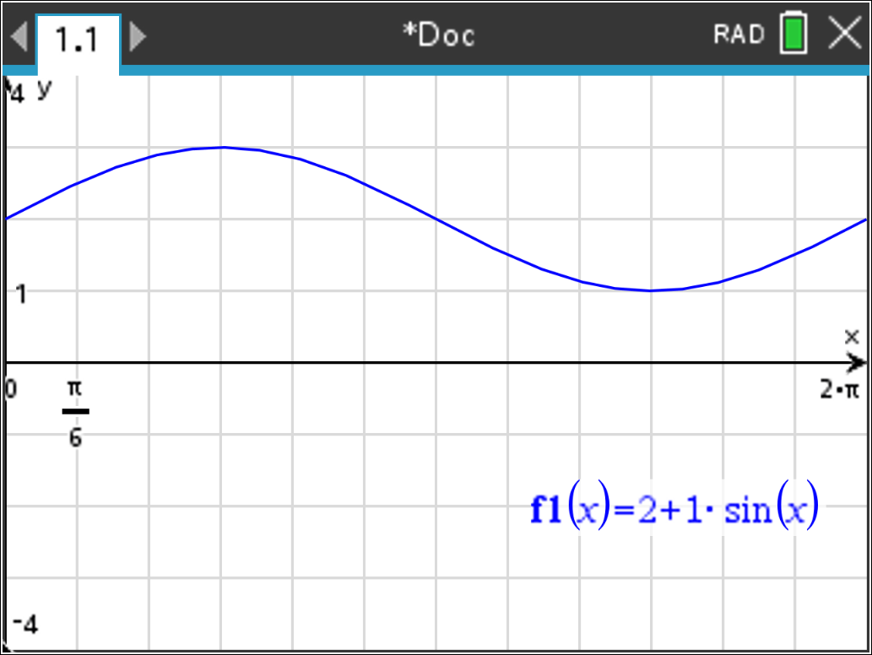

Graph the limaçon given by $r1(θ)=2+1*sin\left(θ\right)$. Trace along the graph of the limaçon. Observe the change in the r and θ values. Explain why the polar curve does not contain the point located at the pole.

