Problem 1 – One Midsegment
1. Measure the lengths, slope, and angles of the triangle using tools
from the Measurement menu. Add additional lines if necessary.
Length of _____ = __________ Measure of ∠ ___ = __________
Length of _____ = __________ Measure of ∠ ___ = __________
Length of _____ = __________ Slope of _____ = __________
Length of _____ = __________ Slope of _____ = __________

2. What conjectures can you make about the midsegment DE and its relationship to ABC? Be sure to drag the vertices of ABC around the screen to confirm your conjectures.

3. Calculate the ratio of the lengths of 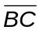 to 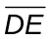. Record your answers below.
BC = __________ BC = __________
DE = __________ DE = __________
Ratio = __________ Ratio = __________

4. Complete the conjectures:
The length of the midsegment is _____________________________________.
The slope of the midsegment is ______________________________________.

5. What is the relationship between ADE and ABC? Can you prove it?

Problem 2 – Three Midsegments
6. Calculate the perimeter and area using the tools in the Measurement menu.
Perimeter of DEF = __________ Area of DEF = __________
Perimeter of ABC = __________ Area of ABC = __________

7. Find the ratios of perimeters and areas. What happens to these ratios as a vertex
of ABC is dragged?
Ratio of Perimeters = __________ Ratio of Areas = __________

8. What is the relationship between DEF and ABC? Can you prove it?

9. What is the relationship between DEF and ADE? Can you prove it?

Apply The Math
Use this diagram for each exercise.  D, E, and F are all midpoints.  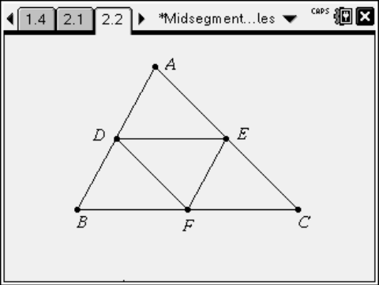 | 1. If DE = 6.2 inches, and AB = 11.4 inches, find the lengths of and 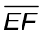.  2. If the perimeter of ABC is 32 cm, find the perimeter of DEF.  3. If the area of DEF is 8.6 cm², find the areas of ABC, ADE and BDF.  4. If m∠AED = 27° and m∠A = 64°, find as many other angle measures as possible.

