Lesson Overview
This TI-Nspire™ lesson introduces students to the median and, by taking the median of each half of the data, to the idea of quartiles, and then to the interquartile range.  The lesson begins with unordered numerical data, moves to an ordered list, and then to a dot plot of the ordered list. Here it is important that students recognize that a list by itself does not really tell the story of the distribution, where gaps, clusters, and outliers are not easily observed. |  |  | Learning Goals
- Identify the median as a measure of center and recognize that a median can be found only from ordered data;
- understand that summary measures of data identify certain key features of the distribution of the data, but do not necessarily give a complete picture of the distribution;
- identify interquartile range (IQR) as measure of spread related to the median;
- recognize that many different data distributions can have the same summary measures.
 | Dot plots display data in a way that makes it easier to identify the median of a set of data, since they show how data clusters. This knowledge of median is the foundation for understanding interquartile ranges.
Prerequisite Knowledge |  |  | Vocabulary
Median and Interquartile Range is the second lesson in a series of lessons that investigates the statistical process. In this lesson students are introduced to the median and, by taking the median of each half of the data, to quartiles and the interquartile range. This lesson builds on the knowledge presented in Introduction to Data. Prior to working on this lesson, students should:  - be able to identify statistical questions;  - understand and be able to describe distributions of data. |  |  | - median: the value that separates the upper half of the distribution of a set of data values from the lower half.  - lower quartile: the value that separates the lower quarter of the data from the upper three fourths of the data.  - upper quartile: the value that separates the lower three fourths of the data from the upper quarter of the data.  - interquartile range (IQR): the difference between the upper quartile and the lower quartile.
Lesson Pacing
This lesson contains multiple parts and can likely be completed in 2-3 class periods, though you may choose to extend, as needed.
Lesson Materials
- Compatible TI Technologies:
TI-Nspire CX Handhelds, TI-Nspire Apps for iPad®, TI-Nspire Software
- Median and Interquartile Range_Student.pdf
- Median and Interquartile Range_Student.doc
- Median and Interquartile Range.tns
- Median and Interquartile Range_Teacher Notes
- To download the TI-Nspire activity (TNS file) and Student Activity sheet, go to http://education.ti.com/go/buildingconcepts.
Class Instruction Key
The following question types are included throughout the lesson to assist you in guiding students in their exploration of the concept:
Class Discussion: Use these questions to help students communicate their understanding of the lesson. Encourage students to refer to the TNS activity as they explain their reasoning. Have students listen to your instructions. Look for student answers to reflect an understanding of the concept. Listen for opportunities to address understanding or misconceptions in student answers.
Student Activity: Have students break into small groups and work together to find answers to the student activity questions. Observe students as they work and guide them in addressing the learning goals of each lesson. Have students record their answers on their student activity sheet. Once students have finished, have groups discuss and/or present their findings. The student activity sheet can also be completed as a larger group activity, depending on the technology available in the classroom.
Additional Discussion: These questions are provided for additional student practice, and to faciliate a deeper understanding and exploration of the content. Encourage students to explain what they are doing and to share their reasoning.

Mathematical Background
In this TI-Nspire™ lesson, students are introduced to summarizing data. Summarizing distribution is the third element of the statistical process according to the Guidelines for Assessment and Instruction in Statistics Education (GAISE) report (Franklin et al, 2005) and to the Common Core State Standards (CCSS) grades 6–8 Statistics and Probability Progressions. Data summaries are important as a way to communicate information about a distribution when it is not possible to see a graph of the data and as a way to compare multiple distributions using quantitative measures. The most typical summaries give measures of center and spread. The common measures of center come from two different approaches to the data; one is based on ordering and relative position, which leads to the median as a measure of center and the range and interquartile range as measures of spread. The second approach is based on the actual data values, which leads to the mean as a measure of center and the mean absolute deviation, and in high school, standard deviation, as measures of spread. Students should realize that a measure of center or spread alone tells a very incomplete story about the distribution of the data.
It is important to note that the range, the lower quartile, the upper quartile, and interquartile range are single numbers. Common mistakes are to give the maximum and minimum for a range and to talk about the lower quartile as the lower fourth of the data. The lower quartile is a point such that one fourth of the data are less than or equal to that point. Note that, while different methods for computing quartiles are common, CCSS-M uses the method that excludes the median to create two halves when the number of data points is odd.

Part 1, Page 1.3
Focus: Counting from an ordered list allows you to summarize the center and spread of a distribution of data.  The data on page 1.3 represent the scores in a game by a group of people, where the object of the game was to get as low a score as possible.  Students will create their own distribution by organizing the numbers on the screen in various ways. | 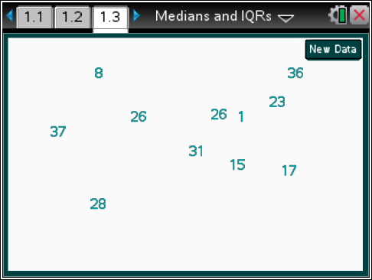
 |  |  |  | TI-Nspire Technology Tips
Use the touchpad to grab and drag objects.
The New Data button generates a new set of numbers.
Teacher Tip: Each student will begin with a different set of data scattered as if on a table top. In Parts 1 and 2, students try to describe the data and observe that moving the values around, grouping and ordering them helps in understanding how the data are distributed. They note that an ordered list reveals more about the data including a sense of center but still does not show gaps and clusters well, and finally they create a dot plot of the data, which gives a better sense of the distribution. With this background, Parts 3-6 introduce the notion of median by using a vertical segment to count from the left until the same number of data values is on both sides of the segment. Parts 1 through 6 might be done over a 2-3 day span.
Class Discussion
Have students… |  | Look for/Listen for…
- Describe your distribution of the number of attempts to a partner. Then listen to your partner’s description. Were there any words you both used in your descriptions? |  | Answers will vary. Responses might include “smallest,” “largest,” “most,” or “mostly.”
- Move the numbers around to help you think about the distribution of the scores. What do you notice? |  | Answers will vary. Some students might notice that there are three of the same values or what the smallest value is.

Part 2, Page 1.5
Focus: Plotting scores on a dot plot allows you to visually identify the center and range of a distribution of data.  Page 1.5 shows a similar randomly generated set of scores where again each number can be moved. Students will order and graph the numbers on a dot plot.  Review the following instructions for page 1.5 with students. These are also provided in the TNS activity for their reference during the activity.  - Order arranges the scores in a list across the top of the page. | 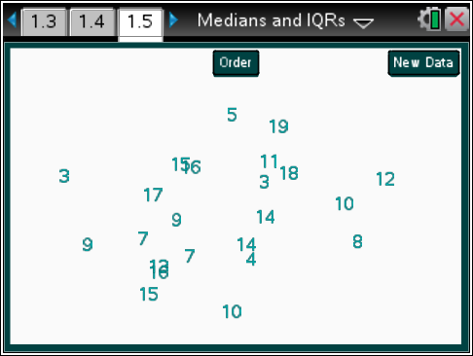
- Graph displays a dot plot of the scores. Press this twice to display the graph.
- Highlight a dot to show the score that it represents. Select the dot once to highlight it.
- Deselect highlighted dots by pressing in the white space on the screen.
- New Data generates a new set of numbers.
- Reset returns the activity to the original screen. Pressing / . on the handheld or computer software will also reset the page.
Teacher Tip: Point out how the range of numbers on the dot plot number line changes to reflect the range of numbers in the list.
Give students time to repeat the activity with various data sets and answer the following questions in their small groups. Encourage them to use the TNS activity to explain or demonstrate their reasoning.
Student Activity Questions—Activity 1
1. Review the scores on page 1.5.
a. What is the largest score? The smallest?
Responses will vary based on the set of data. For example, if the data set is {32, 1, 4, 7, 39, 24, 10, 26, 31, 37, 9, 8, 24, 27, 23} students might respond: “The largest is 39; the smallest is 1.”
b. Are any of the values clustered together?
Answers will vary. Students might suggest for the sample data that scores somewhere in the 30s seem common.
c. What value seems to be in the center of the data? Are most of the values close or not so close to the center you identified? Explain your thinking.
Answers will vary. Students might suggest for the sample data that 26 seems to be in the numerical center of the data, while looking at the physical display some might have chosen the value that looks like it is in the geometric center. A reason might be that the same number of values seems to be below and above the center value.
Class Discussion
Select the Order button on the screen.
- Describe what happened to the scores you had on page 1.5.
Answer: The scores are ordered and arranged from smallest to largest. The sample data set is ordered: {1, 4, 7, 8, 9, 10, 23, 24, 24, 26, 27, 31, 32, 37, 39}
- Look at your answers in Student Activity 1 and see if you want to change them now that you have looked at the ordered values.
Answer: For the sample data set and sample responses, a student might have identified the smallest and largest correctly but not the gap from 10 to 23 nor observed any clusters. They might suggest that 20 is the “center” of the scores because it is half way between the least and the greatest score. They might notice that the “center” of the scores corresponds to the center of the scores as they are lined up.
Select the Graph button on the screen twice.
- Which of the following questions might be answered more easily from the graph than from the list?
a. Are there any gaps in the distribution of the scores?
b. Identify any clusters in the distribution of the scores?
c. What value seems to be in the center of the distribution of the scores?
d. How are the scores spread out?
e. What are the smallest and largest scores?
Answers will vary. The list does not really show gaps or clusters or spread. Finding a middle (as center) of the scores for the whole group can be done from the list given the way the list is displayed in the file. The smallest and largest are easily observed from the list and the graph.
Additional Discussion

Reset the page and display the plot of the data.
- Identify the range of the scores for the group.
Answers will vary, but ranges should all be a numerical value not an interval.

Additional Discussion (continued)

- Describe the “center” of the distribution of the scores for the group. How closely are the data clustered around the value you chose as center?
Answers will vary. Some students might eyeball the distribution and estimate a center; others might use the midrange (half of the range added to the smallest value).
Sample Answers:
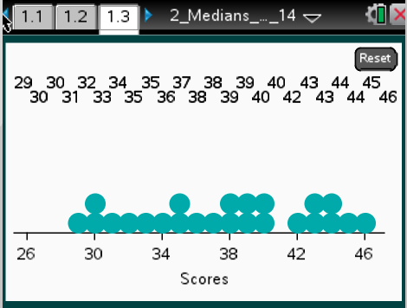 | 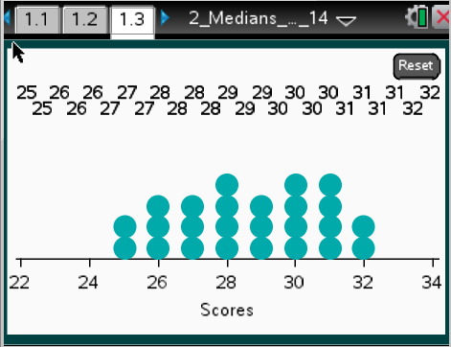 |  | 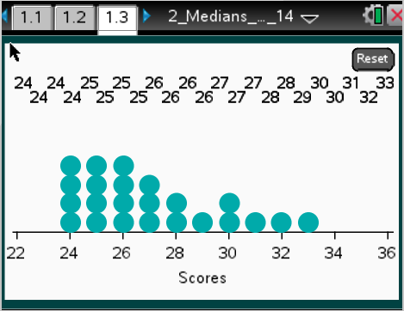
Sample 1 | Sample 2 |  | Sample 3
For the distribution in Sample 1, students that eyeball the distribution might note that the center is around 38, and the scores are kind of spread evenly around the center (almost uniform), although there is a gap before 42. The range is  46 – 29 = 17, and the midrange as center would be 37.5. | The distribution in Sample 2 has a center or middle value around 29, but the scores are all pretty close to 29. The range is  32 – 25 = 7, and the midrange would be 28.5. |  | The distribution in Sample 3 is skewed right. The middle seems to be a score of about 26 with a range of 33 – 24 = 9 scores, and the midrange at 28.5.
Part 3, Page 2.2
Focus: How can students identify the median of a set of data?  Page 2.2 displays a dot plot of the scores for one group of children.  Review the following instructions with students. These are also provided in the TNS activity for their reference during the activity.  - Mark displays vertical line segments on the plot to indicate the lower and upper quartile values.  - Right/Left buttons or the arrow keys can be used to move the lines incrementally to the right or left. To move a vertical segment, select it to activate it and use the Right/Left buttons or the arrow keys to move it on the plot.  - New Data generates a new set of numbers.  - Reset returns the activity to the original screen. |  | 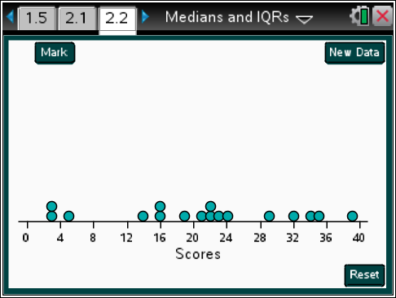
Teacher Tip: Explain to students that one common measure of the center of a set of data is based on counting. Counting to the middle of an ordered set of data will give the number such that that half of the values are greater than that number and half are less than that number. For example if the data set were {1, 2, 3, 4, 5}, the middle number or ‘center’ of the list would be 3 because two values are less than 3 and two values are greater than 3. This number is called the median of a set of data.
Class Discussion
Be sure students have time to make general observations about the data set. Have them describe their observations.
- How many people were in the group playing the game?
Answer: 17
- What do you think will be the middle—the median—of the distribution of the scores for this group of people?
Answers will vary. Some students will guess 22.
Student Activity Questions—Activity 2
1. a. Select Mark. What do the two numbers on either side of the vertical line represent?
Answer: The 0 represents the scores in the distribution to the left of the vertical segment, and the number on the right represents the scores in the distribution to the right of the vertical segment, i.e., 0|17 indicates there are 17 people in the group who were playing the game.
Use the right/left arrows on the keyboard or select the Right or Left buttons to move the vertical line segment so that half of the scores are less than the value marked by the segment.
b. What value marks this point? Describe why this is a “middle.”
Answer: With 17 people in the group, the “middle” is the 9th number in the distribution counting from either the maximum number down or from the minimum number up, with 8 of the scores less than the number marked by the 9th score and 8 of the people having scores higher than the number marked by the 9th score. The 9th score for this data set is 22.
c. Select New Data. Estimate the median. Then check using the vertical line segment.
Answers will vary. Students’ estimates should be close to the “middle” number of the distribution of scores.

Class Discussion
Ask students to decide which of the following are true. They will then use the activity and move the dots to create an example that supports their reasoning.
- When the number of scores is even, the median will be halfway between two of the scores.
Answer: The statement is true. Examples will vary. Look for examples that support the statement.
- When the number of scores is odd, the median will be one of the scores.
Answer: The statement is true. Examples will vary. Look for examples that support the statement.
- When the number of scores is even, the median will not be one of the scores.
Answer: The statement is false. Examples will vary. Look for examples that support the statement. An example might show multiple scores with the same value as the median.
- When the scores go from 3 to 35, the median will be at 21.
Answer: The statement is false in general. Look for an explanation that reflects the following understanding: “21 is called a midrange, which might be the median but not usually.”
Additional Discussion

Guide students in a discussion about how they can use given information about a set of data to describe its distribution.
Have students… | Look for/Listen for…
Describe what you know about the distribution of scores and what you do not know given each of the following:
- The median of a data set is 23. | Answer: You do not know much about the distribution except half of the scores are greater than or equal to 23 and half are less than or equal to 23.
- The median is 23 and the range is 37. | Answer: You know that the scores span 37 units and that half are above 23 and half below 23, but you do not know where the scores start or whether there are any gaps or clusters.
- The median is 23, the range is 37, and the minimum is 1. | Answer: You know that the scores start at 1 and go to 38, with half of them between 1 and 23 inclusive and the other half between 23 and38 inclusive. You do not know how the scores are spread out in each of the halves.
- The median is 23, the range is 37, the minimum is 1, and half of the scores are within 10 units of the median. | Answer: You know everything from the part above and also that half of the scores are between 13 and 33 inclusive.
Student Activity Questions—Activity 3
This section should be used to introduce students to the vocabulary necessary for understanding the concepts in this activity. (Note: This may require more teacher-led, direct instruction, than other parts of the activity).
Reset page 2.2. Find the median. Then select Mark again. Use the new vertical segment to find the median of the lower half of the scores. This value is called the lower quartile (LQ).

1. a. Explain how the points are distributed around the LQ.
Answer: The median is at 22 with 8 scores below the median. The median of these scores is halfway between the fourth and fifth lowest score, which is 15.Four of the scores are below 15 and four scores are between 15 and 22.
Select Mark again and use that vertical segment to find the median of the upper half of the scores. This value is called the upper quartile (UQ).
b. Explain how the points are distributed around the UQ.
Answer: The median of the top half of the scores is between the fourth and fifth largest score, which is halfway between 29 and 32 so it is 30.5, with four scores greater than 30.5 and three scores between 30.5 and the median and one of the two right on the median of all the scores gives four scores above or equal to the median of the top half.
The difference between the upper quartile and the lower quartile is called the interquartile range (IQR).
c. Find the interquartile range (IQR).
Answer: LQ = 15 and UQ = 30.5, so the IQR = 15.5 scores.
Class Discussion

Have students summarize and demonstrate understanding of the above vocabulary with the following questions:
- How did your strategy to count to the middle for the medians change in your answers to Activity 3?
Answer: Point out that the method used to find the quartiles excludes the median to create two halves when the number of data points is odd.
- How many of the scores are between
- … and including the minimum score and the LQ? | Answer: There are four scores.
- … the LQ and up to the median? | Answer: There are four scores counting the one at the median.

Class Discussion (continued)

- … from the median to the UQ? | Answer: The interval from the median up to and including the UQ also has four scores because one of the points at the median can be counted in that interval.
- … the LQ and the UQ? | Answer: At least half of the scores will be in the interval determining the IQR, in this case nine scores because of the double score at the median.
Reset the page and select New Data:
- Find the IQR. | Answers will vary. If there are 20 scores with a minimum of 5, median of 10, LQ of 7.5, UQ 14.5 and max of 35, the IQR will be  14.5 – 7.5 = 7.
- How many of the scores are in the IQR? | Answers will vary, but the number should be at least half of the total number of scores.
- Explain what the IQR represents. | The interval around the median that contains at least half of the scores. At least of the scores are between the median and the LQ and at least between the median and UQ.
Part 4, Page 2.4
Focus: Using dot plots to observe the relationship between the IQR and the median of the distribution of a set of data.  Page 2.4 is similar to page 2.2, but vertical segments and points for the minimum and maximum scores can be fixed at any location.  Review the following instructions with students. These are also provided in the TNS activity for their reference during the activity.  - Move the scores by dragging the dots.  - Lock fixes the middle, maximum and minimum points in place.  - Mark will display another vertical segment.  - Pressing Mark three times before moving the vertical segments will display all three vertical segments that can be highlighted and moved.  - New Data gives the user a choice of three different sets of scores and the option to choose a Random set, which will be different for most of the students.  - Reset returns the activity to the original screen. |  | 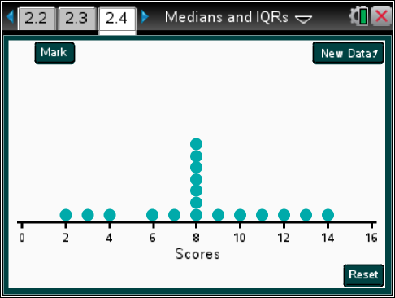
Class Discussion
Find the median, and then select Lock. Move the dots to create a distribution of scores that satisfies the given condition. In each case state the LQ, median, and UQ and sketch the distribution.
Have students... | Look for/Listen for…
- Use Data Set 1 with an IQR = 10. | Answers will vary. Sample answer: LQ = 3; UQ = 13.
- Use Data Set 3 with IQR as small as possible. | Smallest possible IQR for the conditions is 3, from 11 to 14.  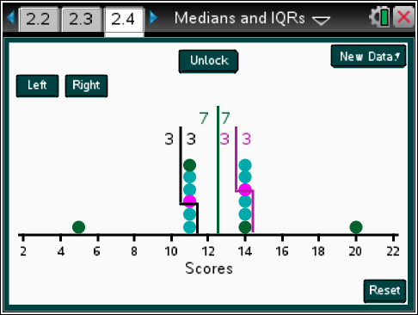
- Use Data Set 2 with IQR as large as possible. | The largest IQR will be when all 7 dots below the median are on 4 and all 7 dots above the median are on 10.
Now have students choose a Random data set.
- Move the dots to create a distribution of scores that is skewed right. Make a sketch of the distribution and identify the IQR and median. |  | Answers will vary. Sample answer: Median is 5.5; IQR is 17.  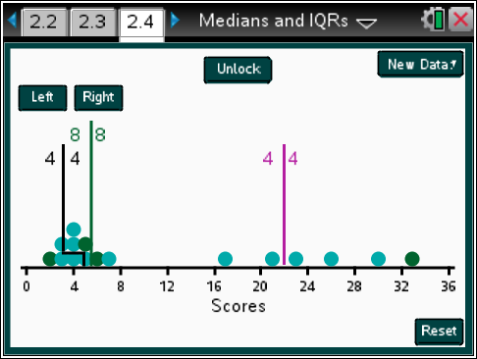

Class Discussion (continued)
- For the same data set as above with the same minimum and maximum, move the dots to create a mound shaped distribution. Make a sketch and identify the IQR and the median. Note that you can unlock the data and move any of the values. | Answers will vary. Sample answer: Median is 19; IQR is 5.  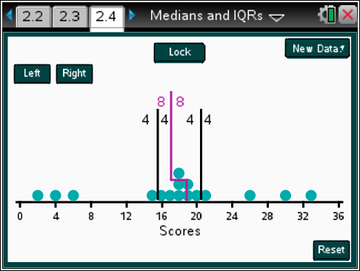
- How do the IQRs and the location of the median in the IQR compare in the two distributions? | Answer: The median is in the center of the range of the distribution of scores for the mound shaped distribution and in the pile of scores at the left end of the skewed distribution. In the skewed distribution, the median is at the left end of the interval determining the IQR, while in the mound-shaped distribution, the median is in the center of the interval determining the IQR. The IQR is much smaller for the mound shaped distribution.
- Suppose the distribution of scores had a large gap in the middle, with the scores piling up about evenly on either end. Use the dots representing the same data set to make a conjecture about the location of the median with respect to the distribution and the size of the IQR. Use the activity to check your conjecture. | Answer: The median should be in the middle of the interval determining the IQR and of the distribution. The IQR will be rather large. Examples will vary. In the example below, the median is at 17, fairly centered in the interval between the LQ and the UQ and in the interval between the maximum and minimum value of the distribution. The IQR is fairly large at 26.  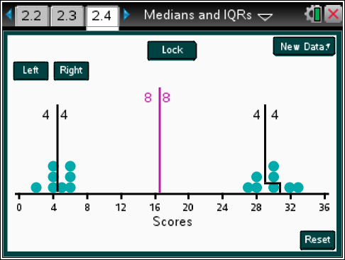

Student Activity Questions—Activity 4
1. Identify the following as true or false and give a reason. Use the activity to help your thinking.
a. The LQ is always one of the elements of the data set.
Answer: False, because if there are 8 unique data values less than the median, the LQ will be halfway between the 4th and 5th values.
b. The LQ is the midpoint between the smallest value in the data set and the median.
Answer: False, because if the median is 8 and the values less than the median are 2,3,3,4,7, the LQ will be 3 not 5, which is the midpoint between 2 and 8.
c. To increase the IQR, you can move values away from the median.
Answer: True, but only if the values are moved below the original LQ or above the original UQ.
d. For a data set with more than 10 different values, if you delete the smallest and largest value, the median will not be changed.
Answer: True, because if a value from either side of the median is deleted, the same number of scores will be still be on both sides of the original median.
Part 5, Page 3.2
Focus: Comparing distribution of sets of data.  Page 3.2 displays four sets of scores.  The distributions on page 3.2 represent the scores earned when the students in five different classes played the game.  Students will describe and compare the distributions of scores.  Review the activity instructions with students. These instructions can also be found in the TNS activity.  - Median marks the median on each distribution of scores. | 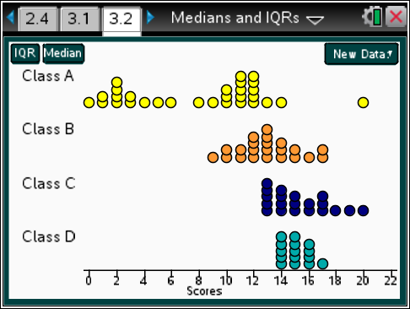
- IQR draws a horizontal line segment between the lower quartile and the upper quartile of the scores.
- The e key on a computer or handheld also displays the horizontal segment.
- Selecting Median or IQR a second time removes the feature.
- New Data provides a drop-down menu with a choice of three different fixed sets of scores and the option to generate a random set of scores.

Student Activity Questions—Activity 5
1. a. Describe the shape of each of the distributions of scores on page 3.2. Share your descriptions with a partner to see if you agree with each other.
Answers will vary. Class A has two clusters of scores, with clumps on either end. The distribution is mildly symmetric. Class B is mound shaped and symmetric, with the scores in the class pretty close together.; Class C is skewed right; Class D is mildly skewed.
b. Predict which of the distributions of scores will have the largest IQR and which will have a median approximately in the center of the interval between the LQ and UQ.
Answers will vary. Students might think Class A will have the largest IQR and the median will be in the middle of the interval between the LQ and UQ.
c. Select IQR and Median to check your answer to b.
Answers will vary: The median is nearly centered in the interval between the LQ and UQ for Classes B, C and D. The IQR is largest for class A, which has the largest range of the four classes.
d. How would you rank the classes in terms of having the lowest scores? Explain your reasoning.
Answers will vary. It looks like Class A had the most students with the lowest scores, but there was a large cluster of students in Class A that had about the same scores as the students in Class B with one outlier at 20 points. After Class A, it seems, as a whole, Class B had about the next lowest scores. The students in Class C might have the next lowest scores as their scores were all bunched together just under the middle of the scores for the students in Class B. More students in Class D had lower scores than those in Class C, but some had pretty high scores as well.
Additional Discussion

Select New Data then choose Data Set 3 to look at the distribution of scores from four different classes and answer the following questions.
- Estimate the median for each class.
Answers will vary. Students might think that, except for Class B, the medians are all quite close to 12 or 13.
- Which of the classes do you think has the largest IQR? The smallest?
Answers will vary. Some might conjecture that Class A will have the largest IQR and Class D the smallest.
- Select the Median and IQR buttons to verify your answers to parts a) and b). If your conjectures were off, describe what misled you about the distributions of the scores.
Answers will vary. Some might have been misled by the gap in Class C scores.

Part 6, Page 3.3
Focus: Describing distributions of data.  Page 3.3 works in the same way as page 3.2.  Have students describe and compare the distributions of scores with partners.  Review the instructions for the page.  - New Data randomly generates the distribution of scores for the classes. | 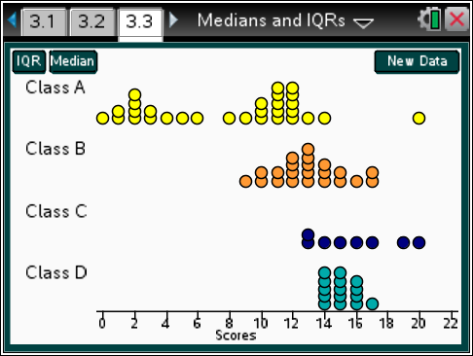
Additional Discussion

- Choose New Data to generate a random distribution of the scores. Work with a partner, taking turns doing the task. Generate a random set of distributions of scores for different classes and describe at least two of them to a partner in terms of the scores. Without looking at your distributions, your partner should sketch what the distributions look like given your description. Show the actual distribution to your partner and discuss the features that are correct in the sketches and those that are not. Together, decide whether you could have used better words in describing the distribution.
Answers will vary depending on student choices.
Student Activity Questions—Activity 6
1. What would you say to each of the following students? Use any page from the activity to support your thinking.
a. Patrice says that if you know the median and the IQR, you can make at least a broad sketch of the distribution.
Answer: Without some fixed points as maximum and minimum values, you don’t know the range of the distribution; the data in the lower quarter could be close together or far apart and the same for the upper quarter of the data. Knowing the IQR does not tell you where the interval that determines the IQR stops or starts or where the median is within the interval determining the IQR.
b. Saraje says that if two distributions have the same median but different IQRs, the one with the smaller IQR has the middle half of the values clustered closer together than the one with the larger IQR.
Answer: This is true.
c. Jay claims that the median is in the middle of the segment from the LQ to the UQ.
Answer: This is not true. Depending on the values, the median can be any value m in the interval
LQ ≤ m ≤ UQ.

Sample Assessment Items
After completing the lesson, students should be able to answer the following types of questions. If students understand the concepts involved in the lesson, they should be able to answer the following questions without using the TNS activity.
1. The prices of gasoline in a certain region are $1.41, $1.36, $1.57, and $1.45 per gallon. What is the median price per gallon for gasoline in this region?
NAEP 2005 gr 8
a. $1.41
b. $1.43
c. $1.44
d. $1.45
e. $1.47
Answer: b) $1.43
2. Millie entered her dog in a dog show. Her dog got a score of 64. Which measure of data can Millie use to determine whether her dog’s score was in the top half of all scores at the show?
adapted from Texas TEKS, 2010 Grade 10
a. Interquartile Range
b. Median
c. Upper Quartile
d. Range
Answer: b) Median
3. The number of French fries in a sample of bags from a restaurant is displayed in the graph.
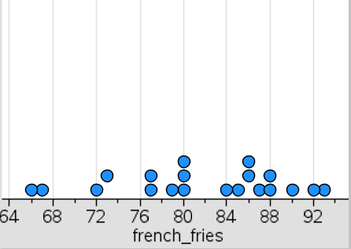
Data: {80, 72, 77, 80, 90, 85, 93, 79, 84, 73, 87, 67, 80, 86, 92, 88, 86, 88, 66, 77}
a. Find the median number of French fries in a bag. Answer: 82 French fries
b. Find the interquartile range Answer: 87.5 – 77 = 10.5
c. Is the statement below true, false, or cannot be determined?
“At least half of the bags in the sample had from 77 to 87 French fries.” Answer: True
4. Identify the following as true or false.
a. The median is the midpoint between the smallest and largest values in the data set. Answer: False
b. At most half of the values in a data set have values less than the median. Answer: True
c. If you add 10 to every element of a data set, the median will not change. Answer: False
d. If you add 10 to every element of a data set, the IQR will not change. Answer: True

Student Activity Solutions
In these activities you will work together to use median and interquartile range to explore and interpret the distribution of data in a dot plot. After completing each activity, discuss and/or present your findings to the rest of the class.
Activity 1 [Page 1.5]
Review the scores on page 1.5.
1. a. What is the largest score? The smallest?
Answers will vary depending on the set of data.
For example, if the data set is {32, 1, 4, 7, 39, 24, 10, 26, 31, 37, 9, 8, 24, 27, 23} students might respond: “The largest is 39; the smallest is 1.”
b. Are any of the values clustered together?
Answers will vary.
Students might suggest for the sample data that scores somewhere in the 30s seem common.
c. What value seems to be in the center of the data? Are most of the values close or not so close to the center you identified? Explain your thinking.
Answers will vary.
Students might suggest for the sample data that 26 seems to be in the numerical center of the data, while looking at the physical display some might have chosen the value that looks like it is in the geometric center. A reason might be that the same number of values seems to be below and above the center value.
Activity 2 [Page 2.2]
1. a. Select Mark. What do the two numbers on either side of the vertical line represent?
Answer: The 0 represents the scores in the distribution to the left of the vertical segment, and the number on the right represents the scores in the distribution to the right of the vertical segment, i.e., 0|17 indicates there are 17 people in the group who were playing the game.
Use the right/left arrows on the keyboard or select the Right or Left buttons to move the vertical line segment so that half of the scores are less than the value marked by the segment.
b. What value marks this point? Describe why this is a “middle.”
Answer: With 17 people in the group, the “middle” is the 9th number in the distribution counting from either the maximum number down or from the minimum number up, with 8 of the scores less than the number marked by the 9th score and 8 of the people having scores higher than the number marked by the 9th score. The 9th score for this data set is 22.
c. Select New Data. Estimate the median. Then check using the vertical line segment.
Answers will vary.
Student estimates should be close to the “middle” number of the distribution of scores.
Activity 3 [Page 2.4]
1. Identify the following as true or false and give a reason. Use the activity to help your thinking.
a. The LQ is always one of the elements of the data set.
Answer: False, because if there are 8 unique data values less than the median, the LQ will be halfway between the 4th and 5th values.
b. The LQ is the midpoint between the smallest value in the data set and the median.
Answer: False, because if the median is 8 and the values less than the median are 2,3,3,4,7, the LQ will be 3 not 5, which is the midpoint between 2 and 8.
c. To increase the IQR, you can move values away from the median.
Answer: True, but only if the values are moved below the original LQ or above the original UQ.
d. For a data set with more than 10 different values, if you delete the smallest and largest value, the median will not be changed.
Answer: True, because if a value from either side of the median is deleted, the same number of scores will be still be on both sides of the original median.
Activity 4 [Page 3.2]
1. a. Describe each of the distributions of scores on page 3.2. Share your descriptions with a partner to see if you agree with each other.
Answers will vary.
Class A has two clusters of scores, with clumps on either end. The distribution is mildly symmetric. Class B is mound shaped and symmetric, with the scores in the class pretty close together. Class C is almost uniform; Class E is skewed right; Class D is mildly skewed.
b. Predict which of the distributions of scores will have the largest IQR and which will have a median approximately in the center of the interval between the LQ and UQ.
Answers will vary.
Students might think Class A will have the largest IQR and the median will be in the middle of the interval between the LQ and UQ.
c. Select IQR and Median to check your answer to b.
Answers will vary.
The median is nearly centered in the interval between the LQ and UQ for Classes B, C and D. The IQR is largest for class A, which has the largest range of the five classes.
d. How would you rank the classes in terms of having the lowest scores? Explain your reasoning.
Answers will vary.
It looks like Class A had the most students with the lowest scores, but there was a large cluster of students in Class A that had about the same scores as the students in Class B with one outlier at 20 points. After Class A, it seems, as a whole, Class B had about the next lowest scores. The students in Class D might have the next lowest scores as their scores were all bunched together just under the middle of the scores for the students in Class B. More students in Class E had lower scores than those in Class D, but some had pretty high scores as well. There were not too many students in Class C, and their scores went from some just below the middle of Class B all the way to the students who had the highest score.
Activity 5 [Page 3.3]
1. What would you say to each of the following students? Use any page from the activity to support your thinking.
a. Patrice says that if you know the median and the IQR, you can make at least a broad sketch of the distribution.
Answer: Without some fixed points as maximum and minimum values, you don’t know the range of the distribution; the data in the lower quarter could be close together or far apart and the same for the upper quarter of the data. Knowing the IQR does not tell you where the interval that determines the IQR stops or starts or where the median is within the interval determining the IQR.
b. Saraje says that if two distributions have the same median but different IQRs, the one with the smaller IQR has the middle half of the values clustered closer together than the one with the larger IQR.
Answer: This is true.
c. Jay claims that the median is in the middle of the segment from the LQ to the UQ.
Answer: This is not true. Depending on the values, the median can be any value m in the interval
LQ ≤ m ≤ UQ.

