Open the TI-Nspire document Multiple_Representations.tns.  Graphs, tables, and formulas can represent algebraic relationships. In this activity, you will use all three to investigate how a student’s spending money is related to allowance and earnings. | 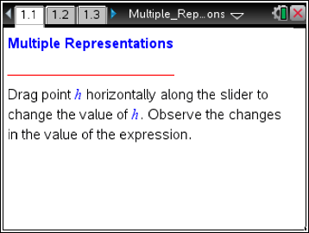

Move to page 1.2.

Problem Situation: Tricia is a 17-year-old student who receives an income from a weekly allowance and also works a part-time job paid at an hourly rate. She always receives her allowance, but on her job she can work any whole number of hours from 0 to 20 hours a week. The TI-Nspire document shows three representations of Tricia’s possible income for one week depending on the number of hours she works.
1. Move h to zero, and use data capture once. (Press / ^ on the handheld; tap on the iPad.)
a. What do you observe about the three representations?

b. What does (0,10) mean in the context of this problem?

2. Move h to 8, and use data capture once. Move h to another value, and use data capture once again. Repeat. What do you observe about the three representations?

3. What do h and i(h) represent? Where do h and i(h) appear in each representation?

4. Using your answer from question 3, how much would Tricia earn if she works 8 hours? Where does this appear in each of the three representations?

- a. What is Tricia’s allowance, and how can you identify this in each of the three representations?

b. What is Tricia’s hourly rate, and how can you identify this in each of the three representations?

c. Why do the points in the graph fall on a straight line?

6. Can Tricia’s income be $75 in one week? Explain.

7. Can Tricia earn $400 in one week? Explain.

8. a. Why can you only move from 0 to 20 on the horizontal axis?

b. We call the domain of the relationship the set of possible values for the independent variable, which is hours. Write the domain of this function using inequality notation.

9. Is it possible for Tricia to have an income of $0? Why or why not?

10. Suppose Tricia’s parents increase her weekly allowance by $5. Describe how this increase in allowance would affect each of the representations.

11. Suppose Tricia gets a $1 per hour raise. Describe how this increase in her hourly rate would affect each of the representations.

12. A representation of how much Tricia gets paid is shown on the left. A representation of how much Stacey gets paid is shown on the right.

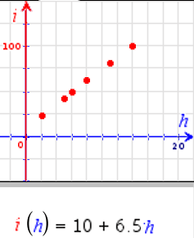  Tricia | Stacey’s hours Stacey’s pay  2 16  3 24  5 40  9 72
- If Tricia and Stacey work 20 hours each, who will get paid more? How do you know?

- How can you tell from the different representations who gets paid a higher hourly rate?

- What do you think are the strengths and weaknesses of each type of representation?

