About the Lesson  A pendulum moves so that the pendulum bob is directly across from a CBR™ 2 motion sensor. Position and time data are collected for several swings. The graph of the data can be modeled by a sinusoidal function.  Students will:  - Collect and graph position versus time data for several swings of a pendulum.  - Model the graph of the data with a sinusoidal function of the form f(x) = a(cos(b(x - c))) + d.  Vocabulary  - Mean of the position data  - Sinusoidal function  - Amplitude and period of a sinusoidal function  - Vertical and horizontal translations  Teacher Preparation and Notes  - This activity provides an opportunity for math-science connections.  - Students should be familiar with sinusoidal functions and their characteristics as well as vertical and horizontal translations.  - This activity is best performed in groups of three: One person will operate the handheld, one person will hold the CBR 2, and the third person will pull and release the pendulum.  Activity Materials  - CBR 2 motion sensor, USB CBR 2 to handheld cable, and TI-Nspire CX II  - String (approximately one meter long) and pendulum bob (ball or other mass)  - Recommended: TI-Nspire™ CX Premium Teacher Software or TI-Nspire™ CX CAS Premium Teacher Software | 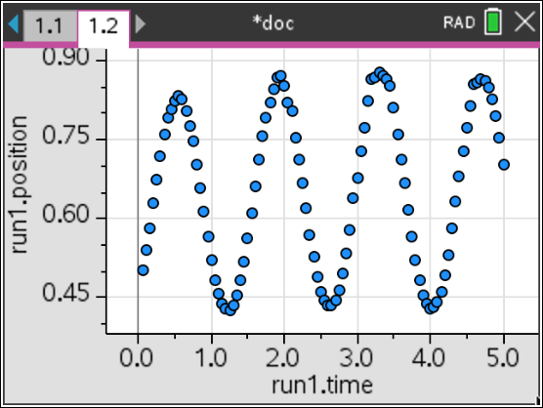  Tech Tips:  - This activity includes screen captures taken from the TI-Nspire™ CX II. It is also appropriate for use with the rest of the TI-Nspire CX family. Slight variations to these directions may be required if using other handheld models.  - Access free tutorials at http://education.ti.com/calculators/pd/US/Online-Learning/Tutorials
Activity Overview
This activity will introduce the Calculator-Based Ranger™ 2 motion sensor and the Vernier DataQuest™ App. You will collect position and time data using a swinging pendulum and fit a model to the data.
Background Information
Pendulum motion has fascinated people for hundreds of years. Galileo studied pendulum motion by watching a swinging chandelier and timing it with his pulse.
In 1851, Jean Foucault demonstrated that the earth rotates by using a long pendulum which swung in the same plane while the earth rotated beneath it.
Equipment
- TI-Nspire™ CX II or the TI-Nspire™ CX II CAS
- CBR™ 2 motion sensor
- USB Connection Cable for CBR 2 motion sensor
Note: To plug the CBR 2 into the computer, a mini-standard USB adaptor is needed.
Materials for Each Group
- String (approximately one meter long) and pendulum bob (ball or other mass)

Set Up
Step 1:  Open a New Document, and press d.  Connect the CBR 2 to the TI-Nspire CX II with the USB cable. A Vernier DataQuest® App page will automatically open, and the CBR 2 will begin measuring the position of the closest object. The position is the object’s distance from the CBR 2. | 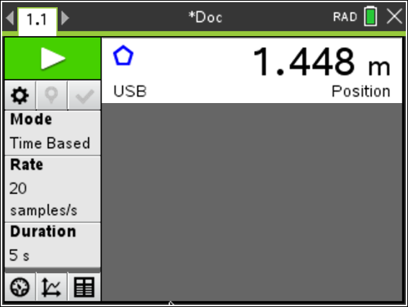
Step 2  Select Menu > View. There are three views. The first view displayed was Meter. Choose the Graph View for additional menu options. (Alternatively, click on the Graph View icon at the bottom of the screen.)  To display only the position versus time graph, select Menu > Graph > Show Graph > Graph 1. | 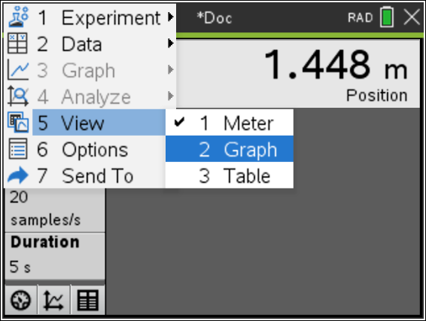  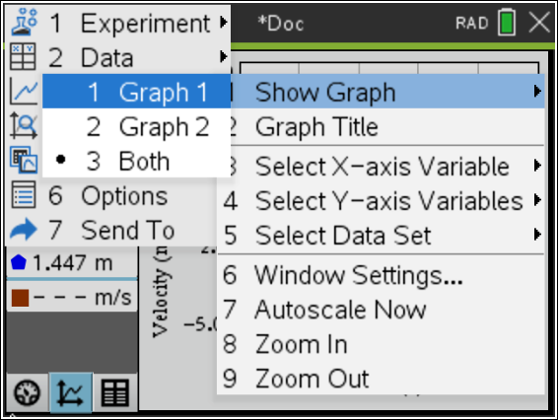
Step 3:
Work in groups of three. One person will operate the handheld, one person will hold the CBR 2, and the third person will pull and release the pendulum.
Step 4:
Hang the pendulum bob from a rigid support or over the edge of a desk or table. Arrange the support so the bottom of the pendulum bob clears the table or other surface by several centimeters.
Position the CBR 2 so that it points at the pendulum bob.
Questions (before data collection)
- Pull the pendulum back from its at rest position, release it, and observe its swing. What is your estimate for the straight-line distance between the two extreme points of the pendulum’s swing? Record this estimate.

- Estimate the distance of the pendulum bob from the CBR 2 when the pendulum is at rest. Record this distance.

- What is the approximate time for one swing of the pendulum? (Consider recording the time for multiple swings and then determine the average time for one swing.)
Step 5:  Before collecting data, make a prediction of what the graph of position versus time should look like for several swings of the pendulum. Sketch your prediction on the grid to the right. | 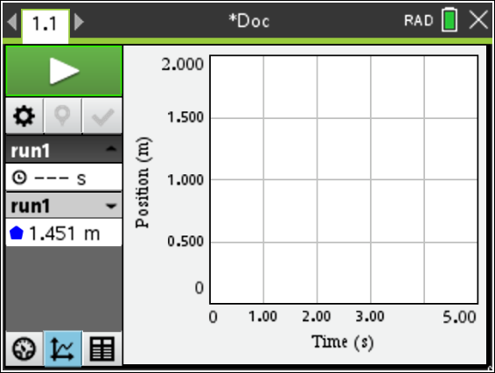
Step 6:
When ready to collect data, the handheld operator should click the Start Collection arrow in the upper-left corner of the screen or press e until the start collection arrow is highlighted, and then press ·.
Step 7:
A graph of position versus time is displayed.
How does the graph compare with your prediction?

Step 8:  Sketch the actual graph of your position versus time graph on the grid to the right. | 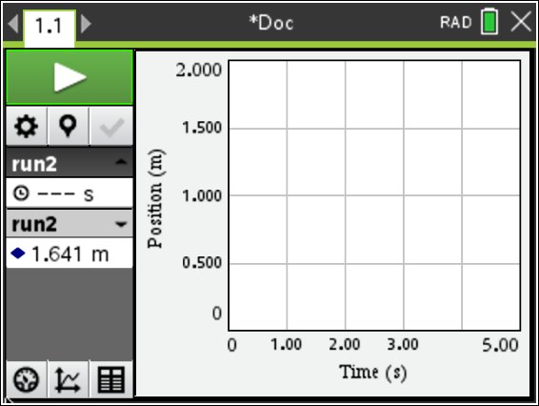
Step 9:
Send the data to a Data & Statistics page by pressing Menu > Send To > Data & Statistics.
A graph of sample data is shown at the right.

Note: Once data collection is complete, the connection cable can be removed from the handheld.
Step 10:  On the Data & Statistics page, select Menu > Analyze > Plot Function.  Enter f1(x) = cos(x). Press ·.  Note that the function does not fit the data well. The function will need to be transformed. | 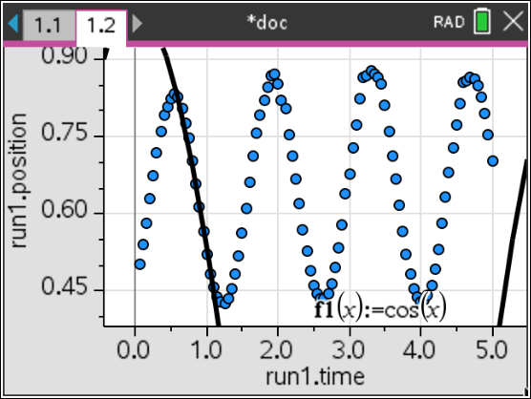
Step 11:  Press /~, and select Add Calculator. Determine the mean of the position data by entering mean(run1.position) and then pressing ·.  The list name can be accessed by pressing the h key.  Record the mean rounded to two decimal places. __________  Sample Answer: 0.66 meters | 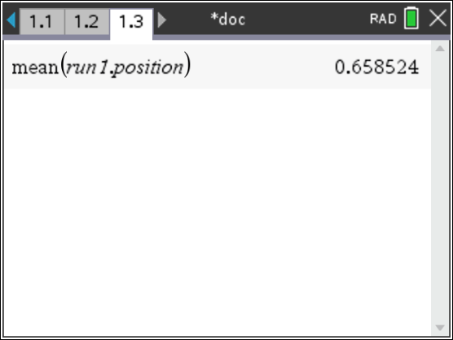
Step 12:  Return to the Data & Statistics page, and select Menu > Analyze > Plot Function.  Enter f2(x) = mean(run1.position). Press ·. | 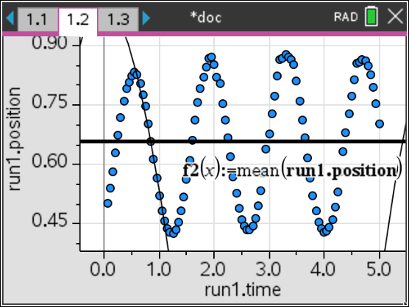
Questions
- How does the mean of the position data relate to the motion of the pendulum?

Answer: This is the distance from the CBR 2 to the pendulum ball when the pendulum is at rest.

How does the mean of the position data compare to your answer to Question 2?

Sample Answer: The values are similar.

Note: The general form of the cosine function is f(x) = a(cos(b(x - c))) + d. In the equation f1(x) = cos(x), the parameters have these values: a = 1, b = 1, c = 0, and d = 0.
Do not change the values of these parameters until you determine a new value for a parameter based on your data.

- Use your value for the mean of the position data to determine the appropriate parameter in the equation f(x) = a(cos(b(x - c))) + d.  Answer: Parameter d (For the sample data, d= 0.66.)  What does this parameter represent?  Answer: The vertical translation.  Write your equation. ________________________  Sample Answer: f1(x) = cos(x) + 0.66  Edit f1(x) to graph this equation. (Double click on the equation of f1(x) to edit. Then, press ·.) | 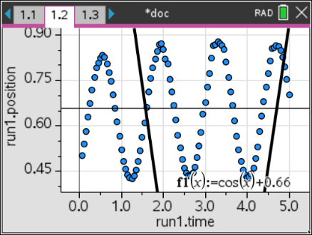
- In the Calculator application, determine Max(run1.position).  Graph f2(x) = Max(run1.position). Adjust the maximum value, as needed, to align with the peaks of the graph of the data.  Use this maximum position value and the mean of the position data to determine the appropriate parameter in the equation f(x) = a(cos(b(x - c))) + d.  Answer: Parameter a (For the sample data, a = 0.22 (maximum (0.88) – mean (0.66)))  What does this parameter represent?  Answer: The amplitude of the function.  Write your new equation. ________________________  Sample Answer: f1(x) = 0.22cos(x) + 0.66  Edit f1(x), and graph this new equation. Adjust the value of this parameter, as needed. | 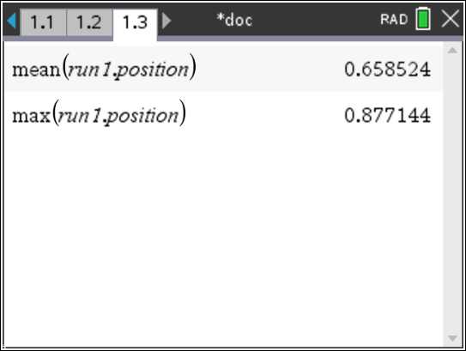  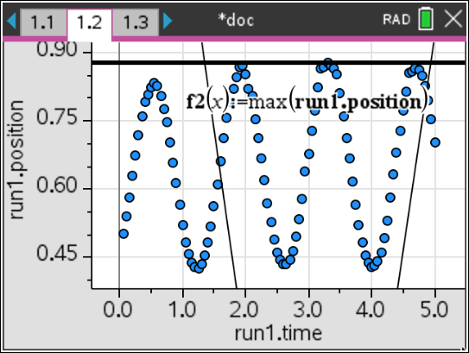  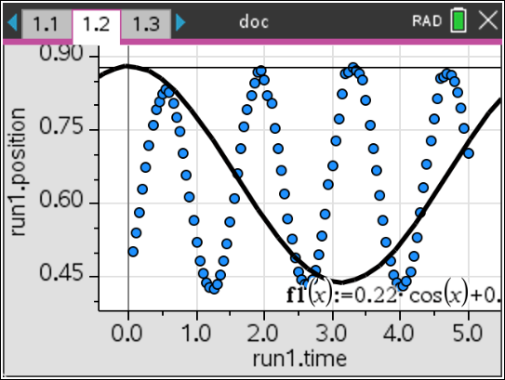
- Use the trace feature to explore the graph of the pendulum data. Locate the coordinates of a maximum point. Explain how a coordinate of this point could be used to determine a horizontal translation for the function.  Sample Answer: The y-coordinate of this point can be used to determine the horizontal translation. Using the maximum point selected with the sample data, the horizontal translation is 1.95 seconds.  Which parameter does this represent?  Answer: Parameter c.  Write the equation that includes this transformation. ________________________  Sample Answer: f1(x) = 0.23cos(x – 1.95) + 0.66  Note: The amplitude was adjusted to better fit the data.  Edit f1(x) to graph this equation. | 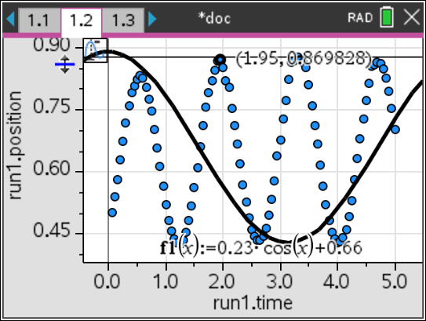  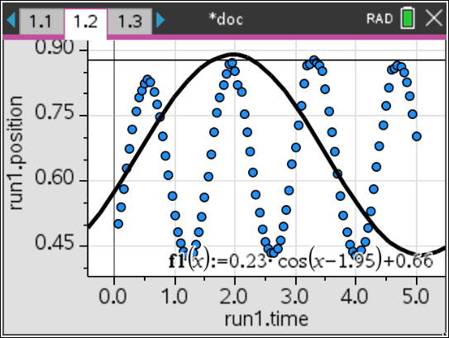
- The time required to complete one swing of the pendulum was estimated in Question 3. Trace on the graph to determine the time it takes to complete one swing. How do these values compare?  Sample Answer: The answers should be similar. For the sample data, the time to complete one swing is approximately 1.4 seconds.  Use this information to determine the number of swings that would take place in 2π seconds.  Sample Answer: $\frac{2π}{1.4}$ = 4.48. There are approximately 4.5 swings in 2π seconds.  What does the number of swings in 2π seconds represent?  Answer: The period of the function.  Which parameter does this represent in the function?  Answer: Parameter b.  Write the equation that includes this transformation. ________________________  Sample Answer: f1(x) = 0.23cos(4.5(x – 1.95)) + 0.66  Edit f1(x) to graph this equation. | 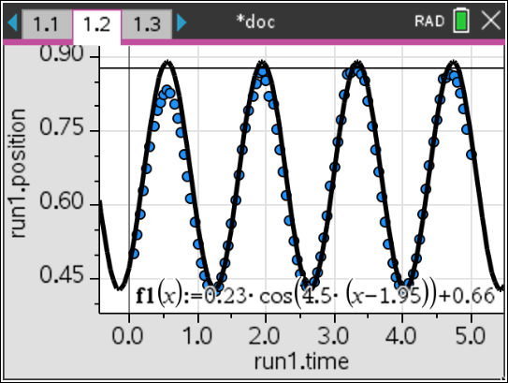
Note:
Alternative method to determine b:
Use the time it takes to complete one cycle to determine the value of b in the function.
Solve $\frac{2π}{b}$= 1.4 for b.
b is equal to approximately 4.5.
This is the approximate number of swings in 2π seconds.
- Edit your equation, as needed, to better match the graph of the data. Record your final equation.

f1(x) = _______________________

Sample Answer: Answers will vary.
- How would the equation differ if the sine function were used rather than the cosine function?

Sample Answer: Answers will vary. Sine and cosine graphs only differ by a horizontal shift.

- Using the sine function, develop an equation that models the data.

Sample Answer: Answers will vary.

