Part 1 – Separable Differential Equations Introduced
1. A capacitor, like one used for a camera flash, is charged up. When it discharges rapidly the rate of change of charge, q, with respect to time, t, is directly proportional to the charge. Write this as a differential equation.

The first step is to separate the variables, and then integrate and solve for y.
2. Find y(0), if 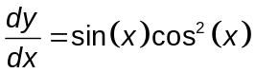 and y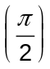 = 0. After integrating, using the initial condition y = 0 when x = 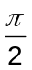 to find the constant of integration. Then, substitute x = 0 to find y(0).

Let’s return to the capacitor. Now that it is discharged, we need to get it charged up again. A 9V battery is connected to a 100kΩ resister, R, and 100μF capacitor, C.
The conservation of energy gives us the differential equation 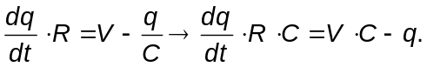 After substituting the given information and simplifying, we get the differential equation 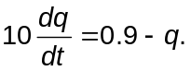
3. For the differential equation 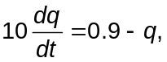 separate the variables and integrate.

4. Apply the initial condition when time = 0, the charge q = 0 and solve for q.

5. On page 1.8, type deSolve(10q'=0.9–q and q(0)=0,t,q). Write down this answer and reconcile it with your previous solution.

6. On page 1.10, enter deSolve(y′=y/x,x,y) to find the general solution of 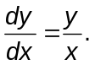 Write the answer. Why do you think there is a bold c number in the answer? Show your work to solve this differential equation by hand and apply the initial condition y(1) = 1 to find the particular solution.

Part 2 – Homework/Extension – Practice with deSolve and Exploring DEs
Find the general solution for the following separable differential equations. Write the solution in an acceptable format, (for example, use C instead of c7). Show all the steps by hand if your teacher instructs you to do so.
1. y′ = k ∙ y 2. y′ = 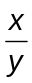 3. y′ = 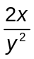 4. y′ = 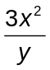

On page 2.4, use the slider to change the c on the next page to observe the family of solutions. Many particular solutions can come from a general solution.
5. Not all differential equation are separable. On page 3.1 use deSolve to find the solution to the non-separable differential equation x ∙ y'=3x² + 2 – y. What does this graph look like if the integration constant is 0? Explain.

Find the particular solution for the following equations. Show your work. Solve for y. Explore other DEs on your own. Do you get any surprising results?
6. y′ = x∙y² and y(0) = 1 7. y′ = 1+ y² and y(0) = 1 8. y′ = 7y and y(0) = ln(e)

