Title: Experimentally Calculating Pi

Background: Because the diameter of a circle is related to the circumference of a circle, we can find this constant relationship by measuring several lids and fitting a regression line to the data. The slope of this line is pi. This is a great activity to allow students to discover that Pi is the relationship between the diameter of a circle and its circumference.

Materials Needed: String, Circular Lids of various sizes, Ruler and/or Meter Stick

Procedure: Each group will be given several lids, string, a meter stick and/or ruler.
Label each lid as Lid 1, Lid 2, etc. Starting with Lid 1, measure the circumference with the string. Find the length of the circumference and record this data. Now measure the diameter of the same lid and record this data. Do the same for all the lids. There is a data sheet attached with questions if you wish to use it. Prior to beginning, have the students predict (hypothesize) the relationship between the circumference and diameter of the lids.

Analysis: Once the data is collected, the relationship between circumference and diameter can be expressed by
$$C=πd$$
This is related to the slope intercept form of y = mx. In this case, the independent variable (x) is diameter and the dependent variable (y) is Circumference. When you plot this data, you should have a line. The slope of that line is equivalent to Pi.
$$\begin{aligned}C=πd \\ y=\text{mx} \\ \\ C=y \\ d=x \\ π=m\end{aligned}$$
Determine the independent and dependent variable. Associate each of those with x and y respectively and then solve the linear equation in slope-intercept form. This equation is already in that form so it is easy to see how Pi is equivalent to the slope.

In order to determine the slope, enter the data into a graphing calculator, and fit a regression line. The slope of that regression line will be equivalent to Pi. Once calculated, that will represent the experimental calculation of Pi. Find the Percent Error by using the formula of

$$\text{\%}\text{Error}=\left|\frac{\text{Actual}−\text{Experimental}}{\text{Actual}}\right|×\text{100}\text{\%}$$

The following is a key by key stroke for a TI-83 (but can be adapted for any TI calculator). These are based on the sample data given below.

Diameter (x) [cm] | Circumference (y) [cm]
2.5 | 7.9
3.2 | 10.0
4.8 | 14.8
5.3 | 16.9
7.1 | 22.3
11.3 | 34.7
14.2 | 44.0

Clear out any data in your lists in your calculator.

To clear out a list use the following strokes:

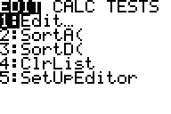

[STAT]

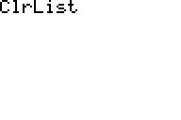

[4]

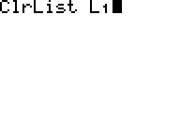

[2nd][1]

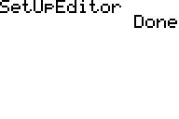

[,]

[2nd][2]
[,]
[2nd][3]
[,]
[2nd][4] Only enter the lists you need to clear.
[,]
[2nd][5]
[,]
[2nd][6]

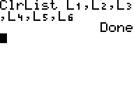

[ENTER]

You can also clear each column by typing [STAT] [1] and then moving your cursor up until it is highlighting the column you wish to delete. Hit the [CLEAR] button and then [ENTER].

If you happen to delete your lists and need to reset them, use the following strokes:

[STAT]

[5] Select the Set Up Editor

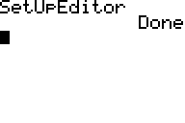

[ENTER]

To input your data (we are using the data above), use the following strokes:

[STAT]

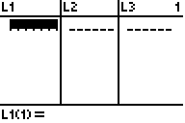

[1]

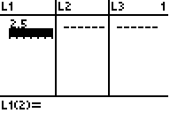

[2.5] [ENTER]

[3.2] [ENTER]
[4.8] [ENTER]
[5.3] [ENTER]
[7.1] [ENTER]
[11.3] [ENTER]
[14.2] [ENTER]
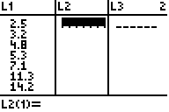

[→]

[7.9] [ENTER]
[10.0] [ENTER]
[14.8] [ENTER]
[16.9] [ENTER]
[22.3] [ENTER]
[34.7] [ENTER]

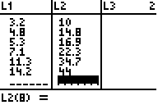

[44.0] [ENTER]

To graph your data, you need to make sure all your other plots and graphs are turned off and your window is set to view the right scale.

To make sure the correct graphs are turned on or off, follow these steps. Please note there are several ways to accomplish these tasks, this is just showing one way.

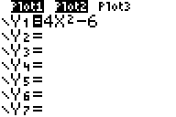

[Y=]

The highlighted PLOT1 and PLOT2 are indicating that those are turned on. The highlighted equals sign under Y1 also indicates it is turned on. This means it will show when you hit GRAPH. You can turn each of these on or off by moving your cursor (with the arrow keys) until you are on top of the highlighted area and then hit enter. It will cause it to no longer be highlighted.

[↑]
[→]

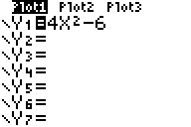

[ENTER]

You want to clear out Y1 since we will be putting our regression line in that place.
[↓]

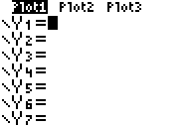

[CLEAR]

We need to make sure our PLOT1 is pulling from the correct lists. You can also turn on and off plots this way as well.

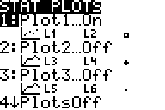

[2nd] [Y=]

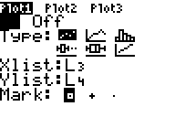

[1]

Notice that the cursor is blinking over the ON button. If you wanted to turn this plot off, you would cursor over to the right and hit enter. Then the OFF button would be highlighted. We want this on, but we want List 1 and List 2 for our x and y values.
Arrow down until the cursor is on L3 and change it to L1.
[↓]
[↓]

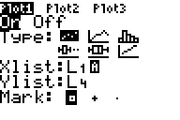

[2nd] [1]

[↓]
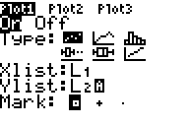

[2nd] [2]

Now choose your symbol. I choose a plus sign.
[↓]

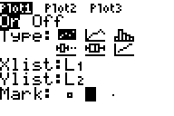

[→] [ENTER]

Since my x-axis is going to be L1 and my y-axis is L2, I am going to make my window to include those lists. I will make my x – axis from 0 to 15 and y-axis from 0 to 45.

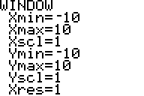

[WINDOW]

[0] [ENTER]
[15] [ENTER]
[↓]
[0] [ENTER]

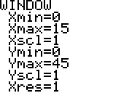

[45] [ENTER]

Now we want to see what we have for our graph.

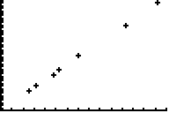

[GRAPH]

For this particular experiment, the graph should be linear. This is pretty close. To fit and plot the regression line, use the following strokes:
[STAT] Here you will arrow over to CALC and choose LinReg(ax +b)

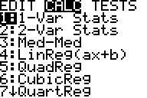

[→]

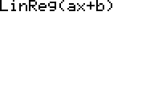

[4]

[2nd] [1] This is determining which columns are used for the
[,] regression. Then it will be put into Y1 to graph over the
[2nd] [2] plot.

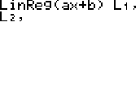

[,]

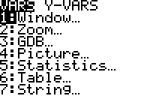
[VARS]

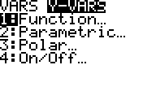
[→]

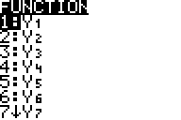

[1]

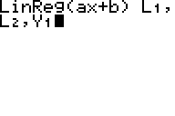

[1]

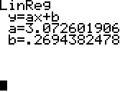

[ENTER]

Write down your slope and y-intercept. To see how well a fit you have, graph the data again by hitting GRAPH.

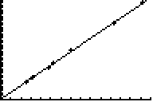

[GRAPH]

Note: To get out of the editor or to clear a graph, one way is to hit [2nd][Mode]. This is a “quit” button.

Now that you have the slope of the data, this is equivalent to the slope of your original equation. In this case, it is just Pi. There are no calculations necessary, since Pi is the slope. To calculate the experimental error, use the following strokes:

[CLEAR] This clears the screen of the graph.
[CLEAR] This clears the screen of the regression information..
[2nd] [^]
[-]

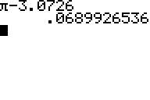

[3.0726][ENTER]

[/] To automatically use the previous answer, just begin with an operation.
You can also recall the previous answer by typing in [2nd] [(-)].

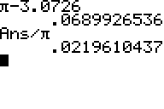

[2nd][^]

[*] To find the percentage, you need to multiply by 100.
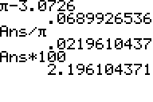

[100] [ENTER]

Based on our data, we have a 2.2 % error. This is a fairly accurate representation of Pi based on measuring lids.
DATA SHEET FOR EXPERIMENTALLY CALCULATING PI

Diameter (x) [cm] | Circumference (y) [cm]

What is your independent variable? ___________________________________

What is your dependent variable? _____________________________________

What is the slope (m) equivalent to? ___________________________________

What are the units of slope? __________________________________________

What is the equation of the regression line used to fit your data?

__________________________________________________________________

What is the slope (or your experimental calculation of Pi) of that regression line in the

previous question? ___________________________________________________

If 3.14 is the actual value of Pi, what is your % Error? ________________________

