Throughout history, mathematicians from Euclid to al-Kashi to Viète have derived various formulas to calculate the sides and angles of non-right (oblique) triangles. al-Kashi used these methods to find the angles between the stars back in the 15th century. Both the famous Laws of Sines and Cosines are used extensively in surveying, navigation, and other situations that require triangulation of non-right triangles. In this activity, you will explore the proofs of the Laws, investigate various cases where they are used, and apply them to solve problems. | 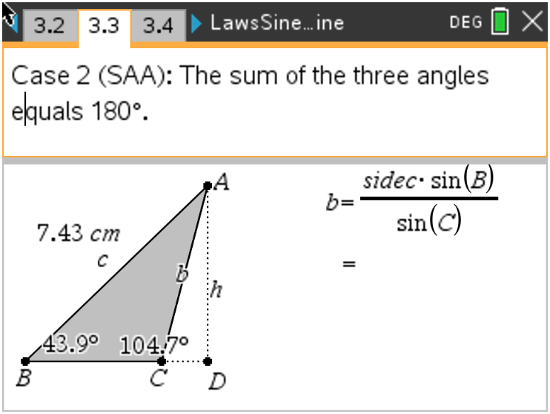

Problem 1 – Review of Geometry

(a) Move to page 1.4. Discuss with a classmate what SAS, ASA, SAA, SAS, SSS, and SSA mean.
Share your results with the class.

(b) Explain why one of these abbreviations does not always work.

Problem 2 – Proof of the Law of Sines

Read the proof of the Law of Sines on pages 2.1–2.3. The angle C refers to the angle ACD.
(a) Move point C so that it is an acute angle. Discuss if the Law of Sines still holds.

Problem 3 – ASA and SAA cases

On pages 3.2 and 3.3 use the Calculate tool and the formula on the screen to find the length of b. Use the Length tool to check your answer.
(a) Case 1: b = ________
Case 2: b = ________

(b) Grab point C and then drag it. Discuss if moving point C affects your answer to the length of b.

Problem 4 – Law of Sines Problem
Use the Law of Sines to solve the following problem on page 4.2.
A surveyor took two angle measurements to the peak of the mountain 500m apart. Find the height of the mountain.

Problem 5 – Proof of the Law of Cosines
Read the proof of the Law of Cosines on pages 5.1–5.3. Use algebra to complete the proof from the 4 pieces of information.
A. Substitute 1 into 2 and simplify.  B. Solve 3 for h² and 4 for e.  C. Substitute the results from B into A.  The result is the Law of Cosines. | 1. $d=a+e$  2. $c^{2}= d^{2}+ h^{2}$  3. $b^{2}= e^{2}+ h^{2}$  4. $\cos\left(C\right)= -\frac{e}{b}$

(a) On page 5.4, move point C so that it is an acute angle. Discuss with a classmate if the Law of
Cosines still holds true.

Problem 6 – SAS and SSS Cases

On pages 6.2 and 6.5, use the Calculate tool and the formula on the screen to find the length of c or the measure of angle C. Use the Length on page 6.2 and the Angle tool on page 6.5 to check your answers.
(a) Page 6.2 Case 3: c = _______

(b) Grab and drag point C. Discuss with a classmate how dragging point C may affect your answer.

(c) Name the trig function that must be used in Case 4 to calculate the angle.

(d) Page 6.5 Case 4: m∠C = ______

(e) Grab and drag point C. Discuss with a classmate how dragging point C may affect your answer.

Problem 7 – Law of Cosines Problem

Use the Law of Cosines to solve the following problem. The diagram is on page 7.3.
A Major League baseball diamond is a square with each side measuring 90 feet. The pitching mound is located 60.5 feet from home plate on a line joining home plate and second base.
a) Find how far the pitching mound is to first base. Also find how far the mound is to Second base.

b) Facing home plate, find the angle the pitcher will need to turn to face first base.

c) If a short stop is standing in the middle of 2nd and 3rd base and 12ft into the outfield, find how
far the player is standing from home plate where the ball is to be thrown.

Further IB Applications

Dwight is reimagining his beet farm. He wants to place posts A, B, and C according to his diagram below. These posts will mark off a triangular piece of his land optimal for growing the finest beets in the world.

From point A, he walks due west 200 meters to point B. From point B, he walks 160 meters on a bearing of $058°$ to reach point C.
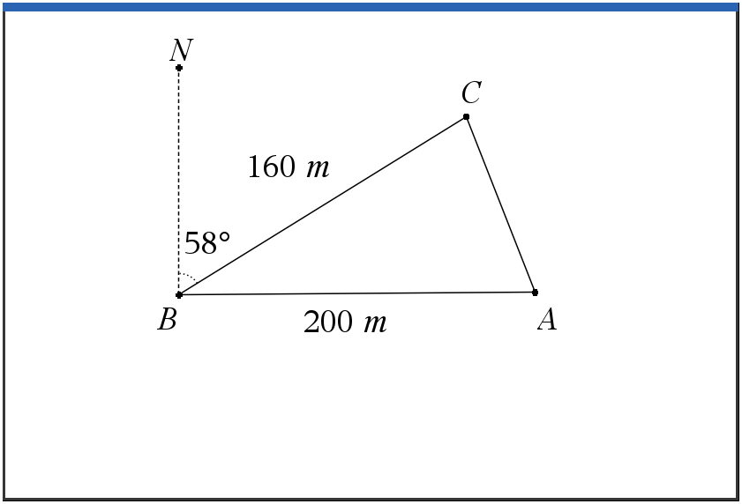

Dwight wants to divide the land into two sections to change his planting patterns and test which produce better beets. He will put a post at point D, which will be between A and C. He wants the boundary BD to divide the land so he will have two equal areas. See the diagram below.

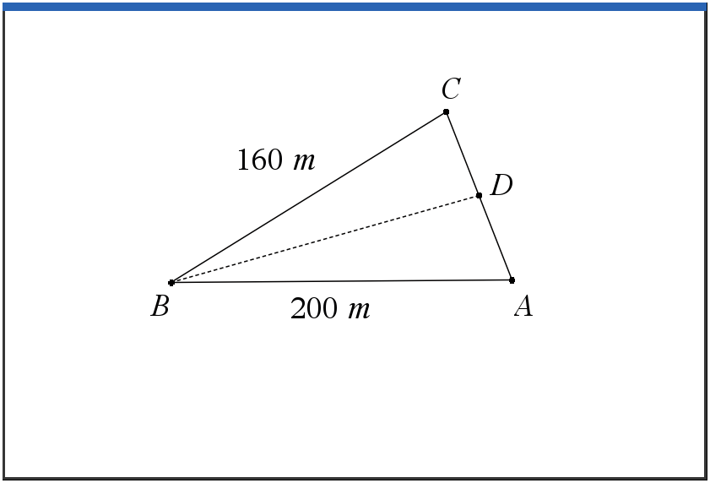
(a) Find the distance from A to C.

(b) Find the area of the entire triangular ABC piece of land.

(c) Find the measure of angle A.

(d) Find the distance from point B to point D.

